Primary 5

Happy Friday Primary 5. I hope that you have had a good week and that you are looking forward to the weekend.
As always, we will start with our morning prayer.

God Our Father, as we begin our days’ work, we ask you to help us to use properly the many gifts that you have given us, so that we may fully benefit from our day together.
St Barbara, Pray for us.
Please say a Hail Mary for any special intentions that you have. Remember you are allowed to pray for yourself it doesn’t always have to be for somebody else.

﻿Numeracy
NLC have set a new competition on Sumdog this week. Today that will be only maths that you need to complete. For anybody that cannot access Sumdog, I have included the Mental 10.
Mental 10
I have included a compass again to help. Remember always make sure you start at the correct point and you move in the right direction. It could be clockwise or anti-clockwise.
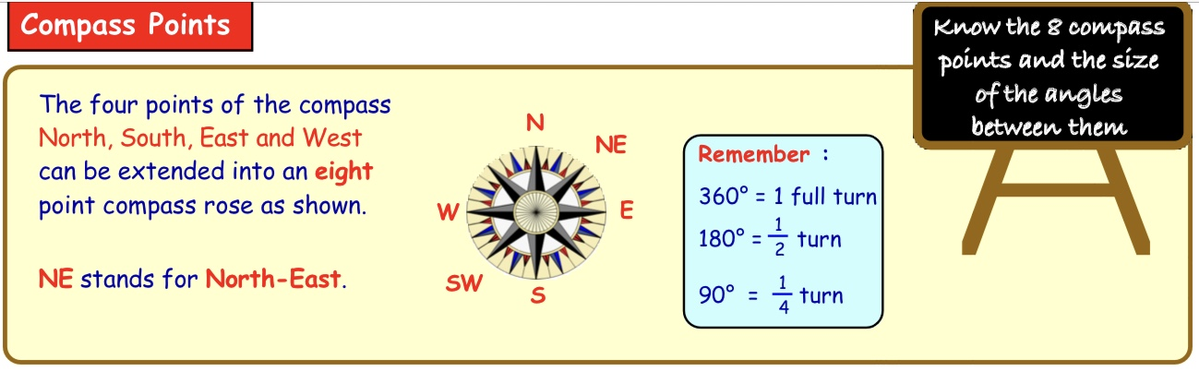

1. Today is June 5th. How many days do we have left in June?
2. Round 434 to the nearest 10. (look at the units digit)
3. Round 6609 to the nearest 100. (look at the tens digit)
4. Charlie was cycling South West. He turned through a 90º anti-clockwise. In which direction is Charlie now facing ?
5. What comes next in the sequence 9,18,27?
6. Write this number fully in words 71 080.
7. Write the number that is 3000after 6888.
8. Write down the answer to 350 + 460.
9. Write down the answer to 540 - 180.
10. Last year Mrs Butler sent 6420 text messages.
This year she sent 4470.
i) How many text messages did Mrs Butler send in total ?
ii) How many more messages did she send last year ?

Please continue to practise your tables. You should still have your table challenge sheet and be working your way through it. If you don’t have your sheet we will pick the 9x table to practise this week.

Language
This week we will look at similes. We have talked about similes in class when we have identified them in our reading books. A simile describes something by comparing it to something else, using like or as. Using similes can make your writing more descriptive and interesting.
Here are some examples
* As quiet as a mouse.
* As hot as the sun.
* As cold as ice.
Now I would like you to look at complete the following worksheet. You don’t have to print it; you can write your own in your jotters or just say them aloud.
After you have completed the similes you could create a simile character. You can draw your character and label it with things like ; eyes as green as an apple, hair as brown as mud. I know that you will have much better ideas than me and I look forward to seeing/meeting all your characters when you send me your pictures.

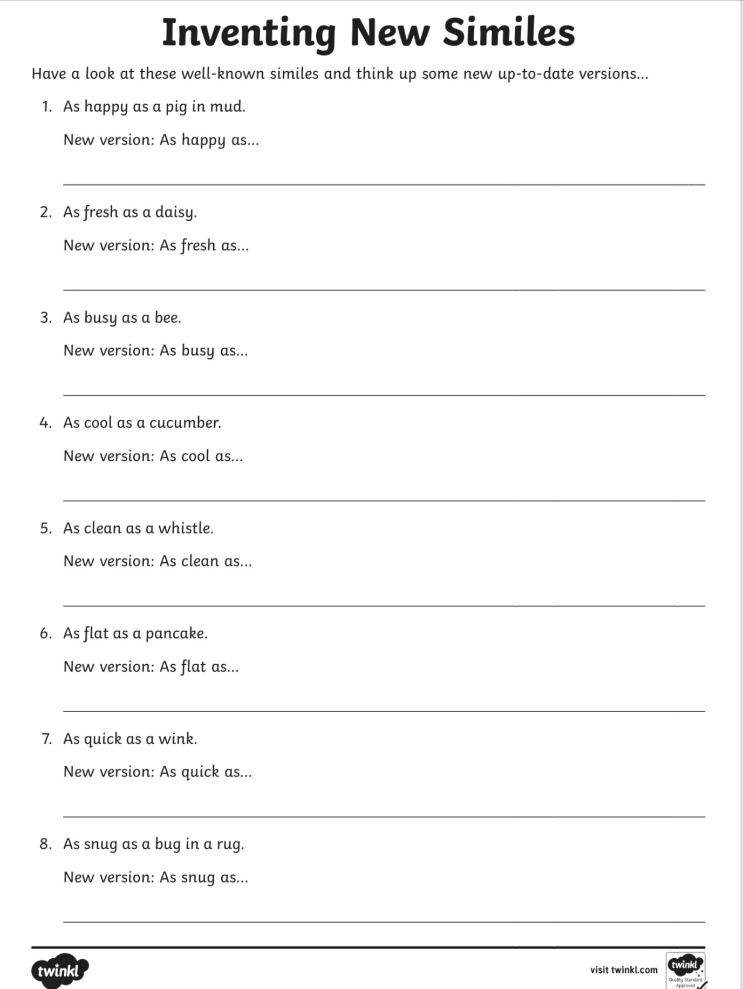

Spelling
You have been practising ‘ow’ words this week.
growl known prowl show growth scowl clown
slow blown brown throw shown down frown throw
I know that you love word searches, below is a link that will let you create a wordsearch with your ‘ow’ words.
http://puzzlemaker.discoveryeducation.com/WordSearchSetupForm.asp
Or you can make your own on squared paper.
Español
This week we will revise ¿Dónde vives ? - Where do you live?
Please make sure that you click on lesson 13 on the link.
Watch the video of Sophie and Miguel talking about where they live. Listen carefully to how they pronounce their words.
https://youtu.be/Agc-G3q8qRY
Practise along with the video and take the part of either Sophie or Miguel asking and answering questions.
When you feel ready you can print and complete the worksheets or try to look at them online and fill in the blanks on a separate piece of paper.

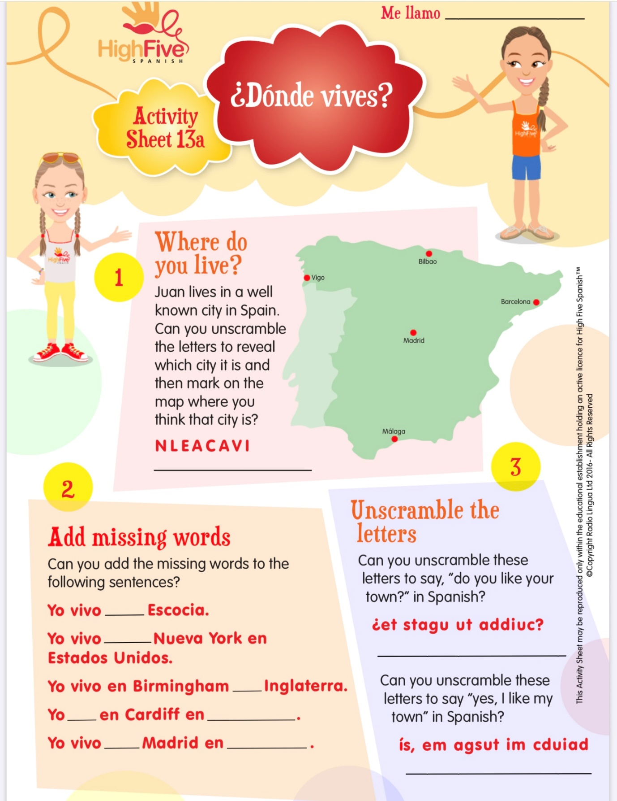

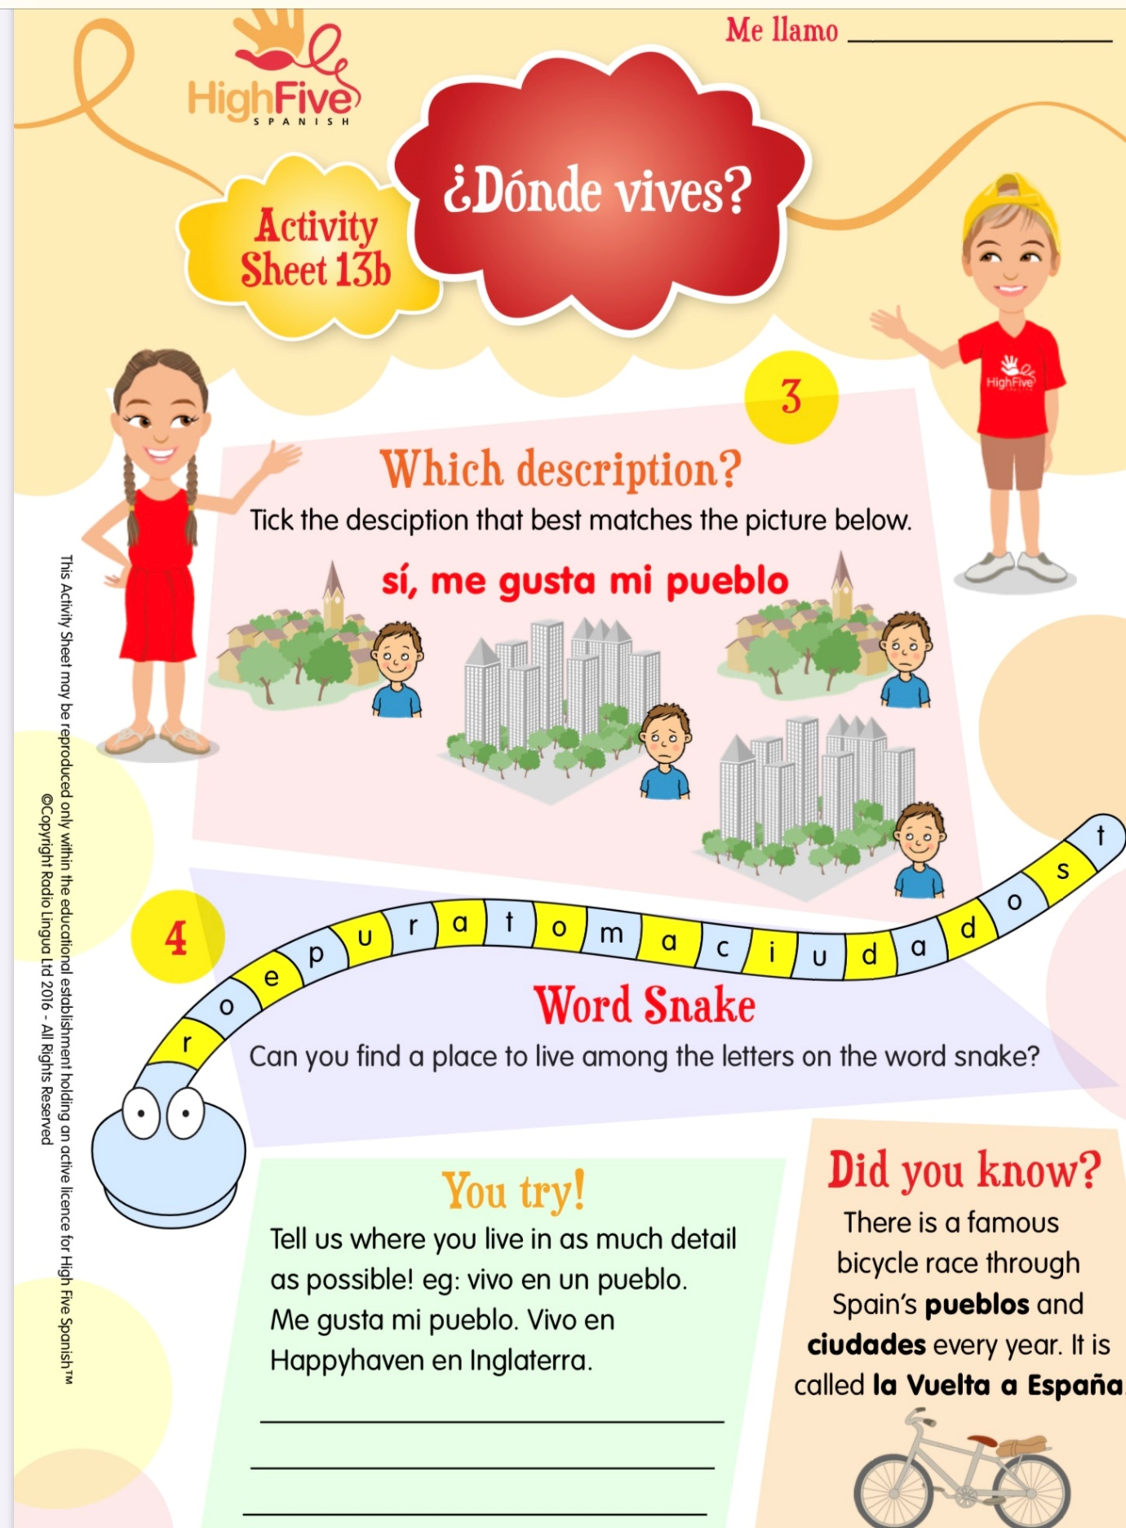

I will continue to leave the video of the alphabet in Spanish too. Please keep practising the Spanish alphabet it is very useful to know it if you study Spanish later on.
https://youtu.be/dVm6A_vl91U
This week you could practise spelling the seasons (Las Estaciones) aloud.
primavera - Spring
verano - Summer
otoño - Autumn
invierno - Winter

Religious Education
Today is the first Friday in June and we would usually be going to First Friday Mass. Please try to join Fr Kenny when he is saying mass today. It is on Facebook so remember you will need to watch with an adult.

Health and Well-being
The health and well-being activity is attached. I really enjoyed trying yoga with Mrs McFall this week. I hope that you all did too.

Well Primary 5 that’s you finished for another week. Give yourselves a pat on the head and say well done to yourselves. As always remember to try and get out to play and get some fresh air. Do something that makes you happy. When you are happy everything else seems much easier.

Remember that you only need to complete the tasks you can manage and don’t worry if you can’t.
Cuidaros mucho y qué sean felices
Mrs Goodwin

