St Barbara’s Primary School
Curricular Areas | Primary 7 Suggested Daily Learning Activities  Friday 5th June
Literacy | - How did you get on with this weeks’ homophones? Can you identify how to use each of them in the correct context? I have attached some sentences below however each of them are missing a word. You have to choose the correct homophone to input into the sentence. Rewrite the sentences in your jotters and underline the word that you have put in.  - I have attached a reading comprehension task to the Primary 7 GLOW homepage for you to complete today. This text is about a subject we are all very familiar with, The Titanic. When you have finished reading the text, read the questions and then skim and scan the text before attempting to answer any of the questions. Answer the questions in your jotter and remember to use the question to help you structure your answer. It is important that you are able to use the reading comprehension strategies that you have been exploring since Primary 4 and apply them to unfamiliar texts. I will upload the answers to these questions on Monday’s blog.  - I have created a metalinguistic and proof reading pod on Study Ladder. Please go on and try to complete these today, editing texts and identifying the meaning of words are important skills for you to develop especially as you are going into high school.
Numeracy | - Complete the maths starter challenge that I have attached below. Today’s starter revisits an area of work that we have explored recently.  - Complete today’s task on your 2nd level June maths calendar. Today’s activity is a 4 digit addition sum. I have no doubt you will be able to successfully answer this question. I have included a copy of June’s calendar below in case anyone did not save it on Monday.  - I know how much you all enjoy a Countdown Number Challenge. I have attached today’s target number below and the digits that you are allowed to use to try to reach the target number. Remember you can only use each digit once and you may use all 4 number operations to reach your target number. Good luck!  - Sum Dog have launched another North Lanarkshire maths competition. Today I would like you to go on and complete as many questions as you can. Remember accuracy plays an important role in how Primary 7 will rank on the table. This could be your last Sum dog competition of primary school so let’s make it our best one yet. I would like all 31 children to participate in this weeks’ challenge. It ends next Thursday, so let’s get playing boys and girls.
Health and Wellbeing | See today’s Primary 7 GLOW homepage for your Health and Wellbeing activities.
TIOF | See today’s Primary 7 GLOW homepage for your This Is Our Faith activities.
Additional Tasks | - If you wish to complete more activities today please select one or two tasks from the Second level grid that you will find on the GLOW homepage.  - I thought it might be nice to have a little uniform day today. Can you put on your school uniform, with your special Primary 7 tie, and get someone to take a picture of you? Put on a big smile and send your pictures to me at gw13reidsiobhan@glow.sch.uk.

Homophone Activity
Can you identify the correct homophone to use in the sentence?
- The teachers’ desk could only be from the back of the classroom. (scene/seen)
- His mum said she could not hear him, so James repeated what he had said at a volume. (higher/hire)
- Last week the was glorious and I spent a lot of time in my back garden, in the sunshine. (whether/weather)
- The thistle is Scotland’s national . (flour/flower)
- The baby continued to at the dog because he had never seen one so fluffy before. (stare/stair)
- When the lady was writing her thank you letters she ordered with her name on it to give a personal touch. (stationary/stationery)
- I wanted to bake a cake for my little brother’s birthday however when I looked in the cupboard there was no . (flower/flour)
- I cannot decide I want to be a doctor or a dentist when I grow up. (weather/whether)

Maths Starter
Use the knowledge that we have explored over the last few weeks to calculate the mean, median and range of a set of data.

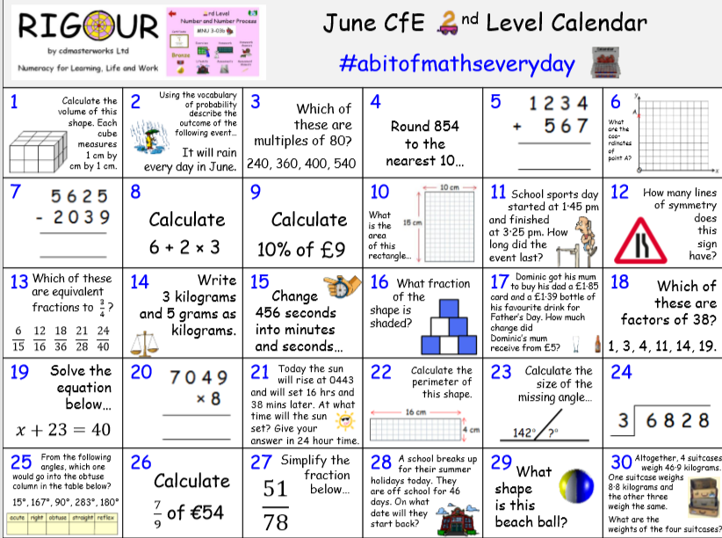
June’s 2nd Level Calendar

Countdown Number Challenge

