**Chopping and Blending in the Kitchen can be Thirsty Work!**

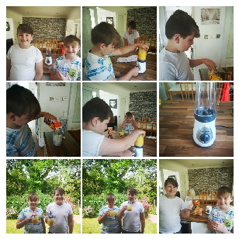**Charlie and Connor make *delicious* drinks!**