**Keeping Safe in the Sun**

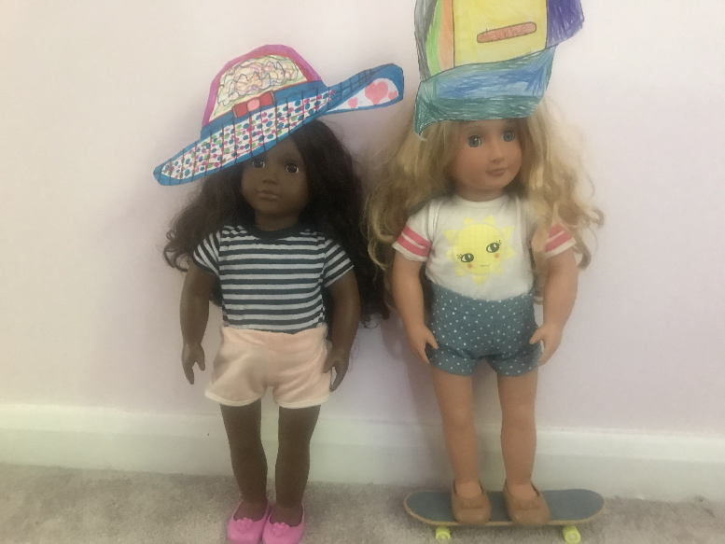**Sunhat Sensations!**

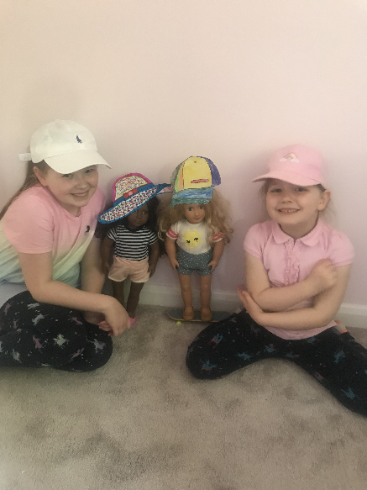

**Beautiful sunhat creations by Hollie and Ailbhe!**