St Barbara’s Primary School
Curricular Areas | Primary 7 Suggested Daily Learning Activities  Wednesday 3rd June
Literacy | - For reading today explore the First News newspaper article, Big Interview. When you have finished reading the article, read the questions and then skim and scan the text before attempting to answer any of the questions. Answer the questions in your jotter and remember to use the question to help you structure your answer. The answers are in the text so always refer back to the article to help support you. I have attached a link to today’s article, questions and answers on the Primary 7 GLOW homepage.  - As you reach the end of your primary school experience I thought it might be nice to make some fun predictions. Today I would like you to think about 20 years from now, the year 2040. I am sure the world will look very different than it does now with even more advanced technology. Where do you think you will be? What do you think you will be doing? Write me a paragraph about where you see yourself in 20 years’ time. Remember you are young, capable children with growth mind-sets’ therefore you can do anything you put your mind to and become whatever you aspire to be. When you have finished writing your predictions, proof read it and then email it to me at gw13reidsiobhan@glow.sch.uk.  - Using your homophone words for this week why not create your own secret code? Assign each letter of the alphabet a specific symbol and record them in a table. Then spell out each of this weeks’ focus homophones using the symbols that you have given to the different letters. When you have completed this give it to someone in your household and they have to use your table to crack the code and discover each of the homophone words. I have attached a very simple example of a code breaker key below to help give you an idea. Try to make yours tricky to catch out whoever is trying to break the code.
Numeracy | - Let’s start our maths lesson today with some fun maths riddles. I have attached the riddles below. Remember to read the questions carefully and break it down.  - In previous years you have looked at tally marks, bar graphs and lines graphs. These are all ways of representing data. Last week we further explored sets of data that had been previously gathered. We calculated the mean, median, range and mode of a set of data. Today we will continue to explore gathered data through pie charts. This is called Data Handling and Analysis, a term you will be familiar with by this point in Primary 7.  Watch the video clip from Rigour Maths that clearly explains how to perform simple calculations from pie charts without a calculator. You will have to apply your knowledge of angles to help with this unit of work.  Watch the video clip as many times as you need to feel confident,  https://www.youtube.com/watch?v=rgtR4SAVfls&feature=youtu.be  - I have attached 3 pie chart tasks. Use what you have learned from the video to answer the questions about the data. Choose the worksheet that challenges you the most or complete all 3 tasks if you want to.  I will post the answers to these worksheets on Thursday’s blog.
Health and Wellbeing | See today’s Primary 7 GLOW homepage for your Health and Wellbeing activities.
TIOF | See today’s Primary 7 GLOW homepage for your This Is Our Faith activities.
Additional Tasks | If you wish to complete more activities today please select one or two tasks from the Second level grid that you will find on the GLOW homepage.

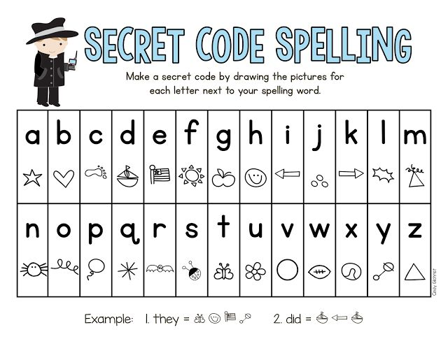
Code Breaker Spelling Activity

Maths Riddles
- When Mary was 6 years old her sister Katie was half her age. How old was Mary when Katie was born?
If Mary is 40 years old today, how old is Katie?
- If there are 7 apples and you take away 5, how many do you have?
- What weighs more- 1 kilogram of feather or 1 kilogram of bricks?

Calculations in pie charts
Sheet 1

Sheet 2

Sheet 3

