Thursday 4th June- Let’s begin as always by saying our morning prayer and a special ‘Hail Mary’ for all the people who are sick in our world and for those caring for them.
Literacy  IALA adjectives. | Today we are going to learn about Adjectives.  What is an adjective?  Let’s sing along with Jack Hartmann to find out!  https://www.youtube.com/watch?v=QxoDGlPUmyU  You should now know that an adjective is a describing word. We use adjectives to give more detail to the reader and help them visualise.  Find an Adjective- Can you read these sentences below and highlight all of the adjectives.  - It is a pretty flower.  - I have a green juicy apple.  - My little dog likes to play.  - Dad gave me a yummy cake.  - It was a hot day.  - Macy’s dress is purple.  - The green snake is long.  Next, can you have a go at writing 2 adjectives to describe each picture below.  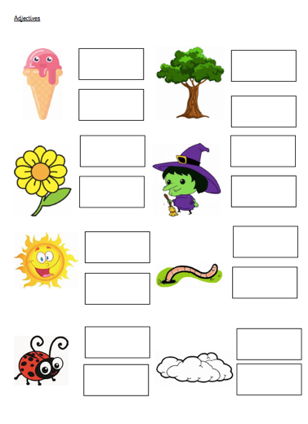
Numeracy | It is important that we continue practising our oral maths.  Count on and back in 2s from 0-20  Count on and back in 5s from 15-70  Count on and back in 10s from 50-150  Next, I would like you to complete ‘Today’s number’ task.  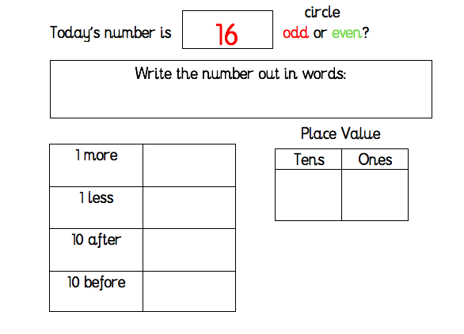  Sumdog- I have set a Sumdog competition for you to take part in today.  You have between 9.00am and 3.00pm to take part. I will announce the winner of the Sumdog competition just after 3.00pm. Good Luck!
HWB | We were talking yesterday about how important it is to look after our bodies. Drinking plenty especially during exercise and warm weather to keep us hydrated. Our bodies are amazing things.  Here is a little activity to keep you busy and at the same time learn about all of the parts that make up ‘US’!!  Have you got a roll of wallpaper lying around or if you have been receiving lots of packages (did you know all our posties are busier than their busiest time of the year, Christmas!) during lockdown and have cardboard boxes around I want you to lie them flat on the ground and get someone in your house to draw round you. (The weather’s not looking that good today but should be dry so even do this task outside)  Here we have our template!! Can you label and identify as many parts of the human body, all the organs? See if you can have a good guess at where they are located. Our heart 💓 Should be easy, what about our lungs, liver etc. Try to see how many you can find. You could even put your artistic talents to good use and draw them in.  Remember to email your marvellous pictures to (gw19shreenannatasha@glow.sch.uk or upload it onto Twitter with an adult’s permission
T.I.O.F | As we know things just now are very different from what we are used to. By now our new Primary 1 children would have been in to visit the school but, like you, they have not been able to come in for their visits. We are thinking that it would be a lovely idea for you to say a little prayer for them. In order to make them feel welcome to our school in August, I would like you to choose the word for your stage below, write/colour it on a sheet of paper, hold it up and ask an adult to take a picture of you holding your word with a big smile and if it is possible you could wear your uniform. Please email your picture to (gw19shreenannatasha@glow.sch.uk). We will use these to make our Primary 1’s feel very welcome to our school.  A Great Big Welcome To St. Barbara’s!  Primary 1 – A; Primary 5 – Great; Primary 4 – Big; Primary 6 – Welcome; Primary 2 – To; PRIMARY 3 – St. (remember the dot); Primary 7 – Barbara’s!  Do you remember our Easter Message?  We still miss you lots!!
Optional  tasks | If you wish to complete more tasks please select one or two tasks from your new First level grid for May.

Remember any work you wish to upload should be done so under your class name and if you would like to share any videos or pictures of you completing any of the tasks you have been set you can do so via Twitter. Have fun, work hard and if you need anything you can contact me by email; gw19shreenannatasha@glow.sch.uk

Miss Shreenan

