Wednesday 3rd June- Morning Prayer
Literacy  Reading  IALT read with understanding and expression. | Reading- Scholastic Reading.  I would like you to read your assigned reading book aloud to someone at home, make sure to use eye contact and expression throughout.  After this I would like you to select one of the reading tasks from the grid below. We have completed all of these tasks before in class..  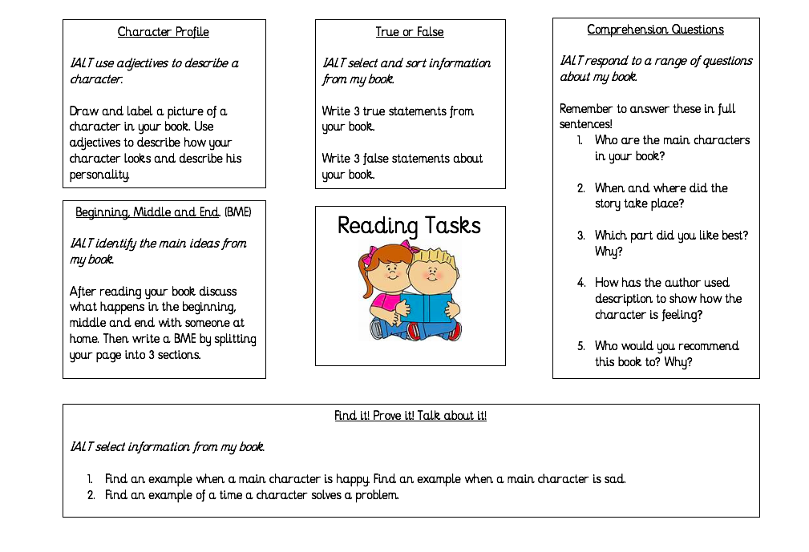
Numeracy  IALT use a calendar. | Time- reading a calendar.  How did you get on yesterday with reading the calendar? It is a very important skill that you will use throughout your lives, especially when you are a grown up.  Let’s see how confident we are at reading calendars by completing the task below:  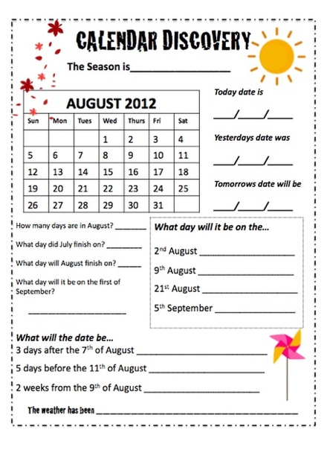  I like to mark important dates on my calendar. First, I always like to put in people’s birthdays so I don’t forget! I also add in any holidays I have planned and any appointments I might need to go to.  I haven’t filled in my calendar for the month of July yet. Could you help me fill it in?  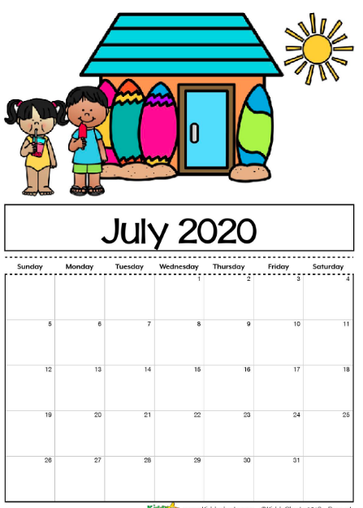  It is my Auntie’s birthday on the 4th of July.  I am going on holiday on the 19th of July for 1 week.  I have to take my rabbit to the vet on the last Friday of the month.  I have the dentist on the 7th of July.  I am going to visit my Gran and Grandad on Thursday 16th of July.  Challenge- My friend asked to meet up on the 21st of July, am I free?
HWB | I hope you enjoyed your Slushies yesterday!! We just managed to get them made in the warm weather as today is to be a bit cooler.  YOGA  We are going to follow a little Yoga session that Mrs McFall (Daniel and Luke’s mum) has kindly allowed us to share on the Blog.  Below is a great Yoga workout that you can do along with an adult or your siblings. You can also have your favourite ted join in too.  https://www.facebook.com/watch/?v=228083418312545  Yoga is a great skill helping you learn the importance of how you breath which in turn helps us relax and sleep well. (Parents: Mrs McFall recommends that you allow your child to go with the flow and, if you are able to accompany them doing the video, ask them similar questions). Remember with any exercise we should remember to drink plenty to keep us hydrated, looking after our bodies!!  Once again a great big thank you to Mrs McFall and Luke. 👏👏
T.I.O.F | Over the course of the last few days we have been learning about the importance of Pentecost. It has shown us how important the feast is in the church’s year.  There are a few activities below which you can complete to reinforce what you have learned about The Feast of Pentecost and the Holy Spirit. You can choose to do one activity or why not complete it together with your siblings.  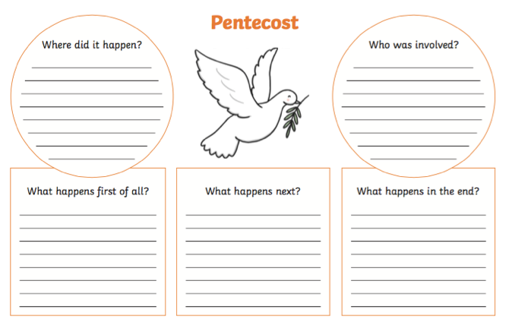  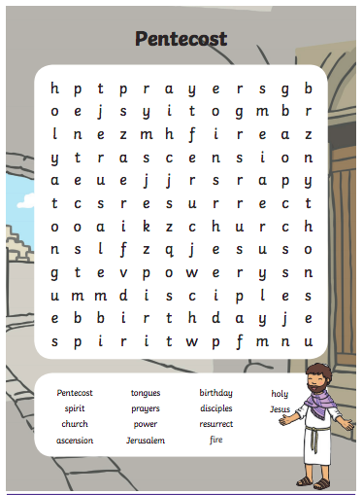  When you have finished your activities, take a few minutes to pray together with your family. I have attached a lovely hymn that you could sing together to finish off your Pentecost work for today.  https://www.youtube.com/watch?v=dnt4ST8HGQA&feature=emb_title
IDL Topic | Around the World  One of the most popular experiences in America is going to see a show on Broadway in New York City. Broadway is one of the most famous streets in America. Follow this link to watch the video and let’s explore together:  https://www.youtube.com/watch?v=sWFhe3xXSj0  I don’t know about you but after that Barnaby Bear would love to visit Broadway to see a show. It looks so exciting! Unfortunately due to lockdown, Broadway has shut down, however today we are going to re-create the Broadway experience for Barnaby Bear.  You are going to create your own theatre by making tickets to your show.  Here is a template you may wish to use or follow.  Barnaby Bear can’t wait to find out what he is going to see!

