[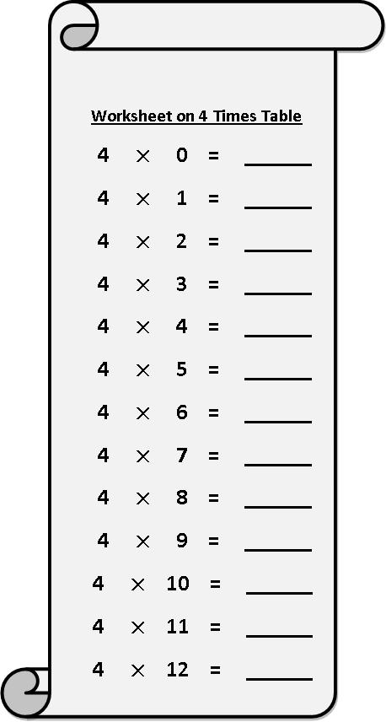](https://www.google.co.uk/url?sa=i&url=https%3A%2F%2Fwww.math-only-math.com%2Fworksheet-on-4-times-table.html&psig=AOvVaw2Cyj0FaiOU651qK20djeGM&ust=1591199045409000&source=images&cd=vfe&ved=0CAIQjRxqFwoTCLjCrcG84-kCFQAAAAAdAAAAABAN)