[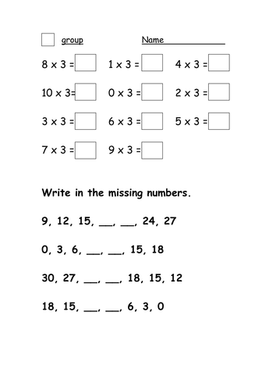](https://www.google.co.uk/url?sa=i&url=https%3A%2F%2Fwww.tes.com%2Fteaching-resource%2F3x-table-worksheet-6140558&psig=AOvVaw1iOeUZxEAhN5LS-HSs_3lj&ust=1591147937161000&source=images&cd=vfe&ved=0CAIQjRxqFwoTCND62ZD-4ekCFQAAAAAdAAAAABAD)