[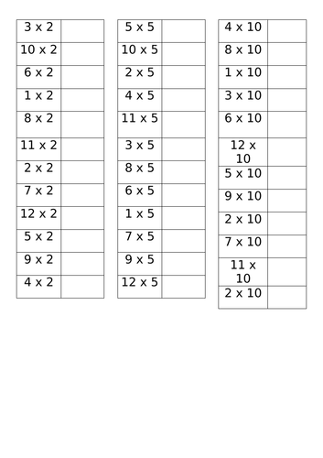](https://www.google.co.uk/url?sa=i&url=https%3A%2F%2Fwww.tes.com%2Fteaching-resource%2F2-5-and-10-times-tables-12251120&psig=AOvVaw2Afh3aLVRqQ6k4AjdiVgOP&ust=1591147787244000&source=images&cd=vfe&ved=0CAIQjRxqFwoTCIC8l8r94ekCFQAAAAAdAAAAABAD)