Tuesday 2nd June- Morning Prayer
Literacy  IALT decode words using phonemes. | Phonics Task  Starter- Alphabet name and sounds- My name is A, my sound is a.. (orally)  Warm-up- read through the phonics cards- see how many you know! (sh for shop, ch for chest…)  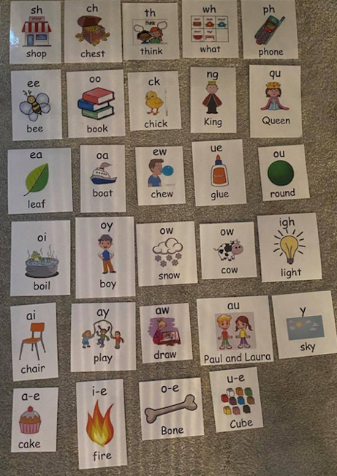  This week’s new phoneme sound is:  Capital letters- ss (miss)  Spelling Rule- We use the (ss) phoneme when we hear a hiss sound in the word.  Watch > https://www.youtube.com/watch?v=6G0G-CEVXis  Phoneme task-  Read out the words below to someone at home- remember to sound out the words (m e ss = mess)  mess, lesson, class, dress, less, moss, kiss  Now, write each word out 3 times using look, say, cover, write and check.  Use a different colour for your phoneme ‘ss’  Next, copy and complete these sentences by filling in the blanks with your ss words from today.  - I have to tidy up my ____.  - The girl had on a pink _____.  - Miss Shreenan misses her primary 2 _____ very much.  - My mum gave me a ____ good night.  - I started my swimming ______ at 5 o’clock.  Full stops- (ow- snow)  Watch> https://www.youtube.com/watch?v=NZdgP2wAQic  Spelling Rule- When we here the letter name ‘o’ at the end of a word we use the ‘ow’ phoneme.  Read out the words below to someone at home- remember to sound out the words (s n ow =snow)  Low, grow, throw, follow, shallow, show  Now, write each word out 3 times using look, say, cover, write and check.  Use a different colour for your phoneme ‘ow’  Next, copy and complete these sentences by filling in the blanks with your ow words from today.  - I water my plant so it can ____.  - I can ____ my ball up high.  - I like to play in the ______ pool.  - I make sure I ______ the rules.  - My favourite T.V ____ is ______.
Numeracy  IALA a calendar. | Yesterday we were looking at days of the week and months of the year.  It is important we know how many days are in each month so that we know when it is a brand new month. How did you get on yesterday with learning the ‘Days in a month’ song?  Let’s begin by singing along with Jack Hartmann to remind ourselves how many days are in each month.  https://www.youtube.com/watch?v=bRU03b5Rt3s  Let’s test our memory and see if we can answer these questions-  How many days are in September? How many days are in July? How many days are in February? How many days are in one year?  Calendars-  A calendar is very useful, it helps us learn about the passing of time along with months of the year and their order.  A calendar is a series of pages that shows the days, weeks and months of a particular year. It is a tool we use to help us keep track of each day, and it allows us to visually see when different events will happen.  Let’s have a listen to find out more > https://www.youtube.com/watch?v=L_rzvbkwYFw  Learning to read a calendar is an important life skill.  Today we are going to have a look at reading a calendar.  I have included a page from a calendar below. Look carefully at the calendar. Along the top we have the days of the week then below it shows you how many days are in that specific month.  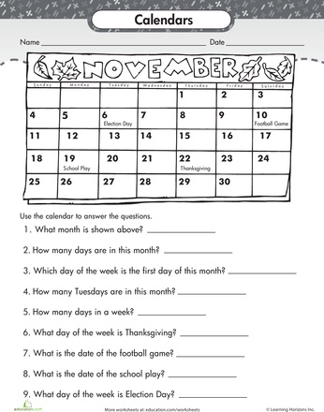  Can you read and answer the questions about the calendar.
HWB | With the hot weather that hopefully we have all been enjoying we are going to look at ways to help us stay hydrated. We know that we need to drink plenty of water and ensure we do that more frequently during hot days.  Another great way to enjoy the hot weather is with a lovely cool Slushie!!  Yum Yum. Below there is a great recipe, with a little bit of science thrown in, that lets you make a slush with your hands!! Yip that is right you don’t need a fancy NutriBullet or a blender, just your hands. So here goes :  Instructions to make a cool mouth-watering smoothie!!  - Place one cup of your chosen juice into a small Ziploc bag and zip tight.  - Place 4 cups of ice and half a cup of salt into a large Ziploc bag along with the juice bag and zip that tight too.  - Shake the large bag over the sink or outside for 2-5 minutes or until the juice bag turns to slush.  - Pour into a cup and enjoy!!  If you have your own recipe/method for making a Slushie please email this along with a picture of your Slushie to (gw19shreenannatasha@glow.sch.uk) or upload it onto Twitter with an adult’s permission.
T.I.O.F | The Feast of Pentecost is a very important celebration in the Church’s year and watching the short clip below will give you a snapshot of the importance of this great celebration.  https://www.youtube.com/watch?v=J5tr4pqWIo4&feature=emb_title  The Feast of Pentecost is seen as the Birthday of the Church.  The Holy Spirit came to the disciples not only as a reminder that Jesus would always be with them but so that they received the strength and courage to continue to build God’s kingdom, not only in Jerusalem but to ensure it reached the ends of the earth. In John’s Gospel on Sunday we heard not only about Jesus’ word but about Jesus’ action, “he breathed on them and said receive the Holy Spirit”. Jesus’ breath gives new life, eternal life into the disciples, giving them the courage to go out and spread the word by being given special gifts. Jesus gave them the gift of speaking different languages to be able to carry out his work all over the world.  The Holy Spirit came to us in the Sacrament of Baptism and will or has come again to us in the Sacrament of Confirmation. Talk to an adult about your Baptism/Confirmation(if you have made it yet). Think about all the wonderful gifts God has given us and give thanks to the Lord for all that we have to be glad of. Just like the disciples we give thanks to the Lord of all the gifts he has given us. We are so grateful to God for always being with us.

