Monday - It is a new week so let’s begin our day with our morning prayer, keeping those who are sick in our thoughts and thanking God for keeping us healthy and safe.
Literacy  Reading  IALT read with understand and expression.  Spelling  IALT use a range of strategies to help me spell. | Reading-  I have assigned a new book for you to begin today on Scholastic Learning Zone. First, I would like you to listen to the story, then read it aloud to a member of your family before answering the quiz.  Spelling Task- Common Words  Starter- read through your common word flash cards, remember to add in last week’s new common words.  You have 4 new common words this week  Capital letters spelling words- four, miss, never, these Full stops spelling words- yellow, grow, again, food  Can you read these words out to someone at home?  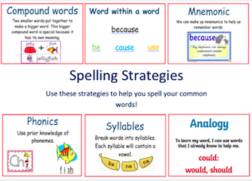  Remember to think about what strategy will help you spell and read these words.  Now, select a fun spelling task to practise this week’s new spelling words.  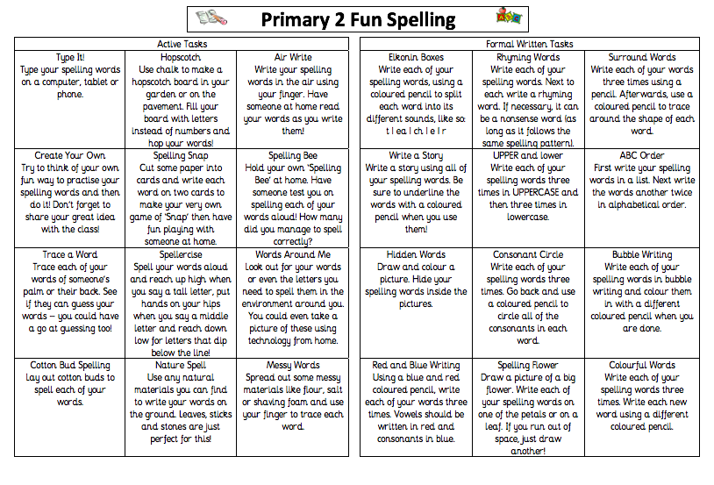  Next, I would like you to create a super sentence for each common word.  Don’t forget super sentences need a capital letter at the start of a sentence, a full stop at the end and finger spaces between each word.  Challenge- try add in a connective to your sentence- and/but/so/because.  Make sure to re-read you work to check it makes sense.
Numeracy  IALA a calendar. | This week we are going to be focusing on Time.  Time is very important in our everyday life. Time helps us to plan and be organised and impacts on our daily routine-when to wake up, go to sleep, when to go to school, when to have dinner. This is why it is important that we understand a calendar.  Let’s begin with the days of the week.  Sing along with our days of the week song.  https://www.youtube.com/watch?v=oKqAblcwFOA  The days of the week are all mixed up, can you write them in the correct order. You could do this outside using chalk.  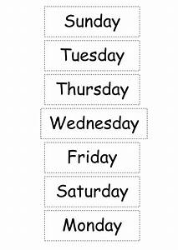  Next, can you answer these questions orally-  What day is it today? (clue-it is the beginning of a new week) What day is it tomorrow? What day was it yesterday?  How many days are in 1 week? How many days are in 2 weeks? What days are the weekend? What days do we go to school?  Why not test your days of the week knowledge by completing this task-  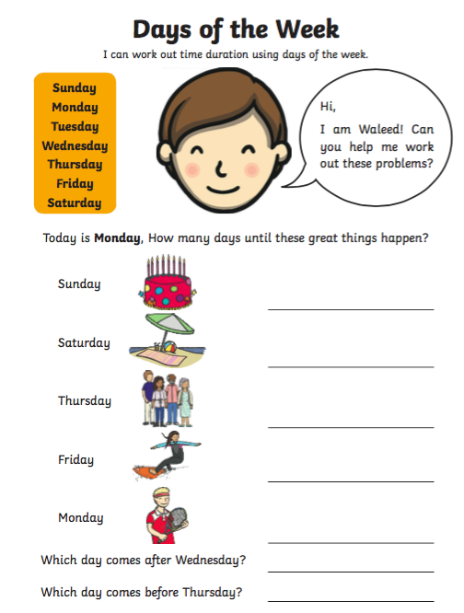  Now let’s think about our months of the year.  Jack Hartmann is here to help, sing along with him!  https://www.youtube.com/watch?v=omkuE6Wa5kQ  Can you say the months of the year? How many months are in one year? If last month was May, what month is it now?  Every month links up to a season- How many seasons are there in one year? Can you name them all?  Complete the tasks below task-  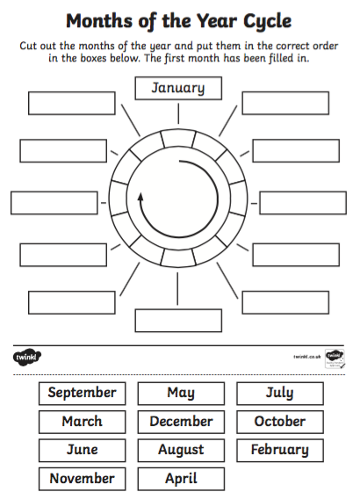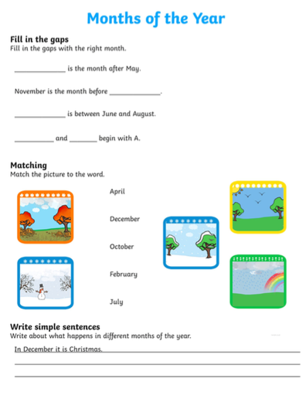  It is important that we not only know the months of the year but also how many days are in each month. Try have a go at learning this song with Jack Hartmann over the next few days! This will help with your next task later on in the week.  Days in the month>  https://www.youtube.com/watch?v=bRU03b5Rt3s
HWB  IALT improve my fitness. | Over the weekend hopefully we were all able to go visit a member of our family! This has been something we have taken for granted all of our lives (as we probably did this every weekend or more). From Friday onward this has been a very special time for many. Hopefully your family don’t live too far away and you have been able to spend some time with them. It must have been a great feeling to spend time, in our gardens, with loved ones.  How it has lifted all our spirits and given us such a positive boast. If you were able to visit someone you have not seen during Lockdown you will know this feeling. Hopefully it won’t be too much longer until we can see all of our family.  Today is also a new month/season JUNE begins our three months of SUMMER, can you believe it!! This too should make us feel more positive as hopefully we have lovely weather.  How positive did this little visit have on us. Being positive makes our world a better place and after all the changes that have happened over the last few months, we will begin to see a brighter, happier, and more POSITIVE future ahead.  I would like you to take the word POSITIVE and write an acrostic poem. (Remember you take the word POSITIVE and in large letters you write it down the left-hand side of your page and then write a word/sentence that begins with each letter of POSITIVE).  Here is an example for the word Welcome to let you see how your poem should look.  You can email your poem to (gw19shreenannatasha@glow.sch.uk) or upload it onto Twitter with an adult’s permission.  Now to keep that positive vibe going let’s try a little Zumba.  https://www.youtube.com/watch?v=9fgA6TJ5VHY&feature=emb_title  Remember to have plenty of drinks throughout the day. It’s going to be another hot day and we need to stay hydrated!! Watch out for tomorrow’s post to give you another idea for keeping hydrated!!
T.I.O.F  IALA the Feast of Pentecost. | The Feast of Pentecost – 31 May 2020  “They were all filled with the Holy Spirit and began to speak”  “When Pentecost day came round, they had all met in one room, when suddenly they heard what sounded like a powerful wind from heaven, the noise of which filled the entire house in which they were sitting; and something appeared to them that seemed like tongues of fire; these separated and came to rest on the head of each of them. They were all filled with the Holy Spirit, and began to speak foreign languages as the Spirit gave them the gift of speech.”  The Feast of Pentecost brings to an end the Season of Easter and falls 50 days after Easter Sunday. Pentecost celebrates the coming of the Holy Spirit. As we heard in the first reading of how the disciples were all together and how they were afraid now that Jesus had left them. On this day they were given the gift of speaking many different languages so that they could travel far and wide to spread the good news.  We learn that God is always here for us, we just need to ask him for help if we are afraid, worried or feeling lonely. He will answer our prayer and help us. Especially in these times when we are feeling sad about not seeing our friends and families like we use to. God will be by our sides to guide us through to better times.  Above you will see an image of Pentecost. There are important symbols that are associated with Pentecost – we can read about them in the extract above from the Acts of the Apostles. We also saw Father Campbell in his red vestments when watching Mass yesterday.  For today’s task I would like you to design your own Pentecost poster incorporating some of the important symbols of Pentecost. This poster will remind us that the Holy Spirit is with us in everything we do.  Please email your poster to (gw19shreenannatasha@glow.sch.uk) or upload it onto Twitter with an adult’s permission.
IDL topic  IALT recognise my own skills and abilities. | Around the World  This week, Barnaby Bear is off to America. The USA is one of the biggest and most well-known countries in the world!    There are hundreds of famous landmarks across the USA. There are many famous buildings, bridges, mountains and much more.  Today we are going to look at the Hollywood walk of Fame. America is famous for making movies and famous film stars. Watch this video to see the Hollywood walk of fame.  https://www.youtube.com/watch?v=8OQ4S5M7UZw&fbclid=IwAR1a8vgg2-tOmCUIMtYeOyFSH4kfEYX746gQQGX5iI5oW9J78Xv8JsYpCg4  I have some great news. Today, the Hollywood Walk of Fame is adding some new stars! The superstars from our class. I would like you to make yourself a star for the walk of fame.  Here is a template for you to use/follow.  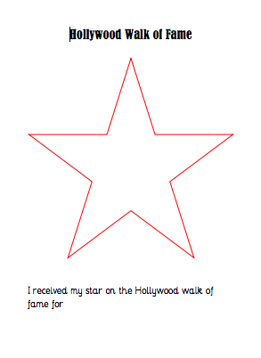  You must include your name and why you are getting a star on the walk of fame. Are you receiving this for a special talent? Is it because you are kind? Have a think and have a chat with people in your family and remember to send me your stars.
Optional  tasks | If you wish to complete more tasks please select one or two tasks from your new First level grid for May.
Remember any work you wish to upload should be done so under your class name and if you would like to share any videos or pictures of you completing any of the tasks you have been set you can do so via Twitter. Have fun, work hard and if you need anything you can contact me by email; gw19shreenannatasha@glow.sch.uk

Miss Shreenan

