Literacy  Friday 1st of May – please begin with our morning prayer.  IALT use a range of strategies to help me spell. | Spelling Test-  Today I would like you to practice your spelling words by doing speed writing. Set a 60 second timer and see how many times you can write your spelling word out correctly. Do this with each of your spelling words.  When you are finished, get someone at home to test you on this week’s spelling words.  Capital letters sp words- Mrs., School, home, two, right, chair, keep, light, boat  Full stops sp words- Like, made, could, said, down, boat, coat, road  Reading Task-  I would like you to read your assigned book again from this week on oxford owl > https://www.oxfordowl.co.uk/  Simply log in to this website by clicking- the pink ‘my class login’ button at the top right hand side.  Enter the username- miss shreenan p2 & password- books  Apples- I would like you to search for ‘What was it like?’  Bananas- I would like you search for ‘Paris Adventure’.  Strawberries- I would like you to search ‘Kipper and the Trolls’.  Read it out loud to a member of your family to enjoy, Remember to use expression and make eye contact.
Numeracy  IALT round whole numbers. | Let’s start by counting together by 10’s with Jack Hartmann- https://www.youtube.com/watch?v=W8CEOlAOGas  Next, I would like you to complete this rounding to the nearest 10 worksheet. This can be completed on the worksheet or in your jotter.  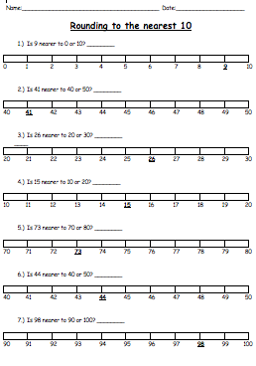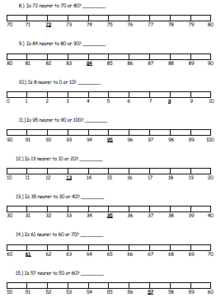
HWB  IALT improve my fitness. | Select one of these to complete to ensure you stay active today.  - Joe Wicks on YouTube @ 9:00am  - Jumpstart Jonny dance and work outs @ 9:00am  - Oti Mabuse Strictly Come Dancing live dance class @11:30
T.I.O.F | During the month of May, we remember Mary. It is a special time to honour Mary, the Mother of God.  Normally during this time we would be setting up a beautiful May Altar in honour of Mary if we were in class today so perhaps you might like to set up your own one at home.  I have included a Power Point on the blog with some useful information to help you set up your own Altar for the month of May.  Once you have set up your May Altar, I would like you to have a go and putting some of your thoughts down. What do you think of when you think of Mary?

Golden Time | Hooray, we made it to Friday!  It is now time for you to do something you enjoy this afternoon.  If you can, post some photos of you having fun on our Twitter.  Have a wonderful weekend everyone!  Take care,  Miss Shreenan

