[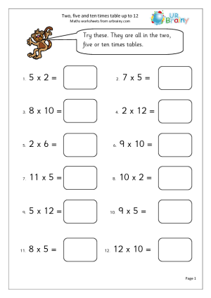](https://www.google.co.uk/url?sa=i&url=https%3A%2F%2Fwww.pinterest.co.uk%2Fpin%2F446067538066272197%2F&psig=AOvVaw0b_EciEEA1swF_ie8HfQ4N&ust=1590745729034000&source=images&cd=vfe&ved=0CAIQjRxqFwoTCICquuSj1ukCFQAAAAAdAAAAABAD)