[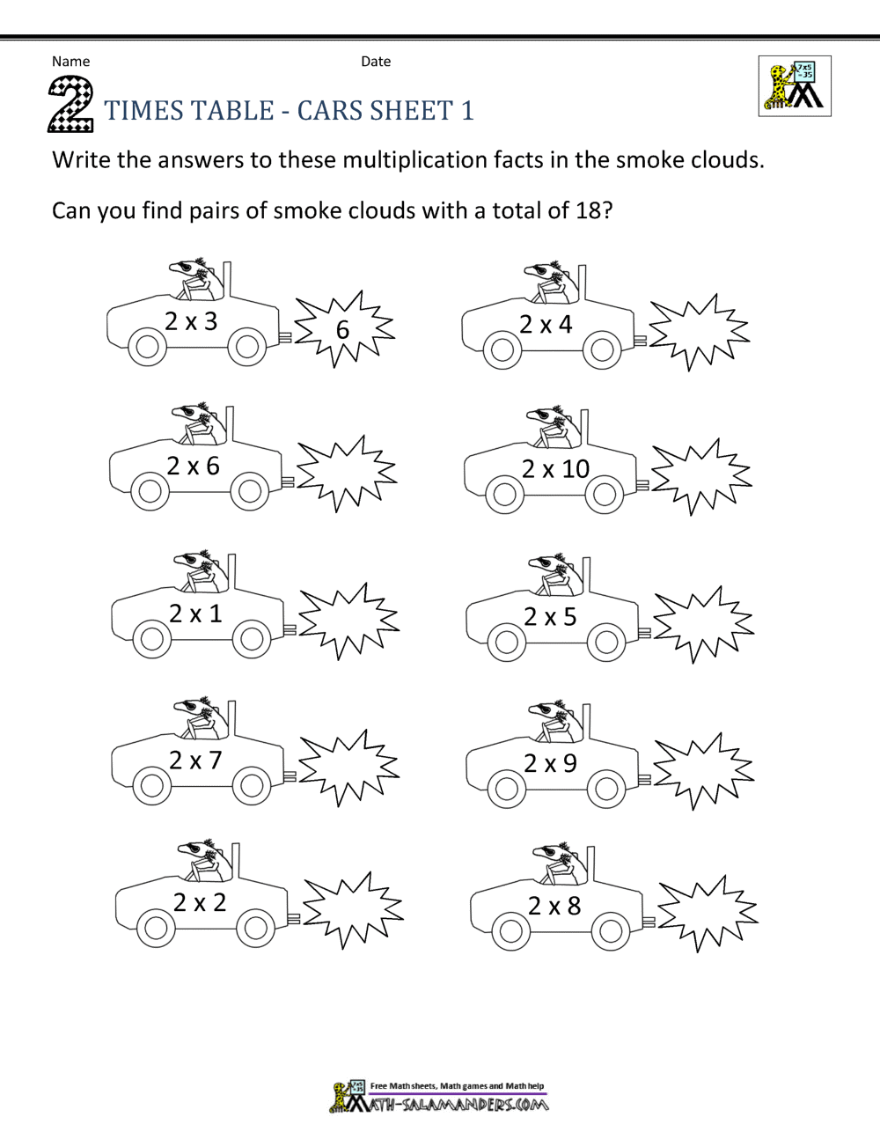](https://www.google.co.uk/url?sa=i&url=https%3A%2F%2Fwww.math-salamanders.com%2Fprintable-times-tables.html&psig=AOvVaw17yMiqdfYXjTj5xIIORRNP&ust=1590745487018000&source=images&cd=vfe&ved=0CAIQjRxqFwoTCOji5e-i1ukCFQAAAAAdAAAAABAN)