Shining Stars – Quiz Time

Thank you to all of you who have submitted a quiz, I really enjoyed having a go. I will send you my answers personally. For now, why not have a go at your classmate’s quiz below:

Amelie’s quiz:

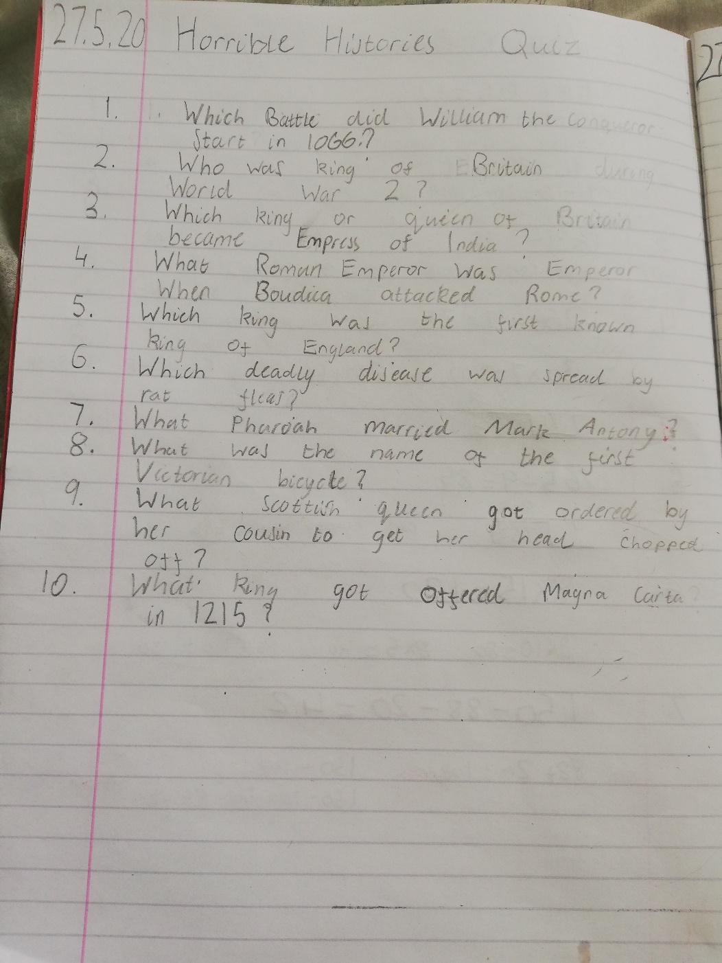

Alix’s Quiz:

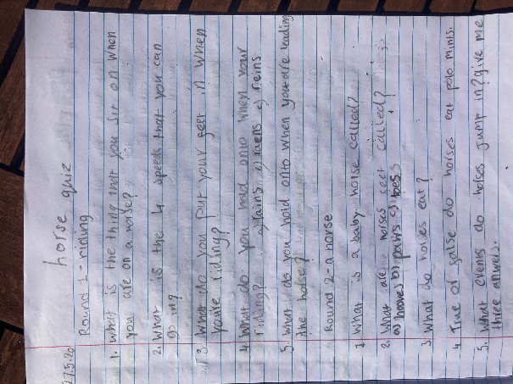

Rory’s Quiz:

