St Barbara’s Primary School
Curricular Areas | Primary 7 Suggested Daily Learning Activities  Thursday 28th May
Literacy | - Today why not set yourself a target of how many pages of your personal reader you would like to read? Try your best to achieve your target and if you beat it, even better! When you have finished reading summarise what you have read to someone in your household.  - With everything that is going on in our world today there are so many people working hard and trying their best to keep our country going. Can you think of some people who could be regarded as ’community heroes’? Who would you say has played an important role in helping support our country during these difficult times? Today I would like you to choose someone that you would class as a ‘community hero’ and write a letter to them thanking them for everything that they have been doing.  When we have explored letter writing in class we have focused on more formal letter writing. For this letter I would like you to follow a typical letter structure and remember your core writing target however it is up to you what you would like to include. I think some illustrations would also be a nice idea for a letter like this.  I have attached our Core Writing Targets below seeing as it has been a while since we have reminded ourselves of these.
Numeracy | - Remember to complete day 2 of your standing long jump maths activity. I look forward to seeing your results on Friday to see how far you can all jump. Remember to highlight your best jump each day.  - Today we will continue to explore how to calculate the mean and range of a set of data.  - I have attached 2 worksheets that explore calculating the mean of a set of data. Complete the worksheet that challenges you the most, you can complete them both if you want. I will post the answers to these this afternoon. Remember the mean is the average number in a set of data.  - I have attached a worksheet to the Primary 7 Glow homepage that explores the range of a set of data. Remember the range of a set of data is the difference between the highest and lowest values in the set.  - Today I would like you to try and complete some of the activities from the Daily Rigour newspaper. I have attached a copy of this weeks’ edition of the newspaper. Try your best to complete as many of the articles as possible. Watch the video link below to find out the solutions for last weeks’ edition of The Daily Rigour. This is a great resource for exploring a range of mathematical concepts and language.  https://youtu.be/b-g3wFaK1YI
Health and Wellbeing | See today’s Primary 7 GLOW homepage for your Health and Wellbeing activities.
TIOF | See today’s Primary 7 GLOW homepage for your This Is Our Faith activities.
Additional Tasks | If you wish to complete more tasks please select one or two tasks from your Second level grid for May.

Calculating the Mean
Activity sheet 1
Activity sheet 2

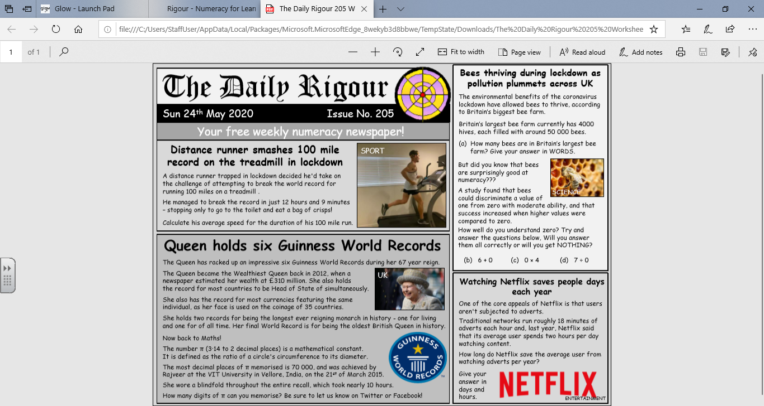
Daily Rigour Newspaper

Core Writing Targets
Core Language Features – Show that you can:
- Use capital letters and full stops in all sentences.
- Spell most commonly used words correctly.
- Spell tricky words correctly in topics, Maths/Science etc.
- Join sentences together using a variety of conjunctions/connectives (and/but/so/then/because).
- Vary the sentence lengths (short and long sentences) and sentence openings.
- Use paragraphs to separate events/ideas/facts.
- When compiling a list, correctly use commas.
- Present all work legibly and include features to make it attractive (headings, labelled diagrams/charts).

