Friday 29th- Let’s begin as we always do with our morning prayer.
Literacy  Spelling  IALT use a range of strategies to help me spell.  Reading  IALT select, read and listen to texts I enjoy. | Spelling Bee-  Today I would like you to practise your spelling words by doing speed writing. This can be done on a whiteboard.  Set a 60 second timer and see how many times you can write your spelling word out correctly. Do this with each of your spelling words.  (You can look at your spelling words during this task to help you before you take your test)  When you are finished, get someone at home to test you on this week’s spelling words and dictation.  Spelling words-  Capital letters- father, head, mother, jump, these, here, eve, complete, Steve  Full stops- each, ask, year, eat, speak, clean, steal, team, stream  Dictated sentences-  Ask someone at home to read out these sentences for you to write. Remember your core targets.  Capital letters-  - My father fell and cut his head.  - You will have to run up and jump off the box.  Full stops-  - Each day we eat a peach after lunch.  - Next year we can go far away in the car.  Reading for enjoyment-  Today I would like you to choose a book of your own choice to read aloud to someone in your family. You could choose a book from Scholastic, Oxford Owl or a book that you have at home.  Find somewhere cosy and quiet to enjoy your book.  Happy Reading!
Numeracy  IALT solve problems using addition and subtraction. | Over the past week we have been focusing on solving problems using addition and subtraction up to 20.  Remember:  - Addition- when you add 2 numbers together it makes a bigger number.  - Subtraction- when you take one number away from another, you get a smaller number.  Let’s get our brains warmed up with a Daily 10. Click this link> select level 2, addition, up to 25.  https://www.topmarks.co.uk/maths-games/daily10  Let’s test ourselves today and see how much we remember about adding and subtracting up to 20. Challenge- time yourself!  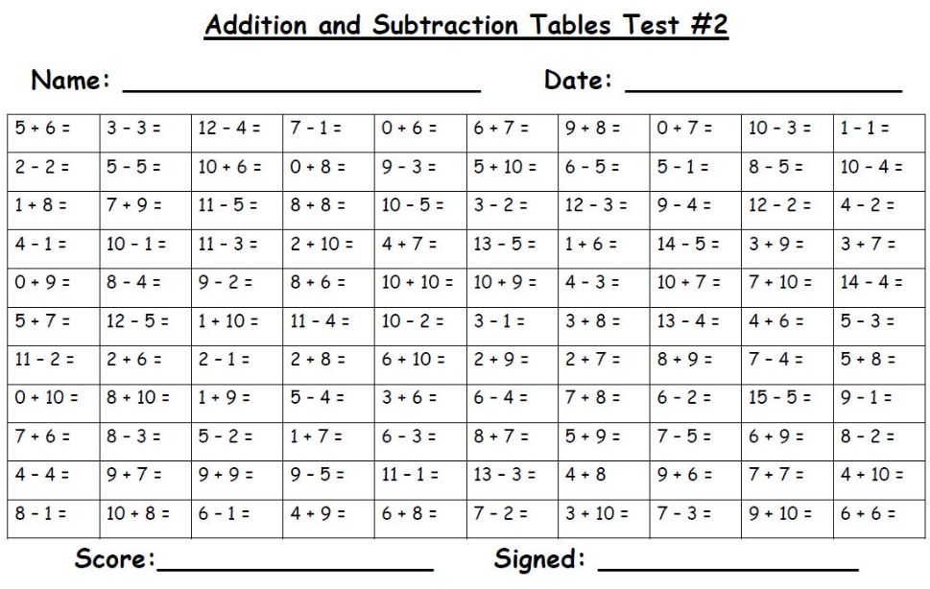  I know we all enjoyed playing the ‘ping pong’ game in class so I have made a similar game but this time you will need a pair of dice.  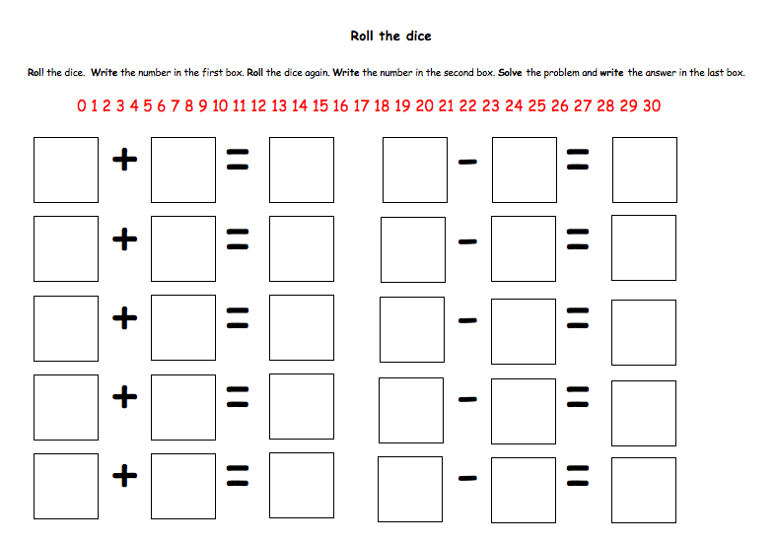  You might have to go through some board games to find a pair of dice. Don’t worry if you can’t find any, you could just pick your own numbers.
HWB  IALT improve my fitness. | It is very important for us to talk about how we are feeling. It is especially important now as some of you may be worried about the changes we have all had to make in the last few months. Talking to someone, exercising and relaxing are all great ways to help your health and wellbeing and keep you feeling happy. Today I would like you to play the lanterns game below where you write down how you are feeling and what has made you feel that way. You will then see your feeling float up into the sky.  https://www.healthforkids.co.uk/game/lanterns/  Now we are going to do some Jump Start Jonny to help us get some fun exercise and make us smile!  https://www.jumpstartjonny.co.uk/home  Click on whichever video you like or do all three! My favourite is I like to move it 🙂 it certainly gets your heart beating!  Now for some relaxing time. A great way to relax is by doing yoga. Yoga is an ancient form of exercise that focuses on strength, flexibility and breathing to boost physical and mental wellbeing. The main components of yoga are postures (a series of movements designed to increase strength and flexibility) and breathing.  https://www.youtube.com/watch?v=LhYtcadR9nw&feature=emb_title  Why not send us some pictures of you taking part in any of the exercises you have been doing today. Send to (gw19shreenannatasha@glow.sch.uk) or Tweet @St_BarbarasPS
T.I.O.F | We have been learning how Jesus prayed for his friends and for all of us and how he taught his disciples to pray to our Heavenly Father. We know that saying our prayers is very important. On the accompanying illustration of Jesus praying, draw pictures or write names in the thought bubble of yourselves and some of the other people Jesus was praying for. You could choose your families and friends, as well as our brothers and sisters throughout the world.    Colour your picture in when you have finished writing in the names of your family and friends. Now show someone your picture and tell them how much you love them and that you will remember them in your prayers.  Please send us a copy of your picture at (gw19shreenannatasha@glow.sch.uk) or Tweet us @St_BarbarasPS
Golden Time  IALT make my own choices. | Hooray, we made it to Friday!  Well done for another great week of home learning.  It is now time for you to do something you enjoy this afternoon.  Have a wonderful weekend everyone!  Take care,  Miss Shreenan

Optional  tasks | If you wish to complete more tasks please select one or two tasks from your new First level grid for May.

Remember any work you wish to upload should be done so under your class name and if you would like to share any videos or pictures of you completing any of the tasks you have been set you can do so via Twitter. Have fun, work hard and if you need anything you can contact me by email; gw19shreenannatasha@glow.sch.uk

Miss Shreenan

