Thursday 28th- Let’s begin with our morning prayer and saying an Our Father. During this time I would like you to keep in your thoughts all of those brave NHS workers who are doing such an amazing job right now. Tonight at 8pm, you could go out and clap for them to show your appreciation.
Literacy  IALT decode words using phonemes.  Reading  IALT read with understanding and expression. | Phonics Task  Starter- Alphabet name and sounds- My name is A, my sound is a.. (orally)  Warm-up- read through the phonics cards- see how many you know! (sh for shop, ch for chest…)  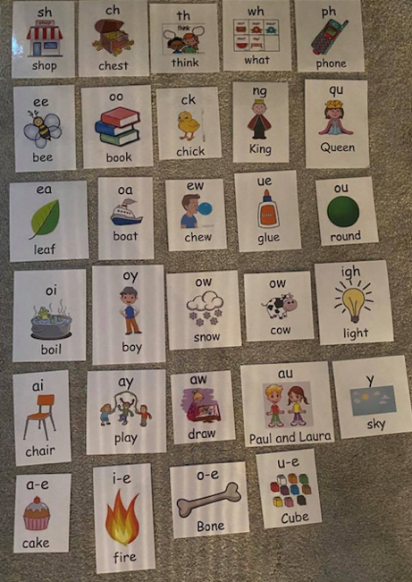  This week’s new phoneme sound is:  Capital letters- (e-e - here)  Spelling Rule-  When we have split diagraphs, the first letter of the diagraph becomes its letter name instead of its letter sound. The ‘e’ at the end is called the magic e because it becomes silent.  Phoneme task-  Watch Mr Thorne e-e > https://www.youtube.com/watch?v=kFuETDoqVnA  Watch- Pete and Steve >  https://www.youtube.com/watch?v=O71-Ih-DKLU  What words did you learn with ‘e-e’?  Read and copy these e-e split diagraph words out 3 times- make sure to join a rainbow over the split diagraph e-e.  these, here, eve, complete, Steve  Next, copy and complete these sentences by filling in the blanks with your e-e words from today.  - I have a big brother called ____.  - I have to go to bed early on Christmas ___.  - I need to ________ all of my work today.  - Look over ____!  - I would like to buy _____ sweets please.  Full stops- (ea- leaf)  Phoneme task-  Watch – Fun phonics ‘ea’ to listen to this week’s sound.  https://www.youtube.com/watch?v=Yc36_Imtiig  Read out the words below to someone at home- remember to sound out the words (s p ea k = speak)  speak, clean, steal, team, stream, wheat  Now, write each word 3 times using look, say, cover, write and check.  Use a different colour for your phoneme ‘ea’  Next, complete these sentences by filling in the blanks.  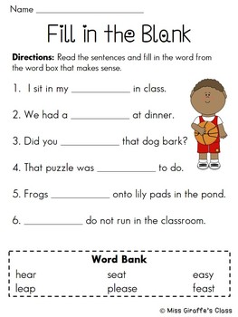  Reading- Scholastic Reading.  I would like you to read your assigned reading book aloud to someone at home, make sure to use eye contact and expression throughout.  After this I would like you to select one of the reading tasks from the grid below. We have completed all of these tasks before in class..  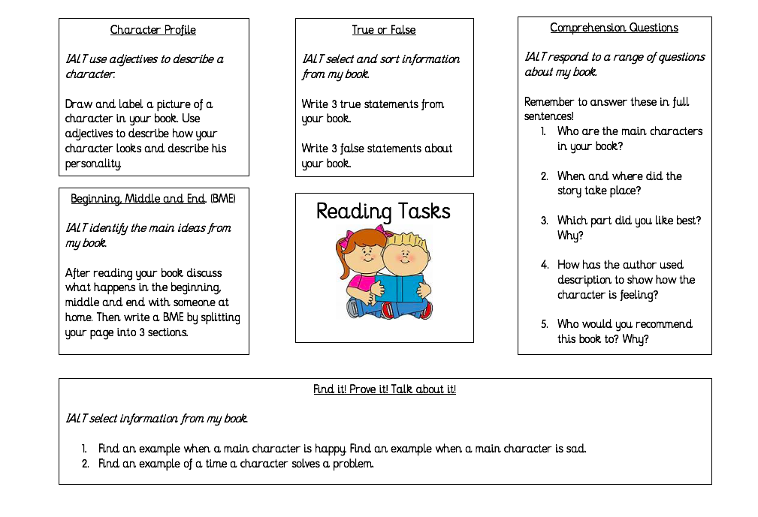
Numeracy  IALT solve problems using addition and subtraction. | It is important we continue our oral maths. This maths activity from your grid is a perfect way to get your brains active.  Out loud, count forward in:  - 2s from 0-20  - 5s from 0-50  - 10s from 0-100  - 100s from 0-1000  - 5s from 25-55  - 10s from 20-80  - 100s from 200-800  Now use the same numbers but count backwards.  Next, I would like you to complete ‘Today’s number’ task.  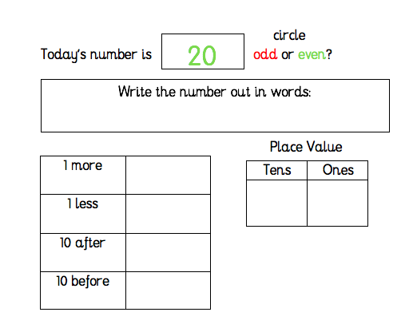  Sumdog- I have set a Sumdog Competition for you to complete today on addition and subtraction.  You have between 9.00am and 3.00pm to complete this challenge. I will announce the winner of the Sumdog competition just after 3.00pm. Good Luck!  
HWB | We have all been enjoying the lovely sunny weather recently and it has been great to be able to get outside and play. Even though it is important for everyone to enjoy the sun we have got to remember that it can burn your skin. There are three important steps to stop sunburn:  • Cover up with clothing and a hat  • Spend time in the shade,  • Wear suitable sunscreen and apply it often  In the attached sheet the character in it is out in the sun with no hat!!! I would like you to design a hat for the character and make sure it offers suitable protection against the sun.  Or if you want to make a more detailed design on your sun hat why not click on the link below.  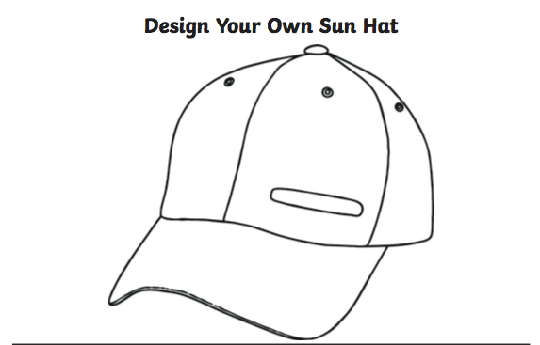  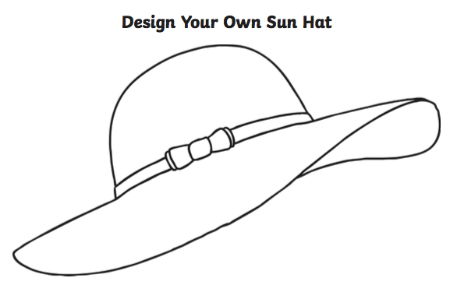  Please send us your pictures at (gw19shreenannatasha@glow.sch.uk) or Tweet @St_BarbarasPS
T.I.O.F | When we pray it is important to remember a few simple things. Prayers can be simple thoughts and words coming straight from the heart. Sometimes God doesn’t seem to give us what we pray for. Do not give up praying – keep on talking to God and listening for he knows what is best for you, even if it is not what you expected. It is also important to remember that we don’t just ask God for things we want. Remember to praise God and thank him for his goodness, to tell him about ourselves and others and say sorry if we have done wrong.  Why not join in with this hymn Alleluia Alleluia Give Thanks to the Risen Lord below to praise God:  https://www.youtube.com/watch?v=2U1MuOCHon4&feature=emb_title  I would like you to write out a short prayer thanking God for all the wonderful things you have in your life. I have included a template below for you to use or you can design your own.  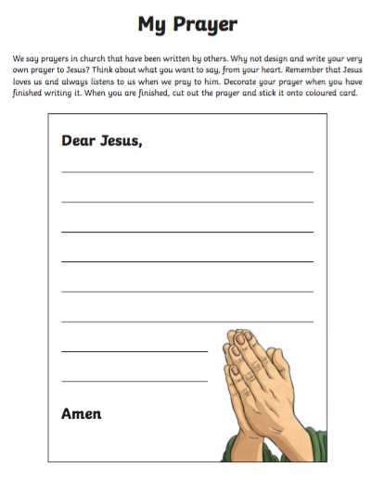  Please send us a copy of your picture at (gw19shreenannatasha@glow.sch.uk) or Tweet us @St_BarbarasPS.  Also as it is Thursday again let’s remember to praise (thank) all NHS workers tonight at 8pm by clapping and making as much noise as you can for them.
IDL Topic | Around the World  One of the fascinating things about Ancient Egypt is their alphabet. Ancient Egyptians didn’t use the same letters and sounds we use today. Instead they use small diagrams which were called hieroglyphics.  I have uploaded a hieroglyphics word map below. I would like you to use this to write your name. When you have finished that, I would like you to complete the hieroglyphic code cracker worksheet. Good luck!  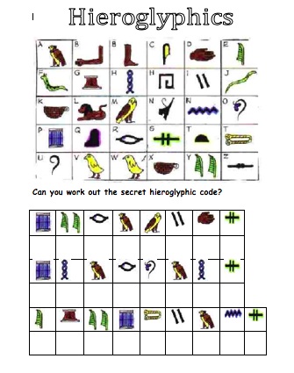
Optional  tasks | If you wish to complete more tasks please select one or two tasks from your new First level grid for May.
Remember any work you wish to upload should be done so under your class name and if you would like to share any videos or pictures of you completing any of the tasks you have been set you can do so via Twitter. Have fun, work hard and if you need anything you can contact me by email; gw19shreenannatasha@glow.sch.uk

Miss Shreenan

