Wednesday 27th- Please begin with your morning prayer, thanking God for looking over us and keeping us safe.
Literacy  Reading  IALT read with understanding and expression.  Spelling  IALT use a range of strategies to help me spell. | Reading-  I have assigned a new book for you to begin today on Scholastic Learning Zone. First, I would like you to listen to the story, then read it aloud to a member of your family before answering the quiz.  Spelling Task- Common Words  You have 4 new common words this week.  Capital letters spelling words- father, head, mother, jump Full stops spelling words- each, ask, year, eat  Can you read these words out to someone at home?  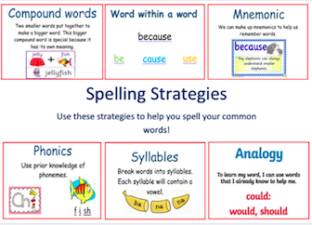  Remember to think about what strategy will help you spell and read these words.  Now, select a fun spelling task to practise this week’s new spelling words.  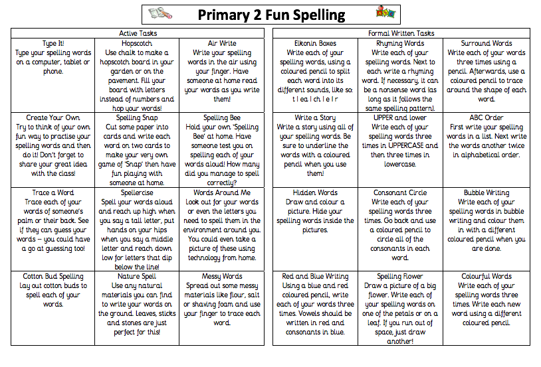  Next, I would like you to create a super sentence for each common word.  Don’t forget super sentences need a capital letter at the start of a sentence, a full stop at the end and finger spaces between each word.  Challenge- try add in a connective to your sentence- and/but/so/because.  Make sure to re-read you work to check it makes sense.
Numeracy  IALT solve problems using subtraction. | Last week we were looking at addition up to 20. We focused on solving problems using the ‘counting on’ strategy.  Today we are going to focus on subtraction up to 20.  Subtraction is when you take one number away from another.  https://www.youtube.com/watch?v=c-vAOjeCUTI&feature=emb_title  Let’s refresh our memory with the subtraction pirates!  https://www.youtube.com/watch?v=QkPa9V2wtZs&feature=emb_title  Complete the task below-  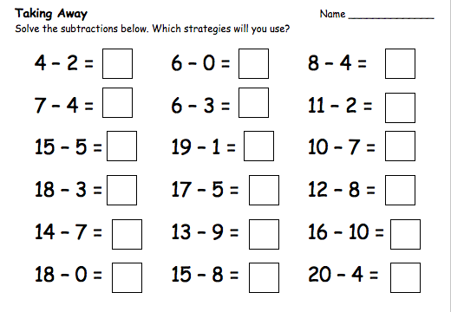  Strategy- counting back  Let’s do the first one together…4-2=?  Look at the first number- 4- put it in your head then count back -2- fingers..3, 2.  We land on the number 2.  So 4-2=2.  Now you try  You may want to use a number line to help you!  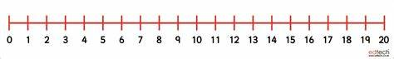  Challenge- Subtracting up to 20 from a single or double digit.  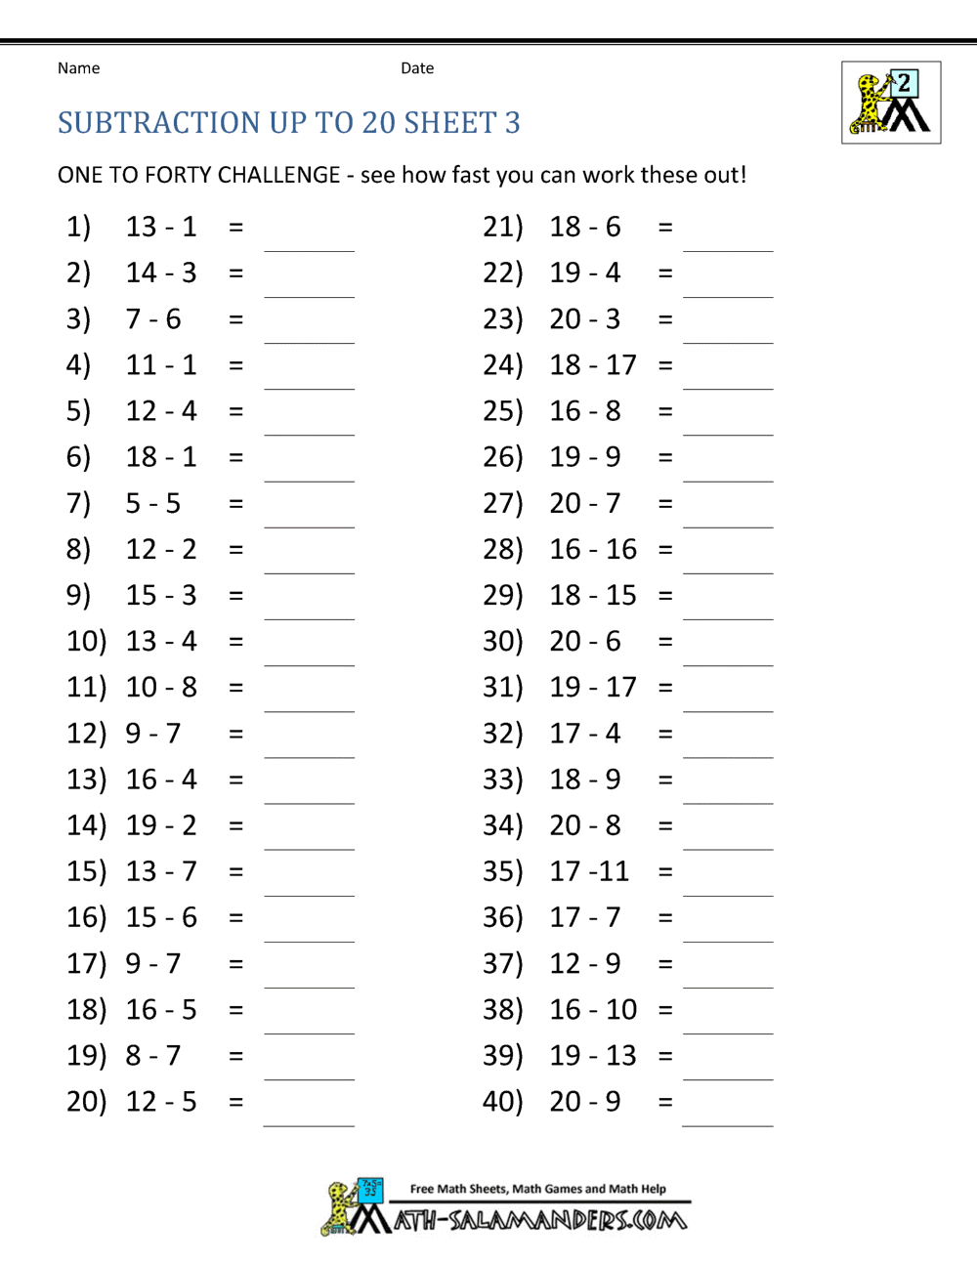
HWB  IALT improve my fitness. | I hope you enjoyed sport’s day yesterday and had plenty of fun! I would like you to keep having fun whilst exercising. Research shows that regular exercise has lots of benefits including:  - improving fitness  - increasing concentration  - building a stronger heart, bones and healthier muscles  - encouraging healthy growth and development  - improving posture and balance  - lowering stress  - Encouraging a better night’s sleep  Today we are going to have a Wild Workout with Andy. Andy is off to the Arctic to see what he can find. Let’s join him and exercise on the way!  https://www.bbc.co.uk/iplayer/episode/p06tmrxh/andys-wild-workouts-series-1-10-arctic  Now let’s do a fun dance video with GoNoodle:  https://www.youtube.com/watch?v=Pwn4beja1QE&feature=emb_title
T.I.O.F | When Jesus needed to feel very close to his Father, what did he do? – He would pray. Jesus prayed in the Garden of Gethsemane, before he was betrayed by Judas. He prayed before he raised Lazarus from the dead and Jesus prayed during the Last Supper, before he broke the bread. Like us Jesus needed to share his worries and problems with his heavenly Father; he knew that he was never alone. Just as we are never alone. God is always with us.  When we pray we are having a conversation with God. When we talk to God, he listens. We don’t have to have special times for saying prayers. Often we say them at bedtime but we can talk to God at any time. Do you ever feel unsure about what to say to God? Don’t worry as God our Father likes to hear about everything we have to tell him and he is always ready to listen.  The apostles knew how important it was to pray to God but like us they often felt uncertain about how to pray. One day they asked Jesus to teach them how to pray. What was the prayer that Jesus taught them? – The Our Father.  Watch this short video about how Jesus taught his disciples the Our Father:  https://www.youtube.com/watch?v=3B0d1_GRH7s&feature=emb_title  Let’s say the Our Father now. I have copied the words to help you if you need it.  I would like you to print the picture below if you can and colour it in. If you can’t print it why not draw a picture like this one.  Please send us a copy of your picture at (gw19shreenannatasha@glow.sch.uk) or Tweet us @St_BarbarasPS.
IDL Topic  IALT construct models. | Around the World  Barnaby Bear is having so much fun touring around the WORLD! He has been to Scotland, France and Spain so far but he isn’t finished yet!  Next stop on Barnaby Bear’s adventure is EGYPT!  Egypt is a country with a fascinating history and is famous for its pyramids and is home to the longest river in the world; The River Nile.  Click on the video below to find out more about the history of Ancient Egypt > https://www.youtube.com/watch?v=lZOPWSXMvzI  The Ancient Egyptians relied on The River Nile for fresh food and water. The Nile flooded every August. When this happened, the water spread across the banks leaving thick and moist mud, perfect for growing crops. The Egyptians also used the Nile as a way to travel. Egyptians travelled on boats down the Nile. Egyptians had many types of boats for farming, fishing, or traveling. The Pharaoh (like a King) used a magnificent boat covered with gold and fancy carvings.  Here are some examples of Egyptian boats:  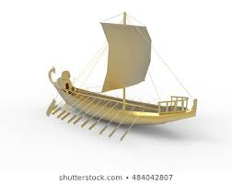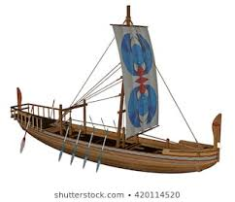  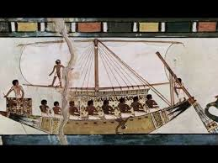  So for your task today I would like you to design and create your own boat. If we were doing this task in class I would give each group a sheet of tinfoil and 4 straws, however you can use whatever you have around the house. The challenge is that your boat must be able to float in water. Good luck!
Optional  tasks | If you wish to complete more tasks please select one or two tasks from your new First level grid for May.

Remember any work you wish to upload should be done so under your class name and if you would like to share any videos or pictures of you completing any of the tasks you have been set you can do so via Twitter. Have fun, work hard and if you need anything you can contact me by email; gw19shreenannatasha@glow.sch.uk

Miss Shreenan

