St Barbara’s Primary School
Curricular Areas | Primary 7 Suggested Daily Learning Activities  Wednesday 27^{h} May
Literacy | - Today I would like you to watch Newsround and take notes about the different news stories that are discussed. Remember to only note down key information and then share what you have learned with someone in your household.  - I would like you to take on the role of the teacher today. I have attached some sentences and paragraphs that have not been punctuated correctly. Your job is to read the sentences carefully and rewrite the text inputting the correct punctuation. This is when your proof reading skills will come in handy. The different punctuation that you need to use is shown under the relevant paragraphs.  - Spend a little bit of time today reading. You may read the novel that I have assigned to you on the Scholastic website or choose your own personal reader.
Numeracy | - Click on the link below to take part in a Countdown number challenge. Use the numbers you are given to get the target number. Remember you can play this as many times as you like.  http://www.maths-resources.com/countdown/practise.html#numbers  - Over the next few days I would like you to complete a little challenge for me. The details of what I would like you to do are attached below.  - As this week’s challenge will require you to work out the average (mean) and the range I thought we could refresh our memories of how to do this. Refer to the PowerPoint that I have attached on the Primary 7 GLOW homepage, complete the activities and then watch the video clip that I have attached below to consolidate your understanding.  https://www.bbc.co.uk/bitesize/topics/zm49q6f/articles/z99jpbk  - Remember to do your daily maths task from your second level maths calendar. Today’s question focuses on finding the volume of a shape. Can you remember how to do this? Share your answers with me via email or Twitter. I have attached a copy of the calendar below in case you are unable to locate it from previous daily learning grids.
Health and Wellbeing | See today’s Primary 7 GLOW homepage for your Health and Wellbeing activities.
TIOF | See today’s Primary 7 GLOW homepage for your This Is Our Faith activities.
Expressive Arts  Art and Design | Let’s develop our drawing skills today. The clip that I have attached below shows some tricks and tips for drawing some interesting images. The drawings and designs get progressively harder so start off with a little easy one and then challenge yourself to try one of the trickier designs.  https://youtu.be/H2RSCtI6GnE  I look forward to seeing some of your creations. Have fun!
Additional Tasks | If you wish to complete more tasks please select one or two tasks from your Second level grid for May.

Standing Long Jump Challenge
This week I would like you to complete a little challenge that encourages you to get active whilst using maths.
Let’s get jumping
How far can you jump from two feet to two feet?
- Bend your legs and swing your arms
- Use a starting marker to show where you took off from
- Jump as far as you can from two feet to two feet
- Put down a marker to show where you finished
- Measure the distance that you managed to jump
- Repeat this 3 times
- Record your 3 jumps in a table format and highlight your best distance for each day ( I have included an example of the table format below)
- Repeat this on Thursday and Friday
- On Friday (after you have finished your jumps) highlight your furthest jump of the week and your shortest jump of the week
Maths challenge
- What is the range of your jumps that you have recorded over the past 3 days?
- What is the average (mean) distance that you have jumped this week?

Day of the week | Jump 1 | Jump 2 | Jump 3
Wednesday
Thursday
Friday

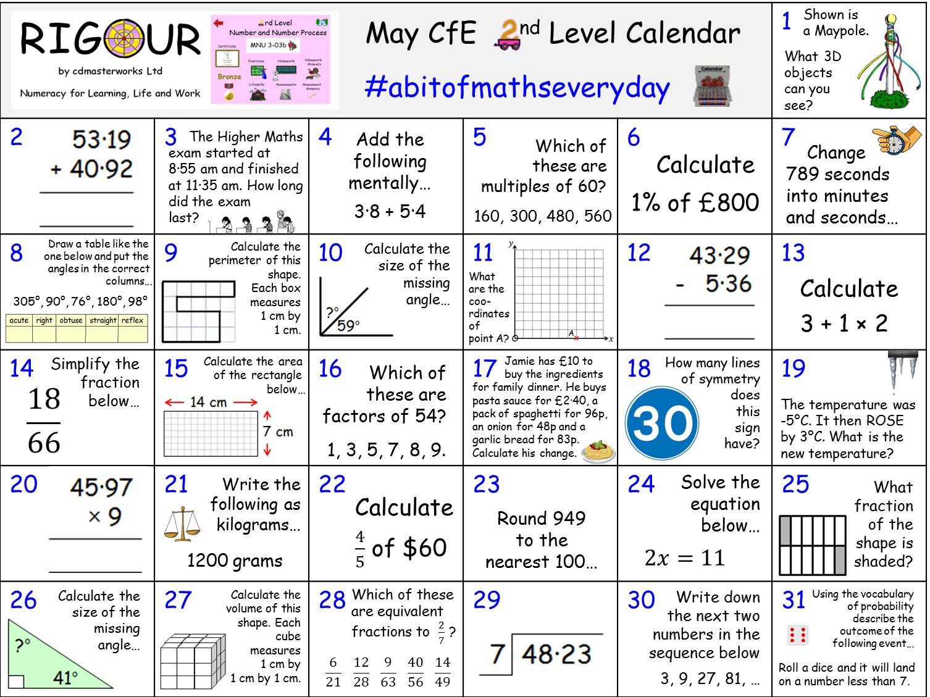
Maths 2nd level calendar

