ST BARBARA’S PRIMARY 4/3

SHINING STARS

Update – 21st May

Alfie’s Time work

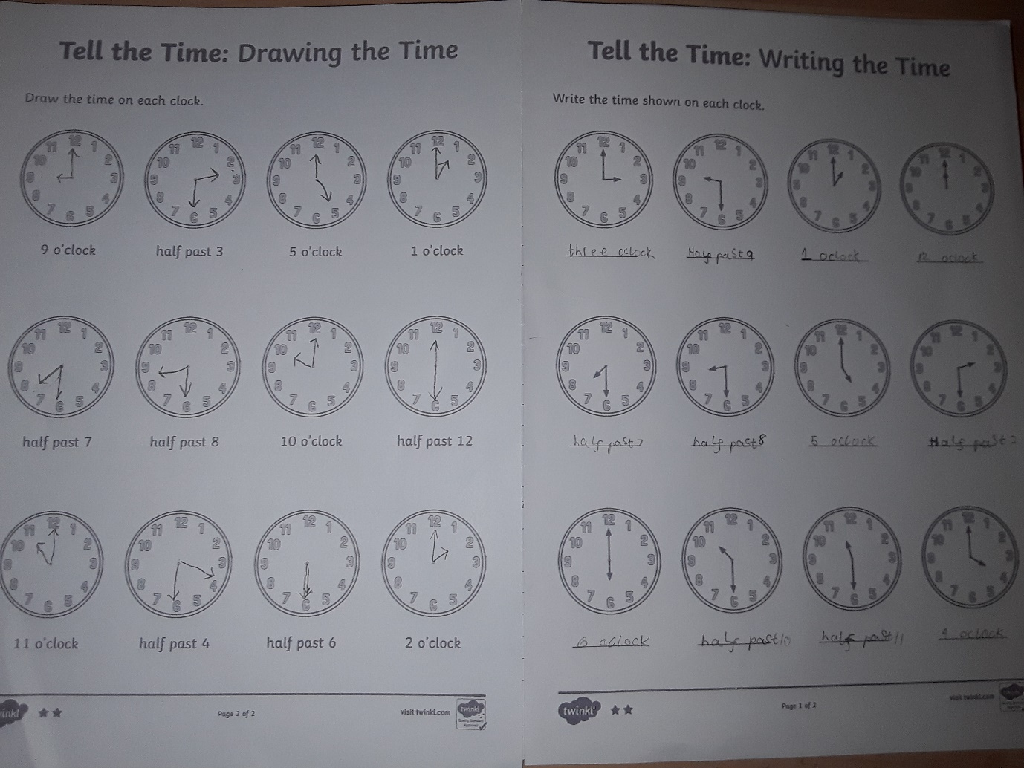

Jenna’s wreath

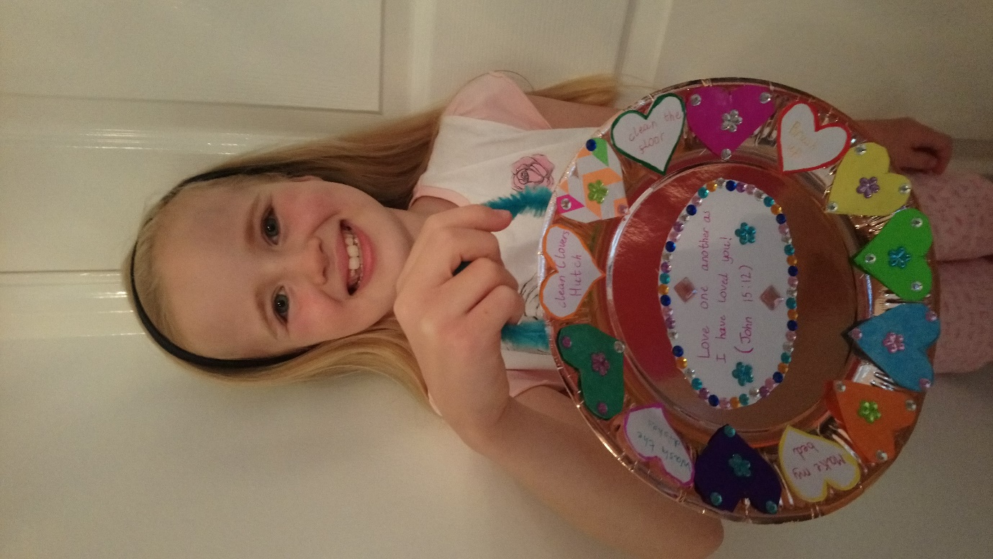

Rudi’s Wreath

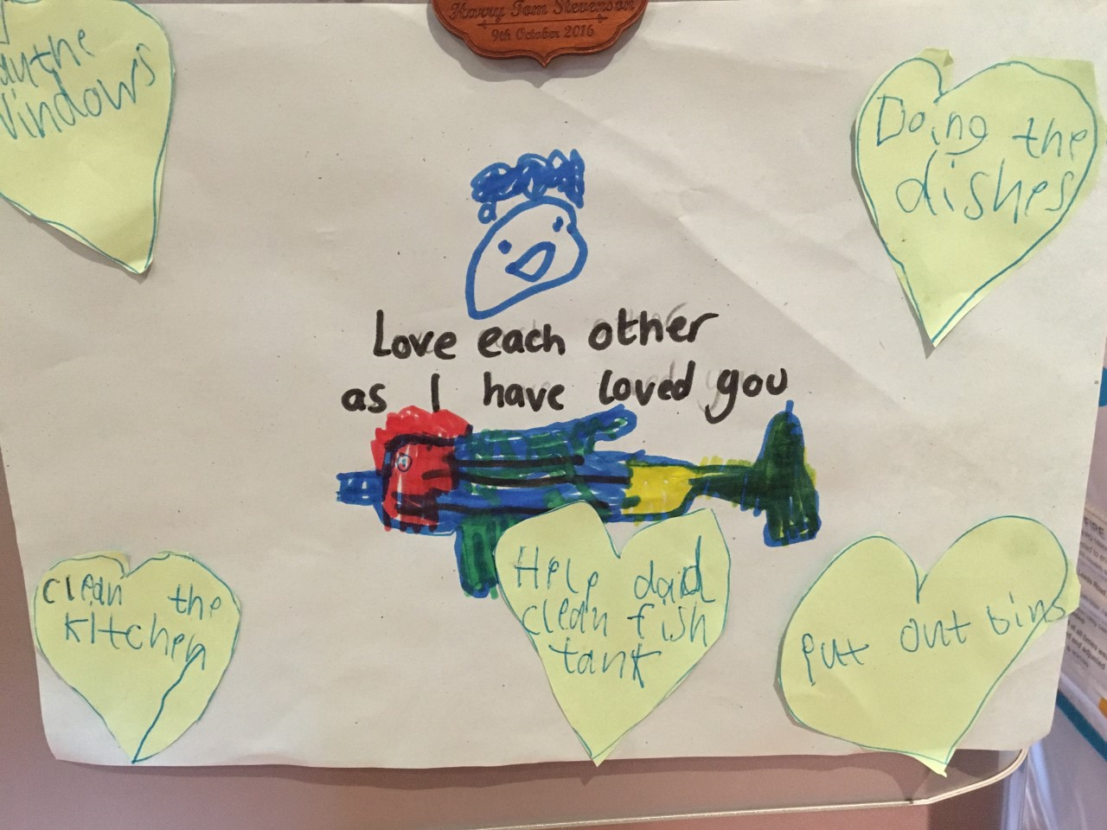

Rory’s Flapjack’s

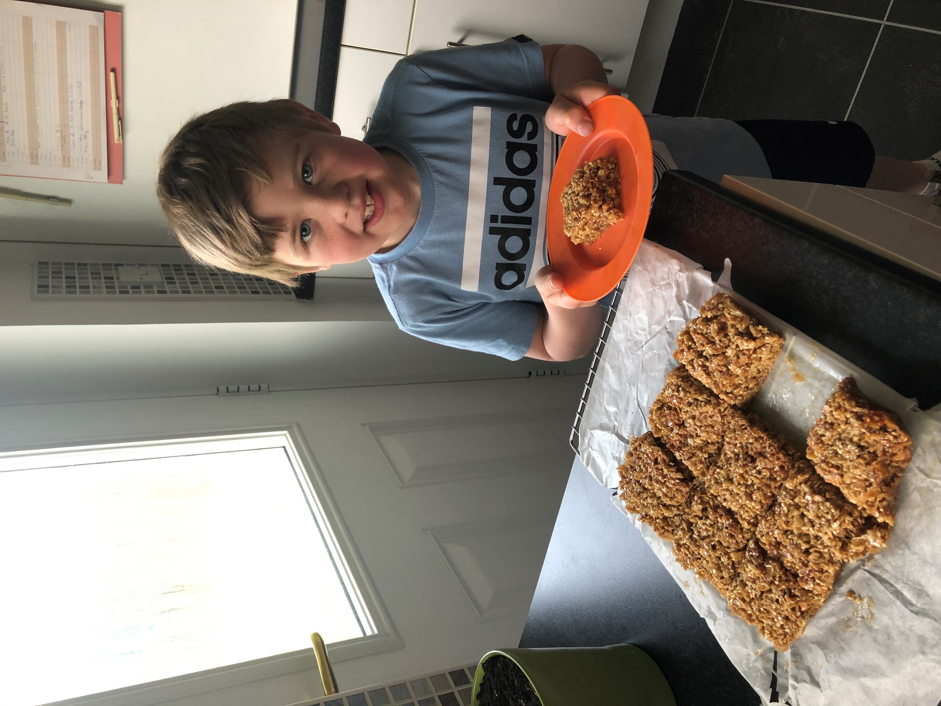

They look delicious Rory!

Here’s the recipe if you fancy having a go yourselves.:-

