[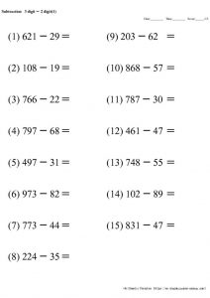](https://www.google.co.uk/url?sa=i&url=https%3A%2F%2Fen.chugakujyuken-sansuu.com%2Fsubtraction%2Fsub2-3%2F&psig=AOvVaw1SS-VA15Zs8hljCE9MWZvL&ust=1590108634128000&source=images&cd=vfe&ved=0CAIQjRxqFwoTCOCh3bTew-kCFQAAAAAdAAAAABAI)