Thursday 21st- Let’s begin with our morning prayer. During this time I would like you to keep in your thoughts all of those brave NHS and key workers who are doing such an amazing job right now. Tonight at 8pm, you could go out and clap for them to show your appreciation.
Literacy  Writing  IALT describe processes. | Taught Writing  This term we would have been working on Instructional writing in class. What are instructions?  Today I would like you to begin by listening carefully to this ‘Writing Instructions’ video > https://www.youtube.com/watch?v=2189sv8Bvy4  Instructional Writing- How to make a famous Spanish dish.  We have been learning all about Spain this week so I thought for today’s lesson, with the help of an adult, you could try follow instructions on how to make a tortilla (Spanish omelette).  This task will help you learn more about instructions and understand why instructions need to be very clear.  I have posted 4 videos and pictures on to a separate blog of my Auntie Nora showing you step by step instructions on how to make a tortilla.  Each video is only a couple of minutes long. I think the easiest way to complete today’s task is to watch all the videos. Then when you are ready to write re-watch them again. Watch video one and then write the instructions for that. Then move onto video 2 again and then write those instructions and so on. However, I am happy for you to do whatever suits you and your family.  It is important we make our instructions clear so that other people can follow them. Here is a template of how I would like you to set it out.  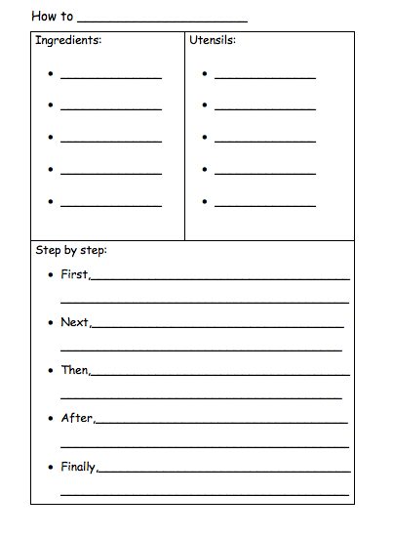  Now that you have written your instructions on how to cook a tortilla, it is time for you to follow them and have a go at making one yourself!  Do not worry if you don’t have the ingredients or time to make one today, you can keep your instructions safe and make one another day.  I can’t wait to hear how you get on. Please send in your final products and instructions so I can have a go at making one myself! (gw19shreenannatasha@glow.sch.uk)
Numeracy  IALA how numbers are constructed. | It is important we continue our oral maths. This maths activity from your grid is a perfect way to get your brains active.  Out loud, count forward in:  - 2s from 0-20  - 5s from 0-50  - 10s from 0-100  - 100s from 0-1000  - 5s from 20-55  - 10s from 20-80  - 100s from 400-800  Now use the same numbers but count backwards.  Next, I would like you to complete ‘Today’s number’ task.  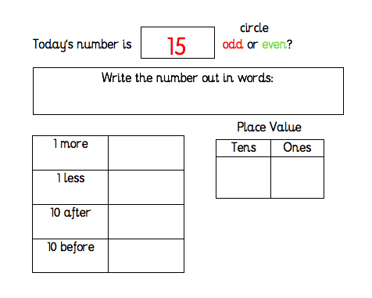  Sumdog- Today is the last day to log on and compete in NLC Sumdog competition! Let’s show everyone how great primary twos maths skills are…GO! GO! GO!
HWB  IALT improve my fitness. | It’s the last day before the holiday weekend and before Sports’ Day on Tuesday!!!  For some of today’s activities you need dice or you can make some (see below).  Select one or more of the following to do today:  Look out for news about Sports’ Day activities!
T.I.O.F  IALA the Feast of Ascension. | Today is Ascension Thursday!  We have been thinking about loving and caring for others all week and we have tried to follow Jesus’ commandment to, ‘Love one another as I have loved you.’  You have created a Caring Wreath to show that you care and you have learned about how Jesus ascended into heaven forty days after his resurrection on Easter Sunday.  Normally on Ascension Thursday we would all be going to Mass. Although we can’t actually go to church today, Bishop Toal is celebrating Mass for all of the children of the Diocese of Motherwell at 11am.  This Mass is being streamed on Facebook so you will need an adult’s permission to watch this:  www.facebook.com/rcmotherwell  Father Campbell is also celebrating Mass on St. Barbara’s Parish website at 10am.  With an adult’s permission, please select a Mass to follow.  You might also like to watch the clip below. You can join in if you like.  https://www.youtube.com/watch?v=jT0ygUgPvP0&feature=emb_title
Golden Time  IALT make my own choices. | Hooray, we made it!  Well done for another great week of learning.  It is now time for you to do something you enjoy this afternoon.  Have a wonderful long weekend everyone!  Take care and keep safe,  Miss Shreenan
Optional  tasks | If you wish to complete more tasks please select one or two tasks from your new First level grid for May.

Remember any work you wish to upload should be done so under your class name and if you would like to share any videos or pictures of you completing any of the tasks you have been set you can do so via Twitter. Have fun, work hard and if you need anything you can contact me by email; gw19shreenannatasha@glow.sch.uk
Miss Shreenan.

