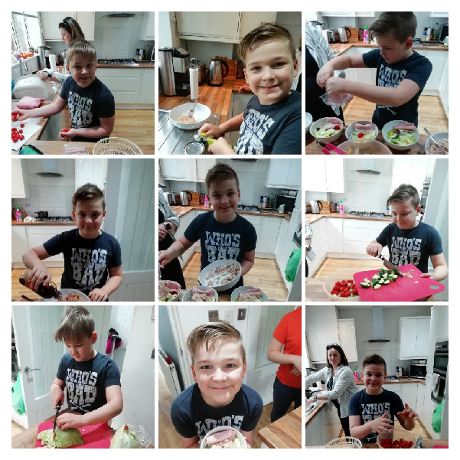**Charlie’s Surf ‘n’ Turf Lunch**

**Have a good look at those cookery skills as Charlie prepares lunch for the family.**

**Delicious!**