**Primary 5**

**Thursday 21st May 2020** ﻿

¡Hola! ¡Buenos días chicos y chicas! ¿Qué tal?

¿Qué tiempo hace es hoy?

Hace buen tiempo 🌞(it’s good weather) o Hace mal tiempo 🌦(it’s bad weather)

Super work this week from Natasha, Conor W, Ethan P and a super smoothie, Euan. Please keep sending your work to gw19goodwinadele@glow.sch.uk

**We will start with our morning prayer.**

**God Our Father, as we begin our days’ work, we ask you to help us to use properly the many gifts that you have given us, so that we may fully benefit from our day together.**

**St Barbara, Pray for us.**

**Please say a Hail Mary for any special intentions that you have.**

﻿**Numeracy**

﻿**Warm up**

Describe the number 210 520

Remember you can write things like

It has 2 tens

It’s 500 more than 210 020

It has 6 digits

Try to write at least 7 more statements about 210 520

Please continue to practise your tables. You should still have your table challenge sheet and be working your way through it. If you don’t have your sheet, we will pick the 8x table to practise this week.

**Mental 10**

I have included last week’s adding and subtracting helpers. If you have super ideas 💡 for adding and subtracting (you always do) please email your solutions/helpful tips.

Remember there are quick ways of adding and subtracting numbers.

Example :- To add 390 and 540

You could add :- 400 + 540 = 940 then subtract 10

                                                        OR

                                 390 + 500 = 890 then add 40

There are other ways that we have talked about in class. You pick the way that you like best.

I have also included a compass. Remember always make sure you start at the correct point and you move in the right direction. It could be clockwise or anti-clockwise.

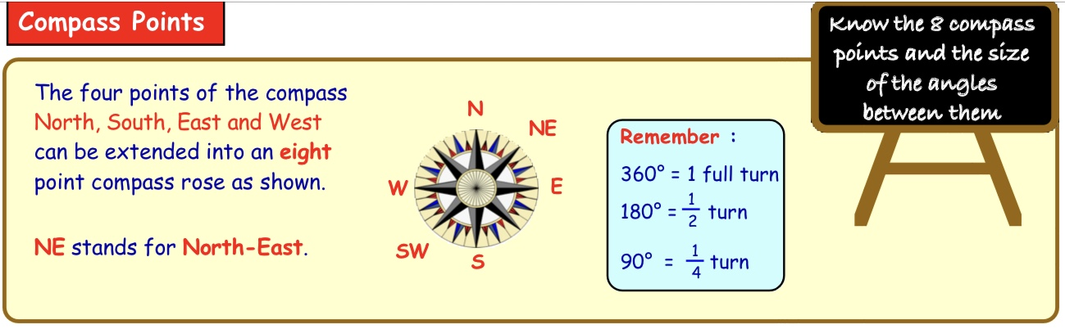

1. Today is May 21st. How many days do we have left in May ?  
  
2. How many days are in February in a leap year? (Remember this is a leap year)  
  
3. How many degrees are there from North to East ( clockwise)?  
  
4. Cole is facing West. He makes a quarter (1/4)turn clockwise. In what direction is he facing ?  
  
5. What comes next in the sequence 14,21,28?  
  
6. Write this number in digits: thirty-four thousand and sixty  
  
7. What does the 4 stand for( the value of)  in 7488?  
  
8. Write down  the answer to 80 add 79  
  
9. Write down the answer to 470 subtract 190  
  
10. The garage charged Mrs McKinney £199 for parts and £104 for labour.

          How much was Mrs McKinney's total bill?

**Statistics**

This week we will continue to work on bar graphs, and we will also be working with pictographs.

A pictograph uses pictures or symbols to show the value of the data. The pictures or symbols used are usually related to the data they are displaying. The symbols will have a key showing you what the value is.

Sometimes 1 tree symbol will mean 1 tree and sometimes 1 tree symbol will mean more than 1. If there are 50 trees, then it would take you a long time to draw the 50 trees and you would have a very big graph. So, 1 symbol tree might mean 5 actual trees. This will be shown as 🌳 stands for 5 trees, so 🌳 🌳 🌳 does not mean 3 it means 5+5+5 or 3x5=15 trees.

This is called a key. It is very important that you check for a key and the value of each symbol.

Please read the page below and complete the questions

Spheres complete Q1 and Q3 Pg 173

Cylinders Complete Q2 and Q3 Pg 173

Prisms Complete Q2 pg 173 and Q4 pg 174

Please use the set questions as a guide, if you feel confident complete as many as you want to. If you don’t feel confident or you need more support either send me an email or pick the questions that you feel you can do.

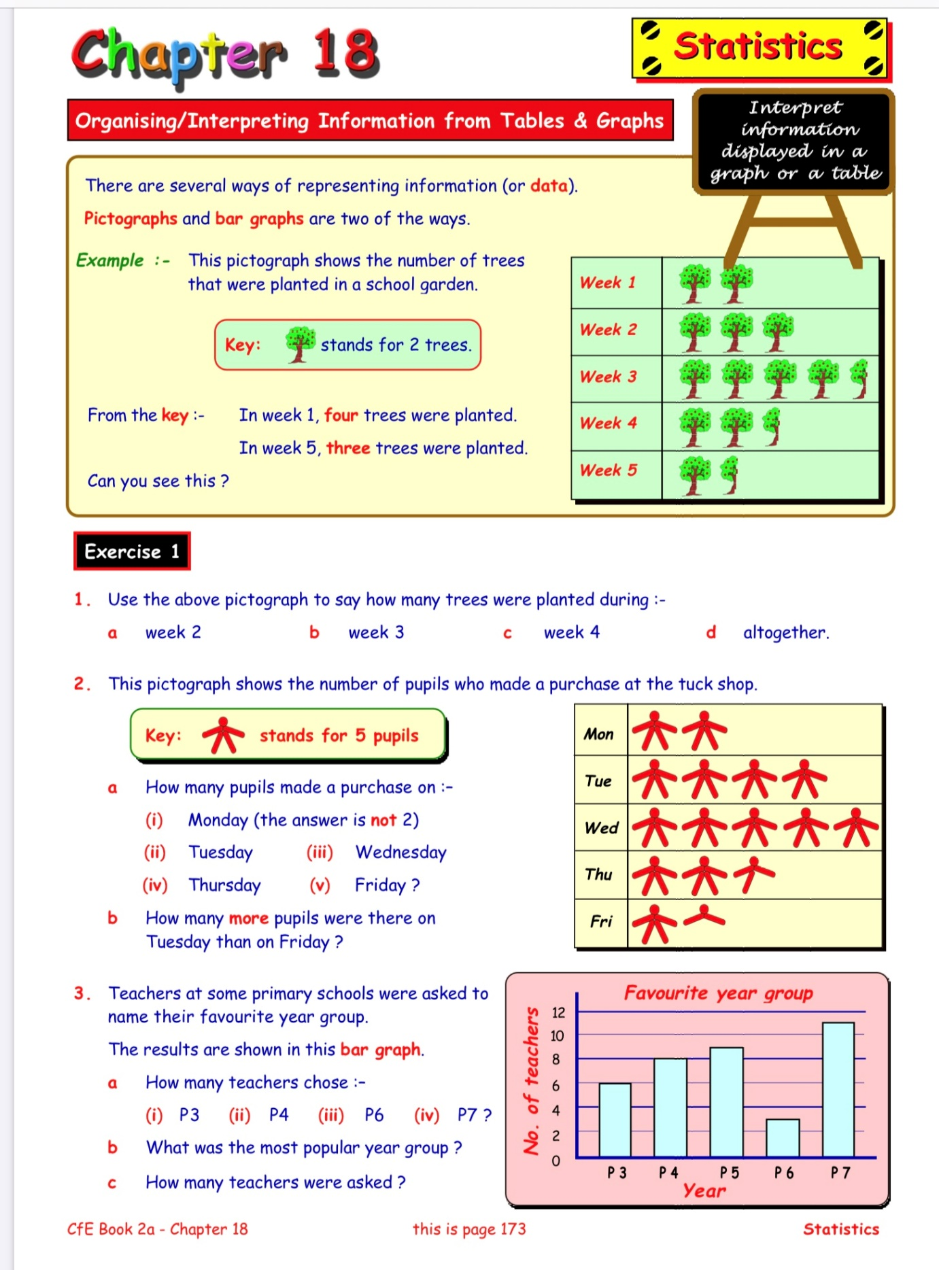

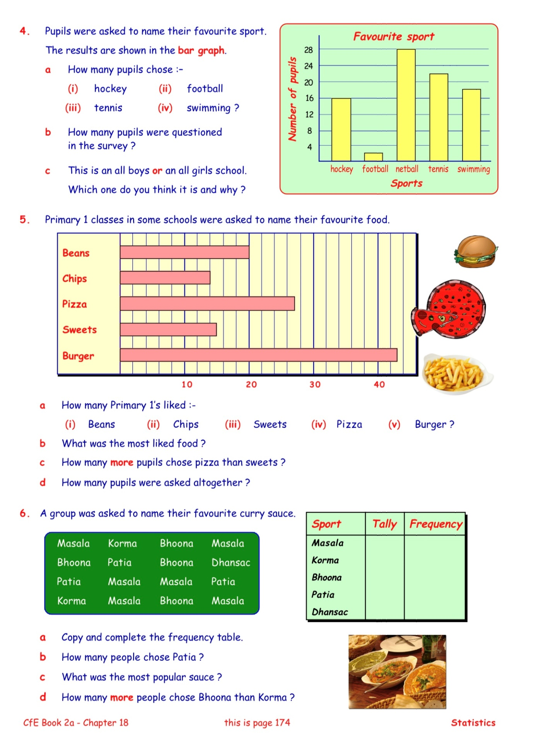

﻿

**Language**

This week in First News the word search is Harry Potter themed. You can access it through First News, or I have included a screenshot below that you can print.

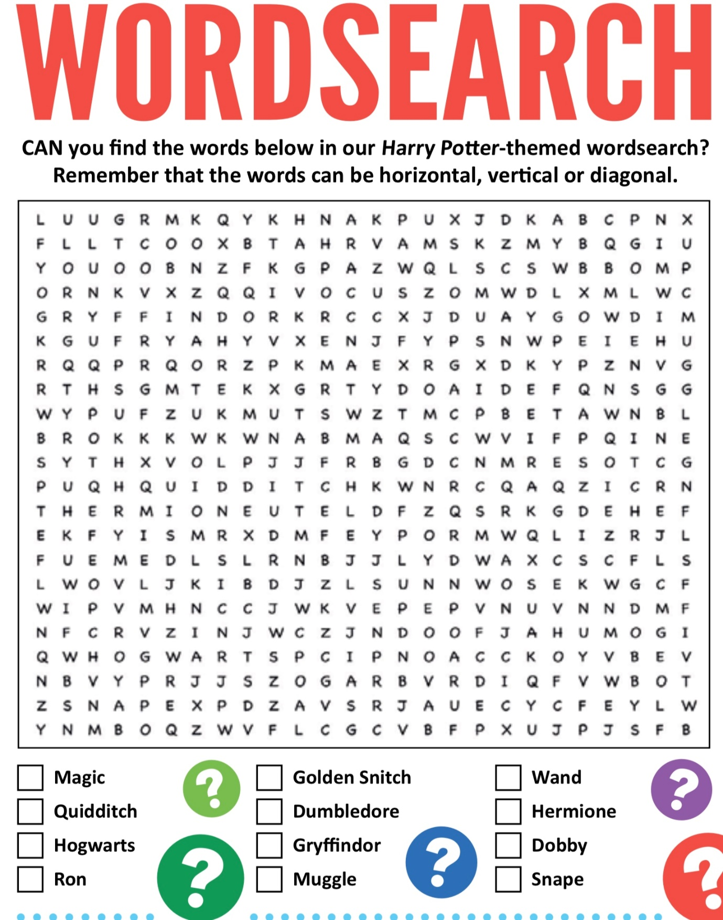

Last week we were working on pronouns.  Pronouns replace nouns and make our sentences less awkward because they mean we don’t have to keep repeating our nouns. They are used to describe individuals or groups of people, rather than using their name or names. Pronouns are short words like I, he, she, you, it, we, us, them. Here is a video in case you have forgotten.

<https://www.bbc.co.uk/bitesize/articles/z64q7nb>

In First News this week there is an article about Florence Nightingale. I have copied it for you. See if you can identify the pronouns in the article? The same pronoun is repeated often.

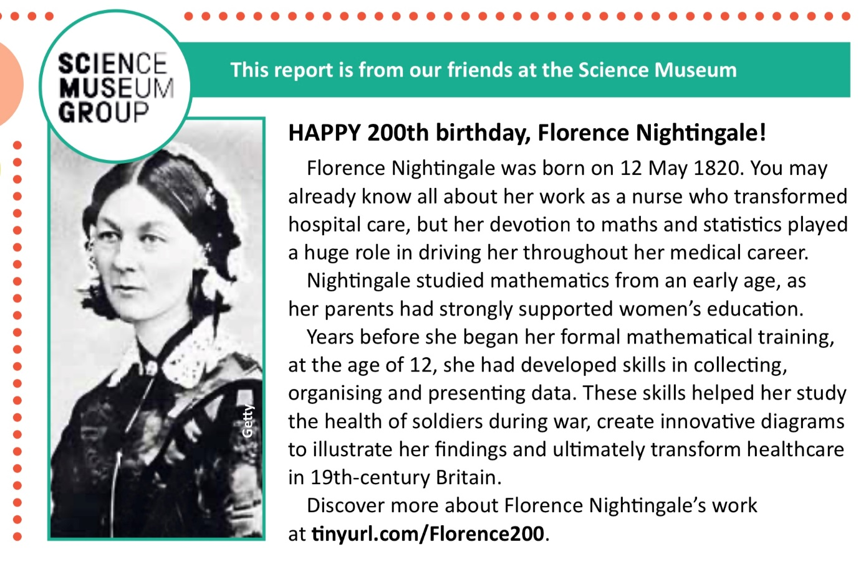

You can also research more information about Florence Nightingale if you would like to.

**Spelling**

This week you have been working on alphabetical order with Mrs McKinney. Today I would like you to try to remember all the first names of your classmates and put them in alphabetical order. You will need to write down everybody’s name first and then make your list. Remember if 2 people have the same first name then use their surname to order them.

It might be hard to remember everybody so try to picture each group in the class. There are 28 children in our class remember. I’m hoping it won’t be long before we can see everybody again.

**Health and Wellbeing**

We have been learning some basic first aid skills. I hope that nobody has had to use them but keep reminding yourself of the skills you have learned so far.

This week we are going to look at the next 2 videos. These last two videos show how you can help if someone has an asthma attack or if they have broken bones.

***Remember*** 

***First Aid is when we give help to somebody that is hurt or suddenly taken ill. First Aid is the steps you can take before a person gets expert medical help. First Aid can sometimes save a person’s life but more often it is the help given in an everyday accident or illness. It includes staying safe yourself and looking out for danger, helping someone feel better and stay calm. It also includes getting help - either by telling an adult or calling 999.***

<https://lifeliveit.redcross.org.uk/en/What-is-first-aid/How-to-videos>

DO NOT try to copy the videos or any of the actions unless it’s an emergency or an adult has allowed you to practise.

Remember to keep washing your hands.

**Español**

Last week we were practising saying our age. This week we will revise birthdays.

¿Cuando es tu cumpleaños? – When is your birthday?

Mi cumpleaños es el (número-number) de (mes-month) – My birthday is on (number) of (month).

<https://rlneducation.com/courses/538624/lectures/9787242>

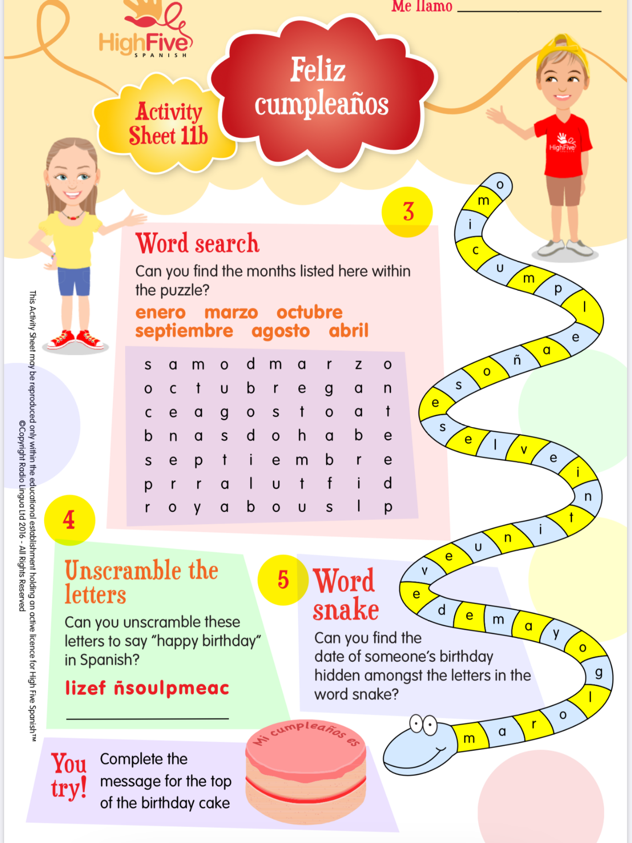

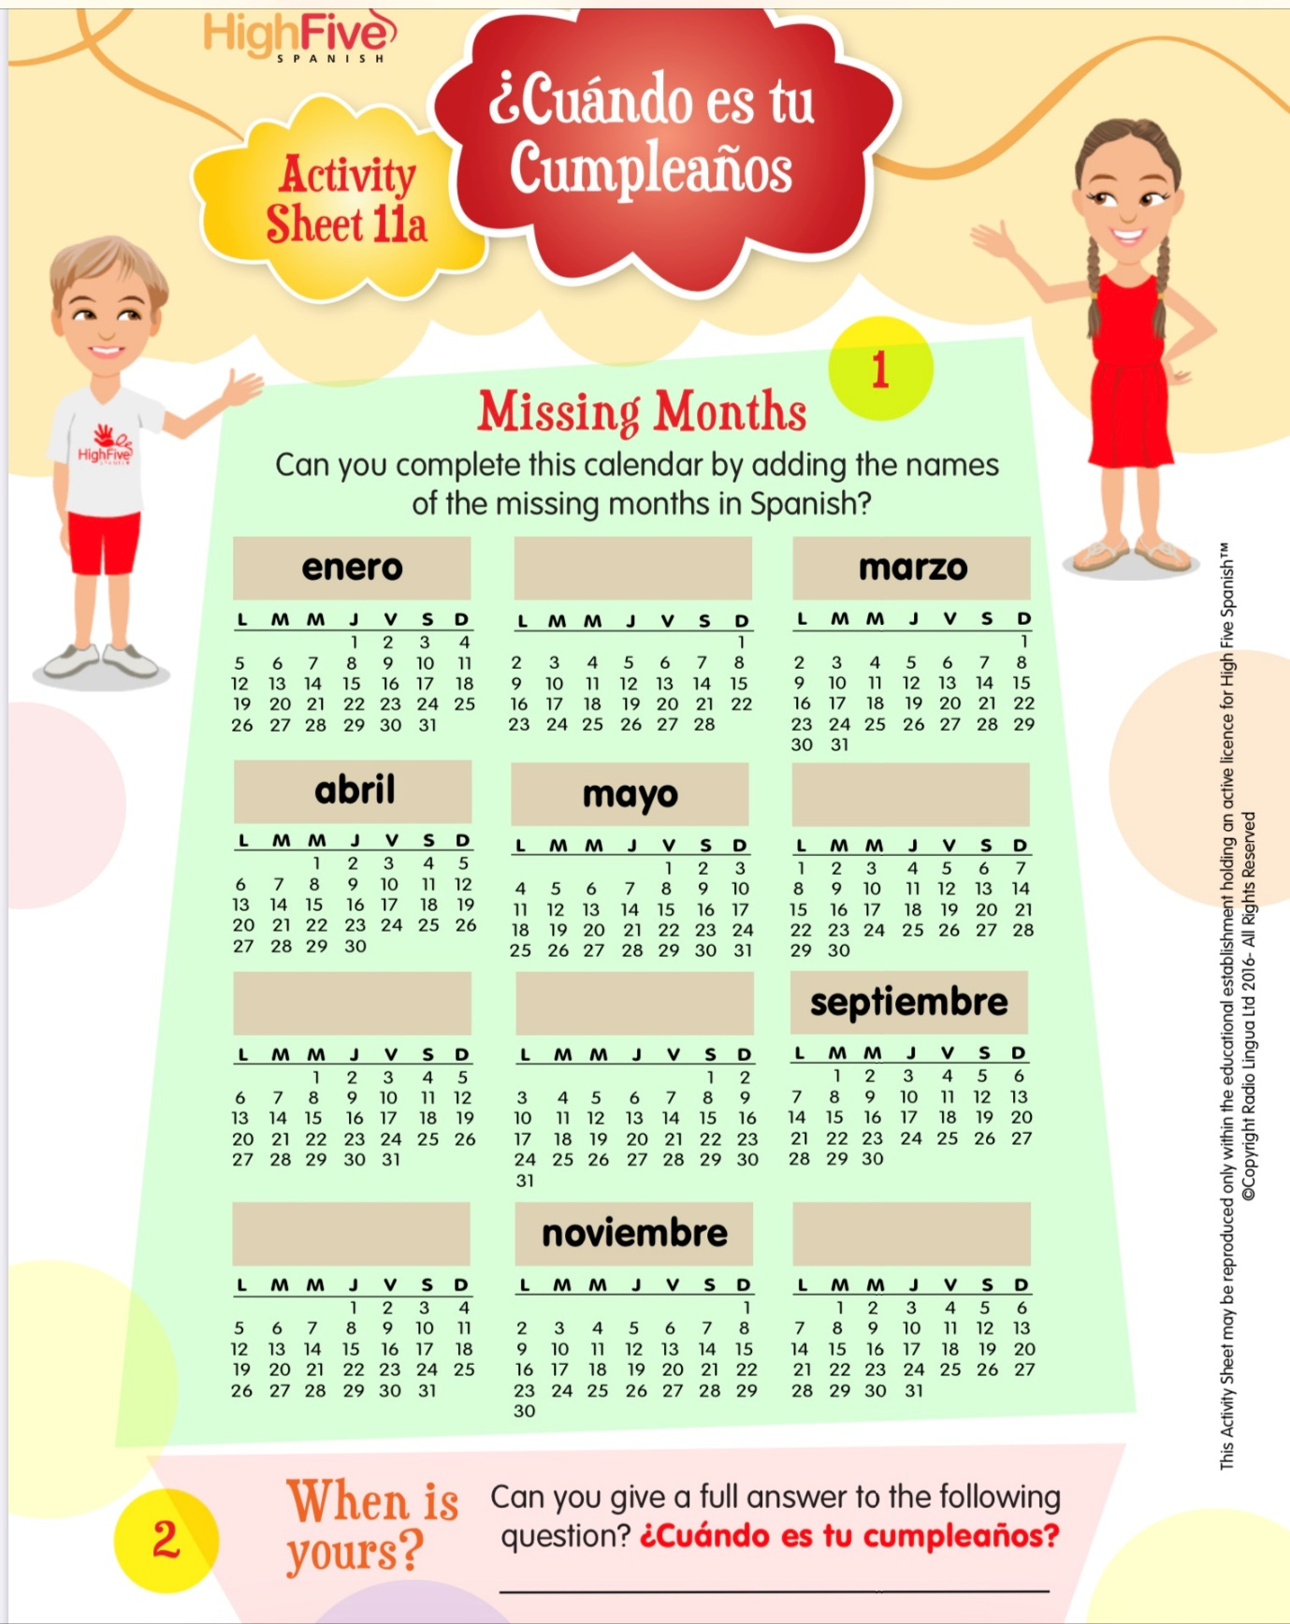

I will continue to leave the video of the alphabet in Spanish too. Please keep practising the Spanish alphabet it is very useful to know it if you study Spanish later on.

<https://youtu.be/dVm6A_vl91U>

You could practise spelling other Spanish words aloud too, for example the months of the year.

enero - January

febrero - February

marzo- March

abril- April

mayo - May

junio - June

julio - July

agosto - August

septiembre - September

octubre - October

noviembre - November

diciembre - December

You will have noticed that the days of the week and the months of the year are not given capital letters in Spanish. In Spanish days of the week and the months of the year are not given capital letters.

**Religious Education**

We continue to honour Mary during the month of May.

I hope that you are continuing to say The Angelus every day and if not every day then as often as you can. Has anybody managed to continue with The Diocese of Motherwell Angelus Challenge ?

**The Angelus**

The Angel of the Lord declared to Mary:   
And she conceived of the Holy Spirit.

Hail Mary, full of grace, the Lord is with thee; blessed art thou among women and blessed is the fruit of thy womb, Jesus. Holy Mary, Mother of God, pray for us sinners, now and at the hour of our death. Amen.

Behold the handmaid of the Lord: Be it done unto me according to Thy word.

Hail Mary . . .

And the Word was made Flesh: And dwelt among us.

Hail Mary . . .

Pray for us, O Holy Mother of God, that we may be made worthy of the promises of Christ.   
  
Let us pray:

Pour forth, we beseech Thee, O Lord, Thy grace into our hearts; that we, to whom the incarnation of Christ, Thy Son, was made known by the message of an angel, may by His Passion and Cross be brought to the glory of His Resurrection, through the same Christ Our Lord.

Amen.

Please remember to keep praying.

The fantastic news is that this weekend is another holiday. I love the month of May 😄. I hope that you all enjoy the long weekend off and that the weather is kind to us. Remember to try and get out to play and get some fresh air. I hope that you are continuing to do The Daily Mile with your family, even if it’s not daily or a mile anything is better than nothing.

Remember that you only need to complete the tasks you can manage and don’t worry if you can’t.

!Hasta luego!

Mrs Goodwin 😄🌈