**St Barbara’s Primary School**

|  |  |
| --- | --- |
| **Curricular Areas** | **Primary 7 Suggested Daily Learning Activities**  **Thursday 21st May** |
| **Literacy** | 1. Using the spelling rules that we have been exploring this week I would like you to complete the activity that I have attached below. You have to make the singular nouns plural by following the correct spelling rule. 2. Today I would like you to take part in a talking and listening challenge. I know how good you all are at talking☺. I have attached the instructions for today’s challenge below. 3. Spend a little bit of time today reading. You may read the novel that I have assigned to you on the Scholastic website or choose your own personal reader. |
| **Numeracy** | 1. Complete the maths starter activities that I have attached below. 2. You have a few hours left to participate in the North Lanarkshire Sum Dog maths competition. Let’s really focus on this today and try to finish higher up on the leader board. I know how competitive you all are and how well you can do when you put your mind to it. 3. Today you are going to get your brains working with some number puzzles and maths problems. Remember to read the question carefully. You do not need to do all of the activities, select a few that you find challenging. |
| **Health and Wellbeing** | See today’s Primary 7 GLOW homepage for your Health and Wellbeing activities. |
| **TIOF** | See today’s Primary 7 GLOW homepage for your This Is Our Faith activities. |
| **Additional Tasks** | If you wish to complete more tasks please select one or two tasks from your Second level grid for May. |

**Can you make the singular nouns plural?**

***By following the spelling rules that we have been revising this week I would like you to make the singular nouns plural.***

1. leaf 2. family 3. yourself
2. dictionary 5. country 6. activity

7. calf 8. scarf 9. shelf

10. university 11. enemy 12. wolf

13. thief 14. possibility 15. life

***Make the following sentences plural-***

1. On Monday morning I went to the local bakery to buy a loaf of bread.
2. For the Virtual Sports Day next week there will be a grid that you have to select an activity from.
3. At the start of spring there was a beautiful baby calf born on the farm near my house.

**Talking and listening challenge**

As next week is our Virtual Sports Day I thought it would be good fun to do a sporty talking and listening challenge.

* Interview a family member about their sporting hero.

Find out:

1. The name of their sporting hero?
2. Why this person is their sporting hero?
3. What is the nationality of this person?
4. The age of their sporting hero?
5. Has their sporting hero won any major awards or been part of a team who have won some major awards? If so, what have they won?
6. Their favourite memory of their sporting hero?
7. If they are part of a team, what teams have they played for?

* Write down 2 more questions to ask about their sporting hero.
* Record your interviewees’ answers and share what you have learned with someone else in your household.

**Maths starter challenges**

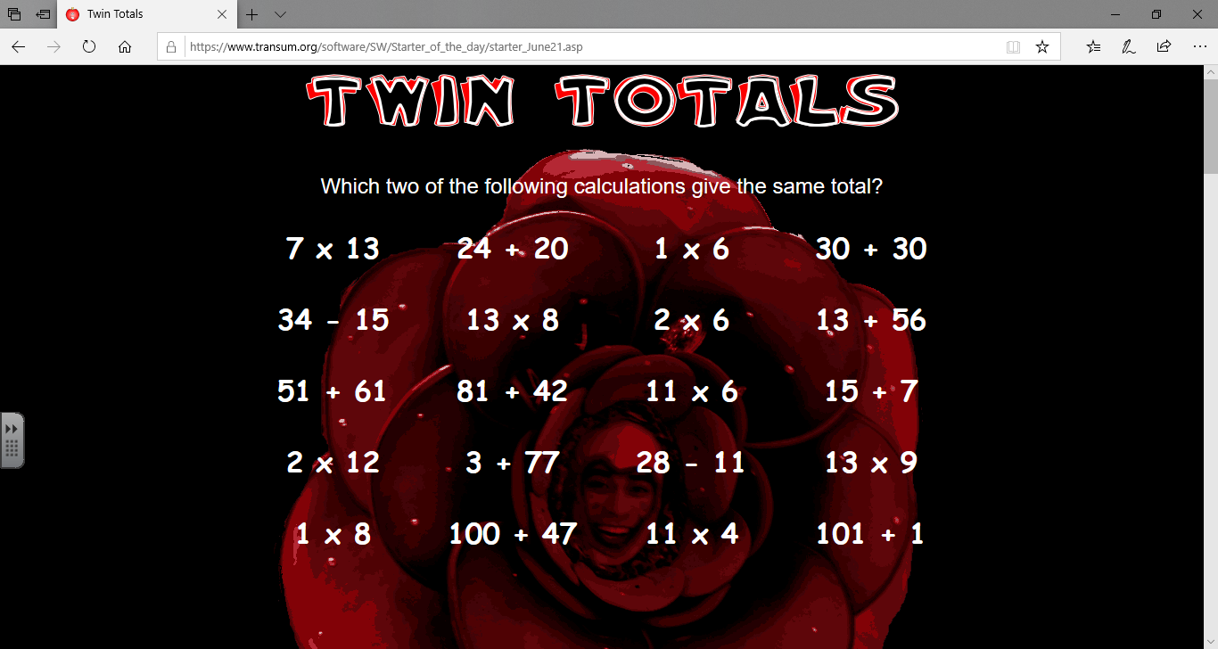



**Maths Problems and Number Puzzles**

