St. Barbara’s Primary School
First Level: School Grids (Primary 2-Primary 4)

The following grids have been designed to support children working from home. The grid includes tasks from all of the curricular areas with digital learning running through many tasks. Many tasks can be repeated with different contexts. Some tasks will take more that one session to complete.
Some of the activities do require adult support and/or permission (e.g. Science investigation; online research; following Mass on Facebook).
If you do not have some of the items selected to complete a task, please substitute the task with another. For example, if a task relates to sewing buttons on material and you do not have the necessary materials, select something similar: perhaps the child could glue some pieces of material they have cut onto another to create a brand new pattern.
In addition to the grids, children should complete core activities as follows:
- Reading and Reading Records
- Sumdog Maths (online)
- Scholastic Books (online)
- Reciting the days of the week and the months of the year
- Log onto ‘Oxford Owl online.’ Enjoy hundreds of free eBooks for all age groups!
- Exercise for at least twenty minutes each day
- Skills for learning, life and work:
- Help to load the washing machine. What do adults need to add in order to wah the clothes?
- Sweep a floor
- Dry the dishes
- Help in the kitchen. You could organize cereal and healthy snacks for your family
- Practise counting…count the number of doors in your house. Multiply them by 6, 7, 8, 9, 10.
- Play ‘Match the Socks!’ Find pairs for the socks once the laundry is finished
- Play a board game with a family member – remembering to take turns and remember to congratulate the other player if he/she wins
- Homework Grids
Please continue to follow us on the school website and on Twitter where staff will provide updates and activities for specific classes in addition to the above/below. Thank you.

First Level Grid: (Primaries 2, 3 and 4)
Literacy |  | Numeracy |  |  | HWB | Other
Spelling Fun!  Compound Words  These are words which are made up of two other words:  - car + pet = carpet  - cup + board = cupboard  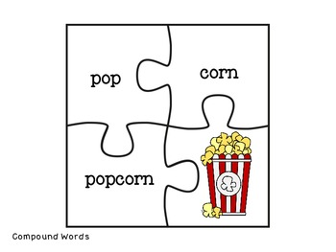  - break + fast = breakfast  How many more can you find?  Choose six and create jigsaw pieces like the one above! |  | Addition and Subtraction  Write 10 sums for addition and subtraction and complete them.  P2- 15+4=  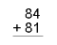  P3- 2 digits (CHIMNEY SUMS)  P4-3 digits (CHIMNEY SUMS) |  |  | 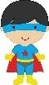  Design a superhero to encourage children to wash their hands properly.  Your superhero might remind people to use soap or to use a towel to dry their hands properly. | Social Studies  Create an illustrated fact file about Scottish Farm Animals. Think about these questions:  - What are farm animals?  - Where do they live?  - What do they eat?  - How many different farm animals are there in Scotland?
 |  | 2D Shape  Using natural outdoor materials, make as many 2D shapes as you can.  Can you make a circle with stones?  Or a pentagon using leaves?  Can you make a hexagon with twigs? |  |  | Skills for learning, life and work!  Help an adult to prepare a snack or a meal. Tick off the following when you do them:  - Washing ingredients  - Peeling  - Cutting  - Juicing  - Grating  Remember to wash your hands before you begin! | R.E.  May is the month we remember Mary and say the Rosary. Can you make up a guide/ instructions of how to use Rosary Beads and say a decade of the rosary?  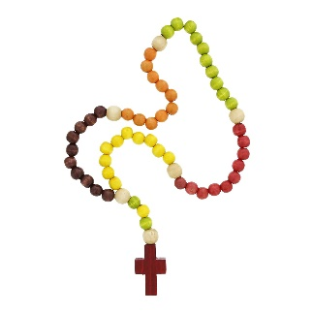
Write a set of instructions titled “How to Wash Your Hands Properly” making sure you include:  - A title  - A list of materials needed  - Short clear sentences  - A diagram |  | Using a 10ml dessert spoon, estimate how many spoons of water you would need to fill:  - A mug  - A litre jug  - A small yogurt tub  Now check to see if you were correct. |  |  | Click on the link below for some Pokémon Yoga!  https://www.youtube.com/watch?v=tbCjkPlsaes
Beginning  Hanging from a tree…  Peeping over the fence…  The sad little puppy…  Once upon a time…  The spacecraft landed…  Far, far away….  The ship sailed…  In the park... | Character  Teacher  Clown  Mr Dobbin  Fairy  Captain Flipper  Gran  Bus Driver  Miss Lemon | Primary 2  Can you draw coins to show:  - 63p  - 19p  - 47p  - £1.24  - £1.67 | Primary 3  Can you draw coins/notes to show:  - £1.09  - £2.64  - £3.16  - £4.23  - £4.99 | Primary 4  Can you draw coins/notes to show:  - £8.34  - £9.03  - £12.86  - £15.27  - £19.62 |  | Social Studies  The ‘Louisa Jordan’ is the new hospital opened in Glasgow. Can you research online who Louisa Jordan was and what her important job was?
Select a beginning and a character from the above list. Write and illustrate a short story. |  | Using a stopwatch or a timer on a phone, how quickly can you…  - Do 20 jumping jacks  - Throw and catch a ball 20 times  - Putting on 5 items of clothing  - Sit down on a chair and stand up 10 times  - 10 sit-ups  - Dribble a ball across the room with your nose |  |  | Healthy Menu  Using the Eatwell Guide, create a healthy menu which should include food from all food groups.  Eatwell Guide - Food and nutrition | NHS inform  www.nhsinform.scot › healthy-living › food-and-nutrition › eating-well | EXP Arts: Art and Design  Using only nature objects found outdoors can you create a self-portrait?  Think about the shades of colours in nature to help you make it as realistic as possible.
Can you work out these kitchen anagrams?

kfro vone sotrate gedifr osonp

elktet ikfen gmu eatlp kins pta

Literacy | Numeracy |  |  | HWB | Other
LEGO Secret Codes  Use Lego bricks and shapes for each letter of the alphabet.  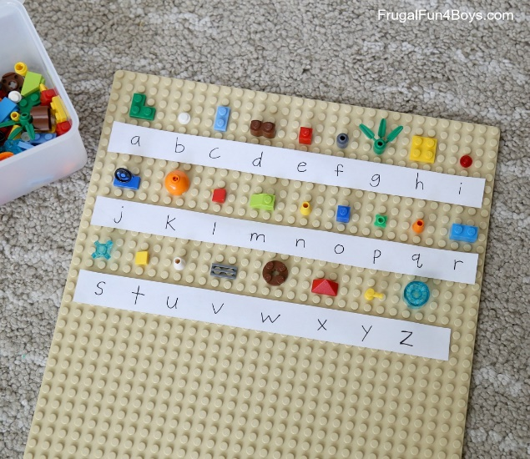  Now create lots of secret messages for others to solve!  Scrabble Fun!  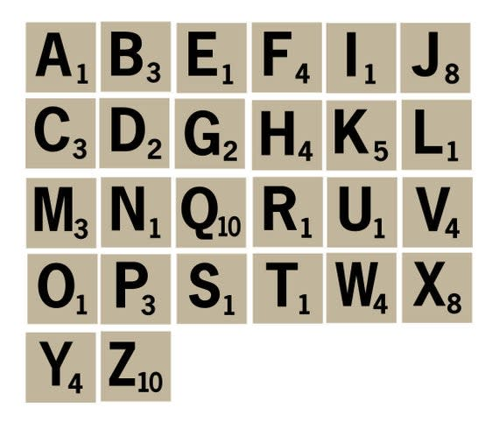  Write down all of the names of those in your family, including those who don’t share your house. Work out the Scrabble values in each name!  Challenge: Include surnames! | Primary 2  How much change from £2 would you get if you spent:  - 36p  - 42p  - 89p  - £1.15  - £1.35  - £1.40  - £1.75  - £1.90 | Primary 3  How much change from £5 would you get if you spent:  - £1.70  - £1.30  - £1.05  - £2.60  - £3.85  - £4.20  - £4.75  - £4.93 | Primary 4  How much change from £20 would you get if you spent:  - £1.80  - £3.85  - £6.40  - £9.05  - £11.70  - £13.69  - £16.49  - £19.72 | Skills for Learning, Life and Work.  Ask four members of your family about their jobs (you might need to phone some of them).  Ask them to list five skills they need to have in order to do it properly.  Can you find any skills they have in common?  Have you used any of these skills in school? | R.E.  Pope Francis has asked all of us to love and to care for others, ‘No ifs, no buts!’  Think of three things that you could do for someone in your family to show that you care for them and that you love them and do them!
 |  |  |  | Road Safety  Watch this video clip to remind you about how to cross the road safely.  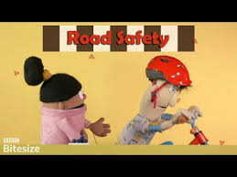  https://www.youtube.com/watch?v=odL77zH42Vs  Create two of your own characters to star in a Road Safety poster or advert for Nursery and Primary 1 children.  - Create a poster listing Top Tips for crossing the road  - Create a stop motion video | Science  What can you find out about human eyes?  Draw an eye, label it and create a poster to show the main parts of the eye.
 | 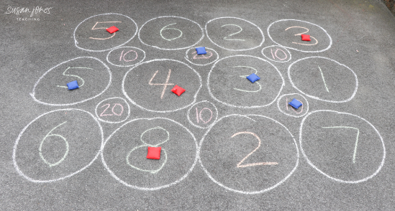  Chalk Maths  Make an outdoor adding/subtracting game using chalk. Throw beanbags or small pebbles onto the numbers, then add or subtract. The older you are, the bigger the numbers you can use. |  |  |  | Science  Look for a plant outdoors. Can you identify the following parts:  - petals  - leaves  - stem  - roots  - anther  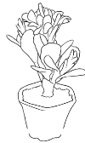  Research online the job that each of these parts do.
Patterns

Go for a walk around your house or garden. Look for as many repeating patterns you can find:
Look out for patterns on curtains, duvets etc. Design and colour your own.

