St. Barbara’s Primary School
Early Level Grid (Primary 1)

The following grids have been designed to support children working from home. The grid includes tasks from all of the curricular areas with digital learning running through many tasks. Many tasks can be repeated with different contexts. Some tasks will take more that one session to complete.
Some of the activities do require adult support and/or permission (e.g. Science investigation; online research).
If you do not have some of the items selected to complete a task, please substitute the task with another. For example, if a task relates to sewing buttons on material and you do not have the necessary materials, select something similar: perhaps the child could glue some pieces of material they have cut onto another to create a brand new pattern.
In addition to the grids, children should complete core activities as follows:
- Reading and Reading Records
- Sumdog Maths (online)
- Reciting the days of the week and the months of the year
- Log onto ‘Oxford Owl online.’ Enjoy hundreds of free eBooks for all age groups!
- Scholastic online
- Exercise for at least ten minutes each day
- Skills for learning, life and work:
- Make a healthy snack
- Brush your teeth
- Vacuum a room in your house
- Help in the garden…perhaps you could water plants or plant some seeds
- Practise counting…count the number of doors in your house. Now add the number of rooms. How many altogether?
- Know the times for breakfast, lunch and dinner
- Play a board game with a family member – remembering to take turns and remember to congratulate the other player if he/she wins
- Home-Learning Grids and daily blog tasks
Please continue to follow us on GLOW and on Twitter where staff will provide updates and activities for specific classes in addition to the above/below. Thank you.

Literacy |  | Numeracy | HWB | Other
Read a book, an online book or listen to an audiobook. Write three things that happened in the story. Now draw your favourite character and write some words which describe him/her/it. |  | Count out loud from 0-30  Count backwards.  Start at 7 can you count on to 30?  Start at 15 and count back to 0.  Count in even numbers: 0,2,4,6,8  Odd: 1,3,5,7,9 | Fitness Fun:  Build an obstacle course, in your garden or indoors! Be as creative as you can!  Get an adult to time you! Can you beat your record? | Science: How to Grow a Rainbow  You will need:  Kitchen roll  Felt pens  Two small bowls of water  - Cut your kitchen roll into the shape of a rainbow  - Colour a rainbow with the felt pens about 2cm up on both sides  - Fill each small container with water  - Hold your kitchen paper with the ends slightly submerged in the water then watch your rainbow grow!
Listening: Time for a Story  Click on the link below to enjoy the story.  https://www.youtube.com/watch?v=SweSXYs6DZc  Can you retell the story to someone in your family? |  | Doubles!  Practise your doubles using 1 dice. Roll the dice and whichever number it lands on double it and find the answer.  2 + 2 = 4  1 + 1 = 2  EXTRA Challenge!  Can you try doing this with 2 dice? | Friendship  Draw a picture of one of your friends.  Can you think of words to describe all things you love about your friend - e.g. kind, funny, helpful, caring?  If you can you could post this to your friend or share a photograph of it with them if an adult allows.
Story-writing: Designing a Book  Choose a character and a place from the list and write a short story.  Now design a front cover for your book.  Remember to write the title of your story and the name of the author! |  | Number bonds to 10  1 + 9 = 10 6 + 4 = 10  2 + 8 = 10 7 + 3 = 10  3 + 7 = 10 8 + 2 = 10  4 + 6 = 10 9 + 1 = 10  5 + 5 = 10 10 + 0 = 10  - Draw pictures to illustrate your number bonds e.g. 2 apples and 8 oranges  - Say your number bonds in a monster voice.  - Try saying them in another funny voice  - Take turns rolling a ball to someone at home and say your number bonds  - Jump on the spot as you practise your number bonds  - Sing your number bonds to the tune of your favourite song  - Say your number bonds as fast as lightning and then in slow motion | Food preparation  Can you look at the guide and make a healthy snack?  Eatwell Guide - Food and nutrition | NHS inform  www.nhsinform.scot › healthy-living › food-and-nutrition › eating-well  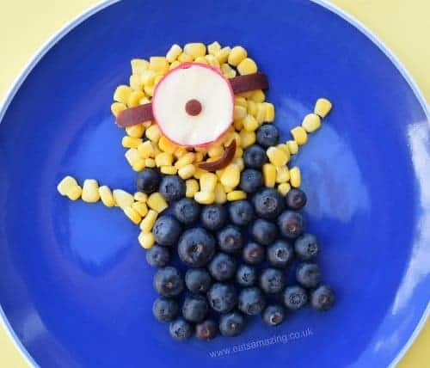 | Technology: Build A Den!  Build a den for two people to read their favourite books. Make it nice and cosy!  You could use…  - Blankets  - Sheets  - Chairs  - Tables  - Torches  - Clothes pegs  - Books for weighing down materials  Once you have finished, think…  - What is the best thing about your den?  - If you made it again what would you do differently?  Take a photo and email it to your teacher!
Character  Monster  Fairy  Sam the Cat  Mrs Plum  Bossy Boots  The Farmer  Bob the Dog  Healthy Hilda | Where  In the park  On a bus  Under the sea  Over the rainbow  Beside the sea  Above the castle  Below the ground  Outside the shop
Literacy |  | Numeracy | HWB | Other
Traditional Tales  Goldilocks  In school you were working on the story of Goldilocks.  Think about Goldilocks now.  Think of words to describe:  - What Goldilocks looks like  - What type of person Goldilocks is  Draw a big picture of Goldilocks and write your words all around the outside of it. |  | Count out 10 of your toys or teddies.  - Put them in a line and tell someone at home which one is first, second, third, fourth right the way to tenth.  - Which toy is the smallest and which one is the biggest?  - Order them from biggest to smallest  - Order them from smallest to biggest | Play a game of ‘Active Simon Says’ with someone at home. You could try:  - Simon says jump on one foot 10 times  - Simon says do 20 ‘step-ups’ on the lowest stair  - Simon says do 5 star jumps  - Simon says run as fast as you can for 20 seconds  Remember NOT to do it if Simon doesn’t say it!  If the weather is nice try this outside in the garden! | Expressive Arts: Art and Design  Watch the video and try some activities!  https://www.youtube.com/watch?v=8kzakhNi3hM  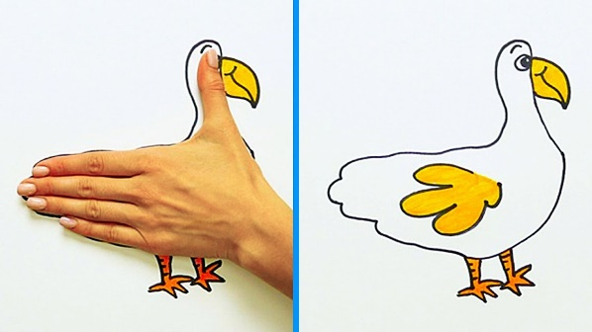
Common Word Practice  How many common words can you remember?  - Read them every day  - Write them in your jotter  - Make a sentence with three every day  have just to  was went his  be but you  if for on  go got get  can we into  did as he  am me my  an is and  I in it  a at the |  | Positional Language  Use the same toys or teddies and ask someone at home to read you these instructions:  - Put the biggest toy on top of your bed  - Put the smallest toy behind your sofa  - Put the (choose any colour) toy in front of your fridge  - Put your favourite toy below your bedroom window  - Put the second-biggest toy at the right side of your television  - Put the second-smallest toy at left side of your television | Food Preparation  Use these skills for when you help an adult to prepare a meal.  Tick off the list when do each of these:  - Peeling  - Slicing  - Mixing  - Spreading  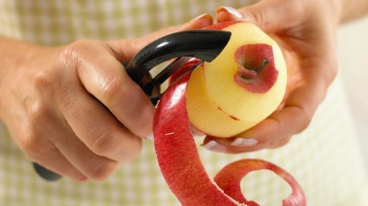  Draw a picture for every skill you used and write the skill underneath. | Spanish: Practise counting!  Numbers - KS1 Spanish - BBC Bitesize  www.bbc.co.uk › bitesize › topics  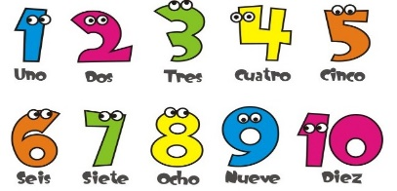  BBC Bitesize has daily online lessons for all age groups.
R.E.
Ask someone at home to help you create a prayer for all the people in the world at this difficult time. In your prayer remember to:

Thank God (maybe for something you are grateful for during this time)
Praise Him (tell God how much you love Him)
Ask Him (ask God to look after and protect your family, friends, nurses, doctors, the world )
Can you say this prayer at bedtime with someone at home?

