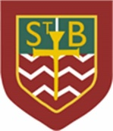**St Barbara’s Primary School**

|  |  |
| --- | --- |
| **Curricular Areas** | **Primary 7 Suggested Daily Learning Activities**  **Wednesday 20th May** |
| **Literacy** | 1. On Monday the reading task you were set encouraged you to focus on adjectives. Today I would like you to add adjectives to the paragraph that I have included below to make it more interesting. Try to use some wow words as this will really engage the reader and make them want to continue reading. 2. Today we will revisit another spelling rule for making plural nouns. If a noun ends in a consonant and then a ‘y’, then the ‘y’ is removed and an ‘ies’ is added:   Example- berry 🡪 berries, army 🡪 armies and story 🡪 stories  Can you think of 10 words that follow this spelling rule? Record them in your jotter.   1. I have created a word list that follows our focus spelling rule, if a noun ends in a consonant and then a ‘y’, then the ‘y’ is removed and an ‘ies’ is added: Write each of the words out three times each in your jotter and then use a dictionary to explore the definitions of the words. When you have recorded their definitions arrange the words into alphabetical order. 2. Read a few chapters from either your personal reader or the novel that I have set for you on the Scholastic learning Zone website. When you have read a few chapters complete some of the follow up reading task cards that I have included below. Record any task card that you do in your jotter. |
| **Numeracy** | 1. Remember to complete today’s task on your 2nd level maths May calendar. Today’s question explores multiplying decimals, something I know that you coped well with in class. I have attached the calendar below in case anyone needs a copy of it however remember you can also access it on Twitter #alittlebitofmathseverday. 2. Continue working on the North Lanarkshire Sum Dog maths competition. We are doing so well but it would be fabulous if we could get all 31 pupils to participate. Do you think we can do this? 3. Yesterday we looked at BODMAS and how to tackle sums with numerous number operations in them. Can you remember what the acronym BODMAS stands for? Write it down in your jotter and decorate it to help make it memorable to you. 4. To remind yourself of the order of operations watch the video clip that I have attached below.   <https://www.bbc.co.uk/bitesize/topics/z69k7ty/articles/z24ctv4>   1. Complete the sums that I have attached below using the BODMAS format. If you find this task super easy you can complete the extension task. |
| **Health and Wellbeing** | See today’s Primary 7 GLOW homepage for your Health and Wellbeing activities. |
| **TIOF** | See today’s Primary 7 GLOW homepage for your This Is Our Faith activities. |
| **Additional Tasks** | If you wish to complete more tasks please select one or two tasks from your Second level grid for May. |

**Can you make this paragraph more interesting?**

As I walked down the road, I kept thinking about the house I had just passed. It sat on the hill above the village. The windows, door and bushes surrounding it made it look very frightening. The drive up to the house seemed to go on forever.  I wonder if anyone still lives there?

**Spelling Rule Word List**

cities

families

dictionaries

abilities

discoveries

possibilities

studies

countries

activities

beauties

universities

enemies

libraries

varieties

**Reading Task Cards**

**Reading Task Card 1**

Look out for words that have apostrophes.

Write down each word which has an apostrophe, and explain why it is there.

**Reading Task Card 2**

Find10 **common nouns** in the chapters that you have read today and make a list of them.

Also find 5 **proper** nouns.

**Reading Task Card 3**

Pick a descriptive word from one of the chapters you have read, write it down and, using a thesaurus, write down five **synonyms** and **antonyms** for that word.

**Reading Task Card 4**

Re-read a chapter. Pick out three words that you feel are **powerful words** and that you could use in your own writing in the future.

**Reading Task Card 5**

Find **adjectives** in your novel.

Make a list of them. Then, make up some sentences. Each sentence must contain at least 3 of the adjectives.

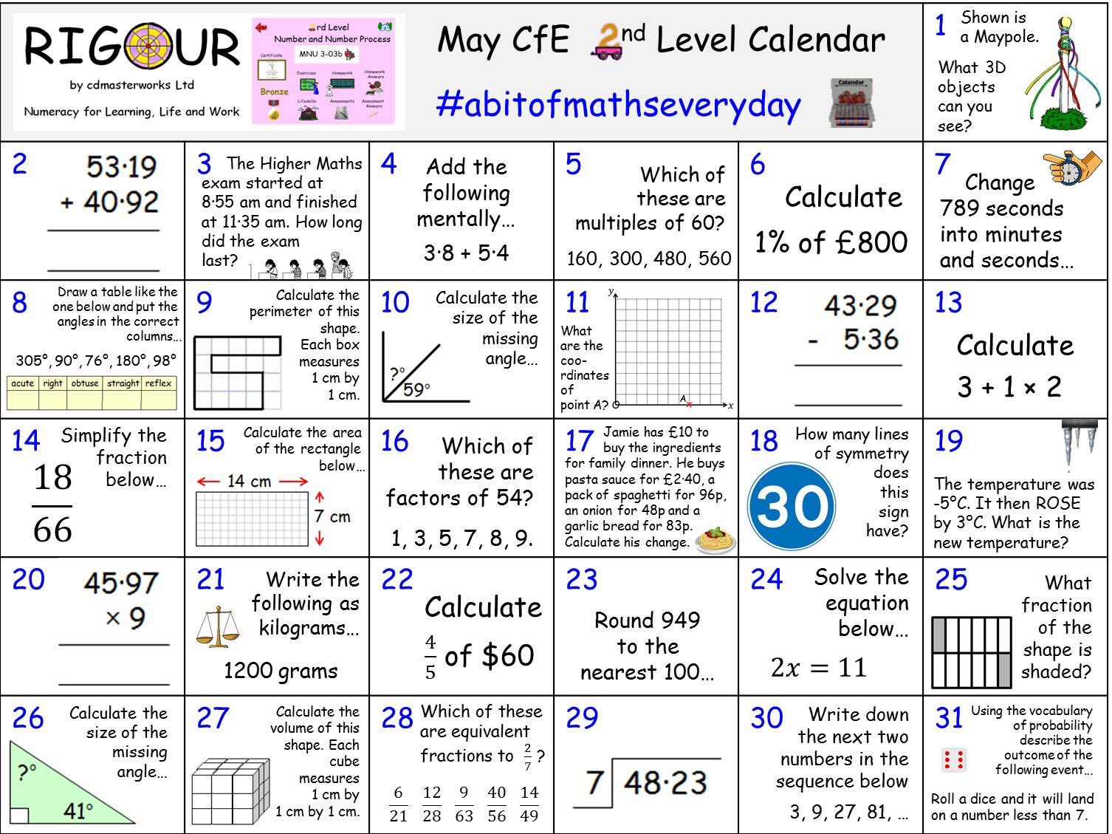**May 2nd Level Calendar**

**BODMAS Questions**

*Remember when completing these sums you do the sums in the brackets first and then any multiplication or division and then lastly any addition or subtraction.*

1. 6 x 4 + 45 =

2. (9 + 4) x 10 =

3. 92 – (10 x 5) =

4. 12 ÷ 5 + 18 =

5. 12 x 12 + 9 =

6. 10 x 4 ÷ 2 =

7. 560 – 5 x 6 =

8. 14 – 1 ÷ 2 =

9. 69 – 4 + 9 + 15 =

10. (56 + 56) + 9 ÷ 2 =

11.(45 + 45) x (5 x 2) =

12. (13 – 2) x (4 + 3) =

**Extension**

Insert brackets in 2 different places to get 2 different answers.

1. 15 – 4 x 2

2. 9 x 4 + 6 =

3. 12 ÷ 2 + 4 =

4. 4 + 6 x 7 =

5. 22 + 3 x 4 =

6. 5 x 2 x 3 + 4 =