**Collective Noun Task**

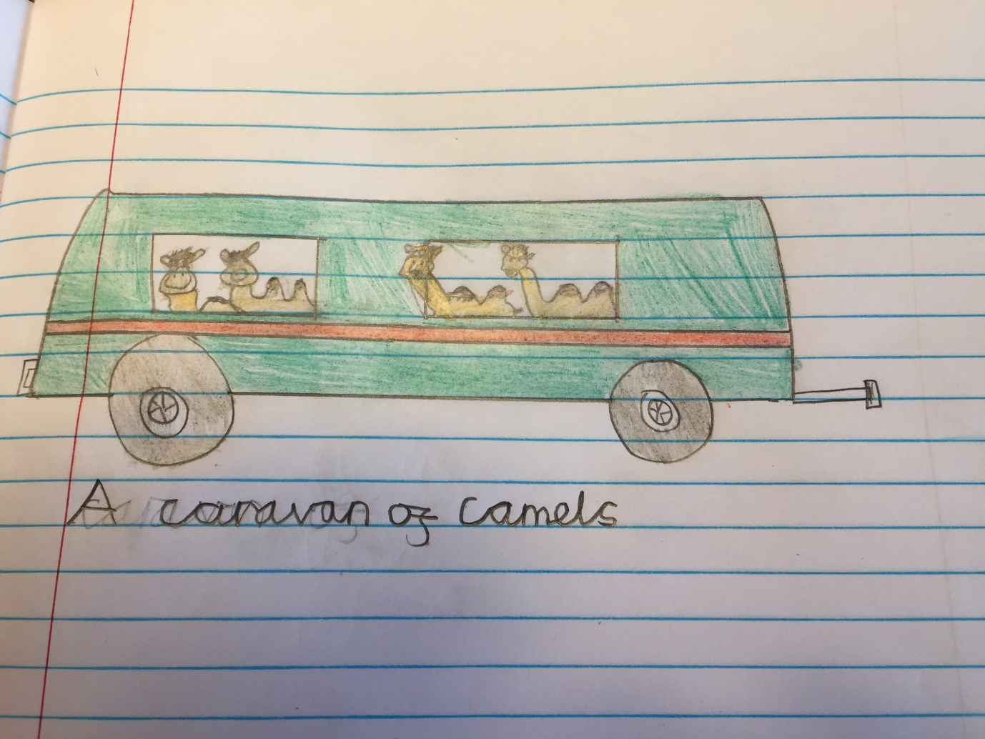**A Caravan of Camels**

**By Ethan P.**