Wednesday 20th- Please begin with your morning prayer, thanking God for looking over us and keeping us safe.
Literacy  Reading  IALT read with understanding and expression.  Spelling  IALT use a range of strategies to help me spell. | Reading- Scholastic Reading.  Most people have sent me an email to ask for their login details for Scholastic. If you haven’t been able to access this resource yet and would like your child’s login details, please send an email. (gw19shreenannatasha@glow.sch.uk)  I would like you to read your assigned reading book aloud to someone at home, make sure to use eye contact and expression throughout.  After this I would like you to select one of the reading tasks from the grid below. We have completed all of these tasks before in class..  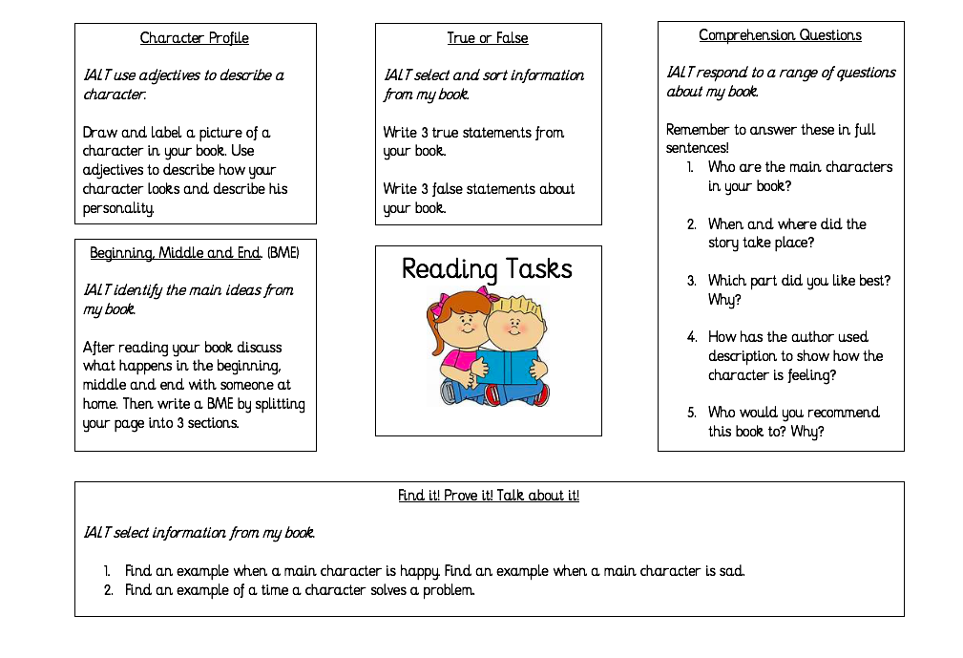  Spelling Tasks-  Phoneme word search  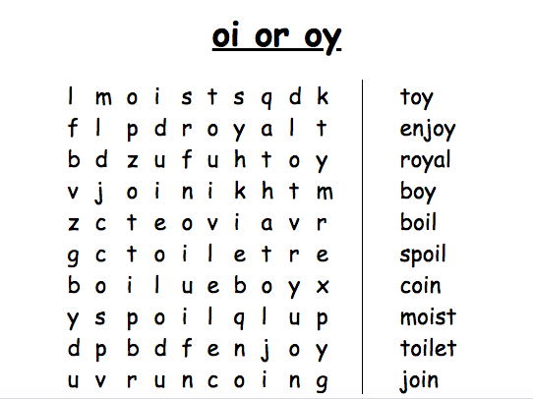  Word Scramble- common words  Unscramble this week’s common words-  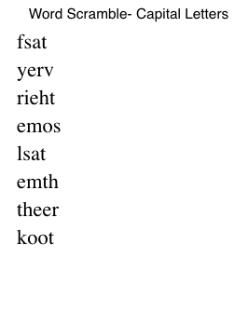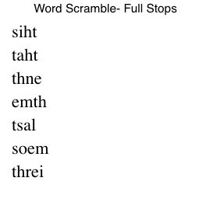  Have a go at trying to unscramble your common words.
Numeracy  IALT solve problems using addition. | Today we are going to look at addition. When you add two numbers together you should end up with a bigger number.  One strategy we use to help us when adding is ‘counting on’. Counting on is when we put the first number in our head and then count on from that given number.  Example- 7 + 5 = ?  Let’s put 7 in our head then count 5 fingers on.. 8, 9, 10, 11, 12. We landed on 12. So 7+5 = 12.  Have a go at solving these problems below- you can complete them on the worksheet or in your jotter.  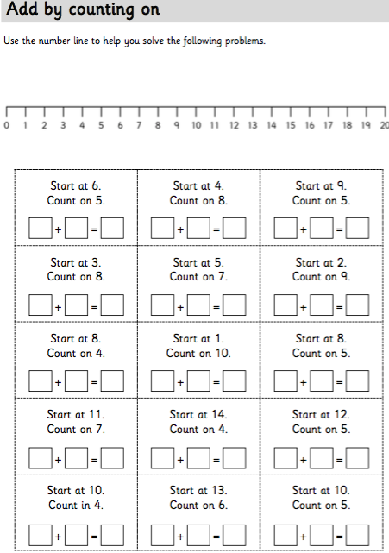  Take ten minutes out of your day to log on and compete in this week’s NLC Sumdog competition! Let’s give it our best shot Primary 2
HWB  IALT improve my fitness. | Time to waken up and put your best foot forward!  We’re getting closer to Sports’ Day – so time for a little movement. There are two video clips to get you moving and some tasks below. Enjoy!  https://www.youtube.com/watch?v=lJPvEs8qpQc&feature=emb_title  https://www.youtube.com/watch?v=KhfkYzUwYFk&feature=emb_title  Now for those tasks:  Play some music lasting about ten/fifteen minutes and do these:  - Jumping Jacks/Star Jumps  - On the Spot running  - Plank  - Squats  - Add your own and have fun!  Remember to have your water bottle handy and to take a few breaks!
T.I.O.F | This week we have been looking at Jesus’ commandment to:  ‘Love one another as I have loved you.’  Jesus showed his love for all of us on Good Friday when he died on the cross. Tomorrow we are going to celebrate the Feast of the Ascension. On this day, forty days after his resurrection on Easter Sunday, Jesus ascended into Heaven leaving the disciples behind to carry on with his work and to be witnesses for him. They were a little scared to be left without Jesus but they believed in him and they knew that he would not leave them alone. They were quite right of course; the Holy Spirit came to help them on the Feast of Pentecost and we’ll explore that later.  Below you will see two very different video clips about the Ascension. Please watch both of them.  https://www.youtube.com/watch?v=7wLrw60bY5w&feature=emb_title  https://www.youtube.com/watch?v=nnRJa4cZQIE&feature=emb_title  Now what I would like you to do is to draw or make your own reminder of what happened on the Feast of the Ascension.  You could think about making the figures of Jesus, his disciples and the two people dressed in white – you could even create your own video clip.  Or you could draw them and write a sentence or a paragraph below; you might want to make a picture using other media – e.g. cotton wool for the clouds.  I have attached some ideas to help you below.  Whatever activity you choose to do, please email it to (gw19shreenannatasha@glow.sch.uk) or, with an adult’s permission, upload it on to Twitter @St_BarbarasPS
IDL Topic  IALA social and cultural aspects. | Around the world  We have previously learned all about Scottish dancing and parties in school. In Spain, people learn different dances. This is called “Flamenco dancing”. This dancing is used to tell a story. Flamenco dancing is accompanied by someone playing guitar and there is a lot of clapping and stomping. Here is a picture from a Flamenco show I went to in Madrid.  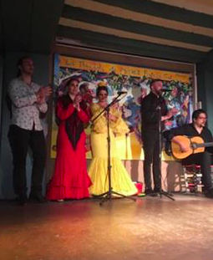  Here is a video which teaches us a bit more about Flamenco dancing. See if you can copy some of the moves!  https://www.pbs.org/video/kidvision-vpk-flamenco-dance-studio/?fbclid=IwAR2xJ3WH9okTvxppaSpdwuzrChCZZnhUSdyQEwbWOiKrsMNfCb3Slgx4CdY
Optional  tasks | If you wish to complete more tasks please select one or two tasks from your new First level grid for May.
Remember any work you wish to upload should be done so under your class name and if you would like to share any videos or pictures of you completing any of the tasks you have been set you can do so via Twitter. Have fun, work hard and if you need anything you can contact me by email; gw19shreenannatasha@glow.sch.uk
Miss Shreenan

