[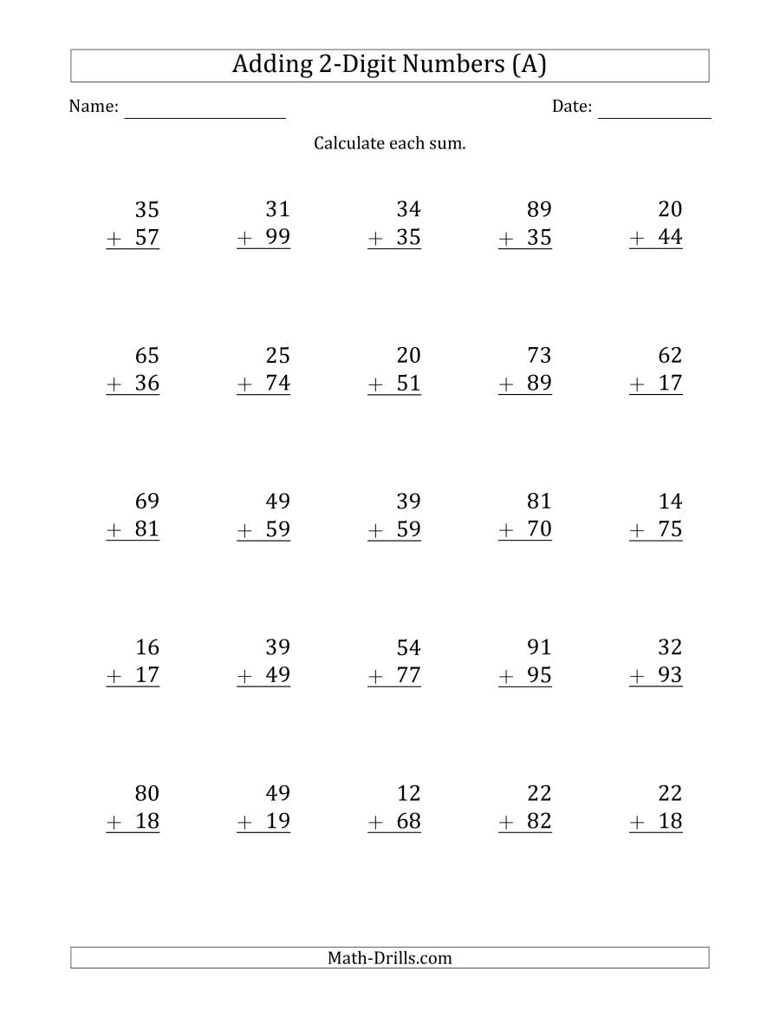](https://www.google.co.uk/url?sa=i&url=https%3A%2F%2Fwww.math-drills.com%2Faddition%2Faddition_2digit_someregrouping_001.php&psig=AOvVaw2899h-3sWhzSKx-gAhqA73&ust=1589905442015000&source=images&cd=vfe&ved=0CAIQjRxqFwoTCNCFo7vpvekCFQAAAAAdAAAAABAD)