[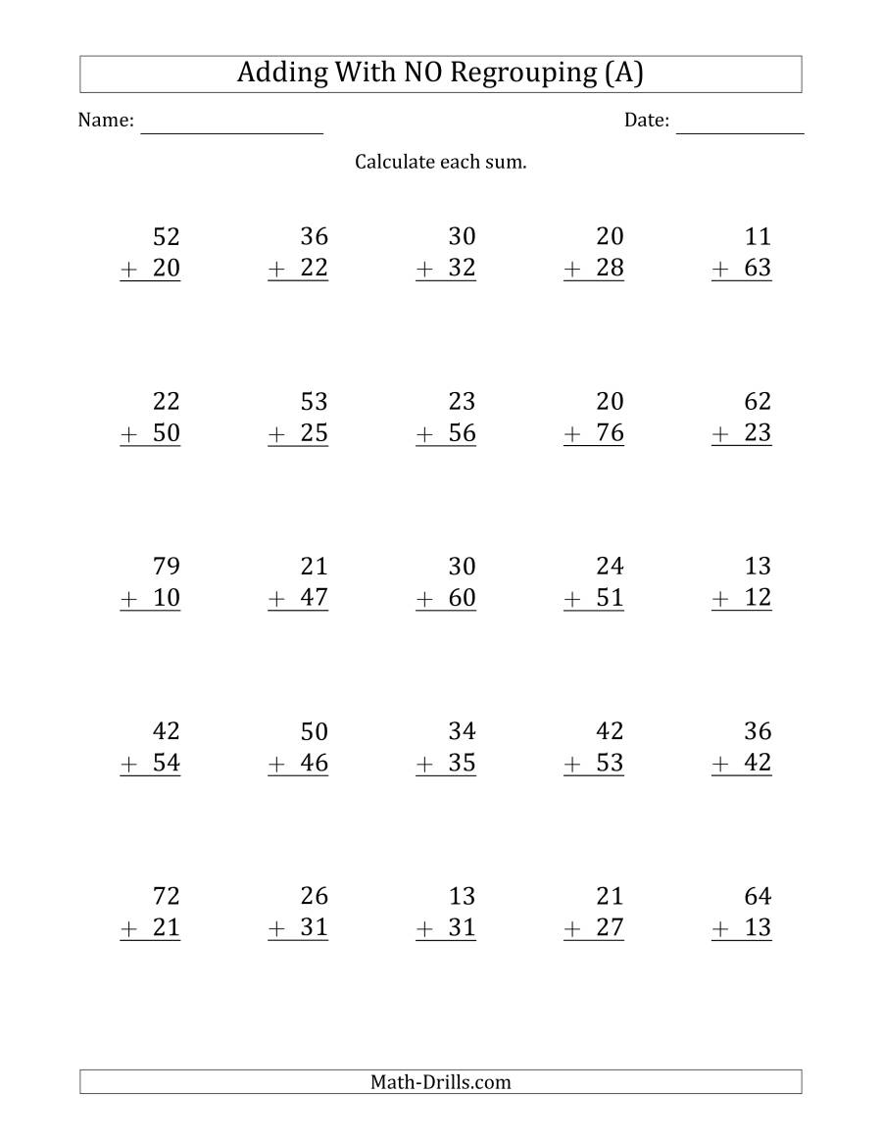](https://www.google.com/url?sa=i&url=https%3A%2F%2Fwww.math-drills.com%2Faddition%2Faddition_2digit_noregrouping_001.php&psig=AOvVaw3Nt5pZQVU3u_hANn_JeaMO&ust=1589872962638000&source=images&cd=vfe&ved=0CAIQjRxqFwoTCNi8zbvwvOkCFQAAAAAdAAAAABAE)