Tuesday 19th- Let’s begin as always by saying our morning prayer and a special ‘Hail Mary’ for all the people who are sick in our world and for those caring for them.
Literacy  IALT decode words using phonemes. | News- All about today.  We are going to begin with our ‘all about today’ news.  Start off by singing your days of the week and months of the year song.  After being asked these questions I would like you to complete the task below.  If yesterday was Monday, Today is?  Yesterday was the 18th, what date is it today?  Last month was April, so this month is?  Can you look outside and describe the weather?  May is the last month of the season of new beginnings- what season is it?  Can you name all 4 seasons?  What season comes after Spring?  Complete the following-  Today is _______the ___ of ___ It is ____ outside. May is the season of ______. Next month will be the beginning of the ______ season.  Draw a picture below to illustrate today.  Phonics Task- consolidation  Starter- Alphabet name and sounds- My name is A, my sound is a.. (orally)  Warm-up- read through the phonics cards- see how many you know! (sh for shop, ch for chest…)  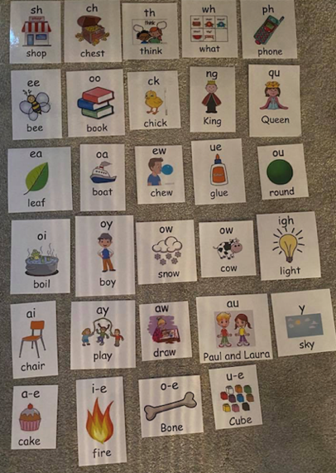  This week’s phoneme- oi or oy (both make the same sound)  Last week we looked at ai or ay and when to use the correct phoneme.  This week we are going to look at oi or oy. These both make the same sound and have a similar spelling rule to ai or ay.  Please watch this video- oi and oy spelling rule.  https://www.youtube.com/watch?v=g9znxk0JQB4  Here is the catchy song to go along with today’s lesson >  https://www.youtube.com/watch?v=fFZw9dwASI4  You will now know that we use ‘oi’ when the sound is in the middle of the word and ‘oy’ when the sound is at the end of a word.  (eg, boil / boy)  (Exception- if the word ends in ‘al’ we use ‘oy’, eg- royal/loyal)  Let’s watch this video to learn some oi and oy words.  https://www.youtube.com/watch?v=Hbt0Thvs1GE  Now that you have listened to the video, I would like you to think of 5 oi words and 5 oy words.  Make a list of the words and draw a picture to illustrate each word below.  oi oy  boil boy  Challenge- can you write a sentence including 3 of the words from your list?  Don’t forget to put a capital letter at the start of the sentence, a full stop at the end and finger spaces between each word. Remember to re-read you work at the end to check it makes sense.
Numeracy  IALA how numbers are constructed. | Today we are going to look at ordering numbers. Can you order these numbers from the smallest number to the greatest number.  Let’s begin by counting to 100 by 1’s forwards and backwards to help with ordering our numbers.  You can use this 100 number square to help you!  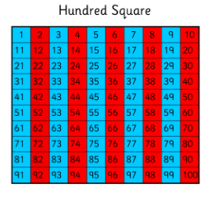  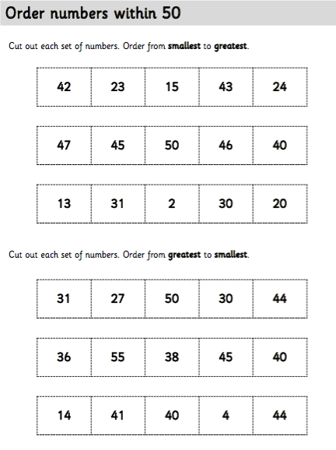  Sumdog- Take ten minutes out of your day to log on and compete in this week’s NLC Sumdog math competition! Let’s move ourselves up on that live leader board
HWB  IALT improve my fitness. | Yesterday we had a look at making healthy snacks and the skills you need to create something delicious in the kitchen!  Today as we get closer to Sports’ Day next Tuesday, let’s be a little more energetic with a dance and then some yoga!  Click the links below to join in-  https://www.youtube.com/watch?v=m_Clwq4osEQ#action=share  https://youtu.be/Rzw-Oir8UPw  Remember to stay hydrated!
T.I.O.F | Yesterday we were looking at the Ten Commandments and Jesus’ message to,  ‘Love one another as I have loved you.’  I asked you to think about your families and how much you love them. I also reminded you that Pope Francis has told us all to care for others, ‘No ifs, no buts!’  Today I would like to think about the people living in the same house as you; there might be two of you, there might be six of you! It doesn’t matter. Now I would like you to think of FIVE little things that you could do this week for those in your home. It could be that you set the table, make your bed, clear up after a meal, make someone a cup of tea or even take the vacuum cleaner for a walk!  When you have selected five things, draw some heart shapes and inside each, draw or write your tasks. You can make some extra hearts for decoration. Colour or decorate them carefully. Next make a circle wreath-shape like the picture below or if you have a paper plate, use that. Attach your heart shapes and display your Caring Wreath somewhere you can see it easily. Carry out your tasks this week and show that you care – no ifs, no buts!  Please email your Caring Wreath to (gw19shreenannatasha@glow.sch.uk) or, with an adult’s permission, upload them on to Twitter @St_BarbarasPS and to Pope Francis’ Twitter @Pontifex

IDL topic  IALT explore the patterns and sounds of language. | Around the World  Barnaby Bear had so much fun in France last week learning all about the famous landmarks and the language! He loved the view from the Eiffel Tower and met so many amazing friends at Disney Land Paris.  He is back today to tell you where he is off to on his next adventure…  Hola ninos! We have arrived en Espana this week. I am very excited to learn all about the country Spain. It is one of my favourite places to visit.  Did you know the capital of Spain is Madrid, but it has many other large cities including Barcelona, Valencia, Seville and Malaga. There are also many islands around Spain including Mallorca, Tenerife, Ibiza and Fuerteventura, which are very popular destinations. Have you been to any?  In Spain, they speak the language Spanish and today we are going to learn some Spanish words! Some important things to know about speaking Spanish is the letter sounds. In Spanish, the letter H is silent, the letter Z makes a ‘th’ sound and two ‘ll’ together makes a y sound.  Today we are going to try and introduce ourselves to someone at home in Spanish.  Here are a few useful phrases:  Hola- Hello  Como te llamas? What is your name?  Me llamo ____- My name is ____  Example-  Hola, me llamo Miss Shreenan.  Hello, my name is Miss Shreenan.  Next, we are going to learn a fun song called ‘Juan Pequeno’, which means ‘Little John’ in English. This song is about Little John who likes to dance.  Here are some helpful translations:  Juan- John  Pequeno- Little  Baila-dances  Con el dedo- with his finger  Con la mano- with his hand  Con el todo- with his elbow  Con el hombre- with his shoulder  Con la Cabeza- with his head  Con la rodilla- with his knee  Con el pie- with his foot  Now try and sing along with the song! It plays in Spanish and then is translated into English. Enjoy  https://www.youtube.com/watch?v=vEWv4Gxp2i4&fbclid=IwAR0V8ppOV1GI-EVJGiAIlPTdMbMVaBMTaW1oKNJMsavdDTkrdcruW5mzsHc

Optional  tasks | If you wish to complete more tasks please select one or two tasks from your new First level grid for May.

Remember any work you wish to upload should be done so under your class name and if you would like to share any videos or pictures of you completing any of the tasks you have been set you can do so via Twitter. Have fun, work hard and if you need anything you can contact me by email; gw19shreenannatasha@glow.sch.uk

Miss Shreenan

