St Barbara’s Primary School
Curricular Areas | Primary 7 Suggested Daily Learning Activities  Tuesday 19th May
Literacy | - Can you complete the literacy starter task that I have attached below? What chilli can you make it to? Can you complete the extra hot chilli challenge?  - I have created a word list that follows this weeks focus spelling rule, nouns ending in a single ‘f/fe’, change the ‘f/ fe’ to a ‘v’ adding ‘es’. Write each of the words out three times each in your jotter and then select 5 of the words to write interesting sentences.  - Choose 2 spelling activities from the menu below and complete them in your jotter. These spelling tasks will help reinforce your knowledge of your new focus spelling words.  - For reading today explore the First News newspaper article, Space Technology News. When you have finished reading the article, read the questions and then skim and scan the text before attempting to answer any of the questions. Answer the questions in your jotter and remember to use the question to help you structure your answer. The answers are in the text so always refer back to the article to help support you. I have attached a link to today’s article, questions and answers on the Primary 7 GLOW homepage. Remember no peeking at the answers before you give the questions a go!
Numeracy | - Continue to work on the Sum Dog North Lanarkshire competition. This competition finishes on Thursday and we are doing so well. Try to answer all of your questions with speed and accuracy. We can win this!  - Choose a chilli challenge from the work that I have attached below. Try to choose a chilli that will get your brains working. See how many different mental math strategies you can use to get to the answer and explain some of the strategies that you used to someone in your household. Remember you have to do these sums mentally!  - When solving equations that have numerous number operations in it there is an easy way of remembering what order we do them in. We use the acronym BODMAS. BODMAS stands for Brackets, Order, Division, Multiplication, Addition and Subtraction. Go through the PowerPoint that I have attached to the Primary 7 GLOW homepage to practise following the BODMAS format. When you feel confident with BODMAS try one of the activity sheets that I have attached below. Choose the worksheet that you find the most challenging.
Health and Wellbeing | See today’s Primary 7 GLOW homepage for your Health and Wellbeing activities.
TIOF | See today’s Primary 7 GLOW homepage for your This Is Our Faith activities.
Transition | To help you get prepared for life at high school I thought we would complete a timetable activity today. Normally we get to use and explore a high school timetable during out visits in June however preparations for high school will be a little different this year. Today I would like you to familiarise yourself with the model timetable that I have attached below and see if you can answer the questions that relate to it.
Additional Tasks | If you wish to complete more tasks please select one or two tasks from your Second level grid for May.

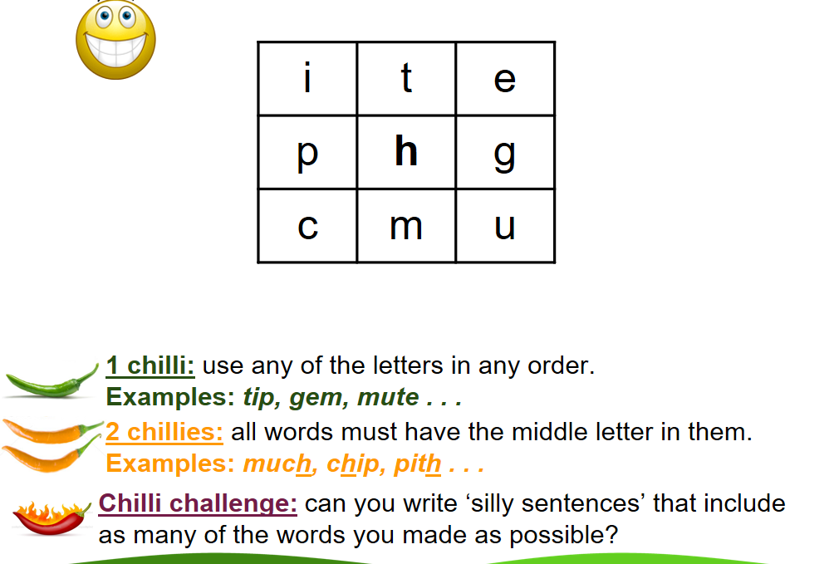
Literacy Starter Task

Spelling rule word list
leaves
thieves
yourselves
themselves
shelves
wolves
scarves
calves
knives
lives
loaves

These might seem like very easy words however it is important that you understand this spelling rule in order to apply it to trickier words that follow this rule.

Spelling Menu
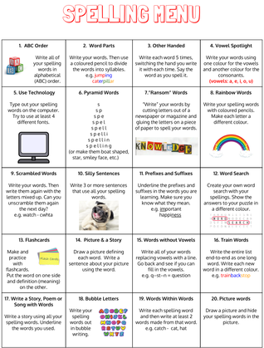

Chilli Challenges
Mild 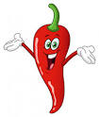

77-38

Spicy

984-464
Hot
63,107- 3,094

BODMAS Worksheets
Sheet A

Sheet B

Sheet C

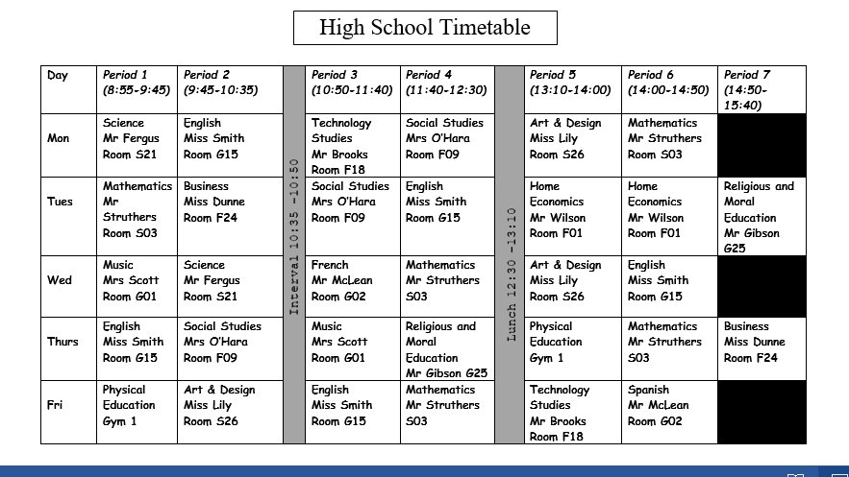
Timetable Activity
