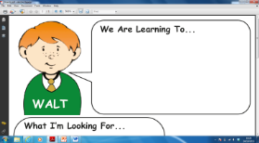 | To solve missing number subtraction problems. | With support | Independently
 | Look at the first number – put it in your head or find it on the numberline/100 square.
 | Count back (with fingers or on the numberline/100 square) until you reach the total.
 | The number of fingers you put up or jumps you made on the numberline/ 100 square is the missing number.

17 - = 14 16 - = 12
20 - = 16 19 - = 18

18 - = 16 20 - = 11

19 - = 13 18 - = 15

16 - = 14 20 -= 18

17 - = 12 15 - = 12

Challenge: can you make up some more missing number problems?

