[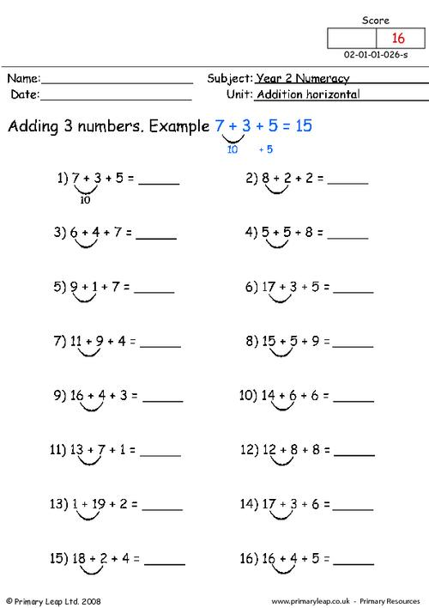](https://www.google.co.uk/url?sa=i&url=https%3A%2F%2Fprimaryleap.co.uk%2Fprimary-resources%2F520%2Fyear-2%2Fnumeracy%2Fnumbers%2Faddition-horizontal-(2)&psig=AOvVaw1HL_NMrmmn_wtLJZ8YuQU4&ust=1589872580285000&source=images&cd=vfe&ved=0CAIQjRxqFwoTCIj144XvvOkCFQAAAAAdAAAAABA6)