ST BARBARA’S PRIMARY 4/3
SHINING STARS
- RORY
https://vm.tiktok.com/3wU6EF/
(press control and click on the above link to listen to this amazing pianist!!)

- Jenna
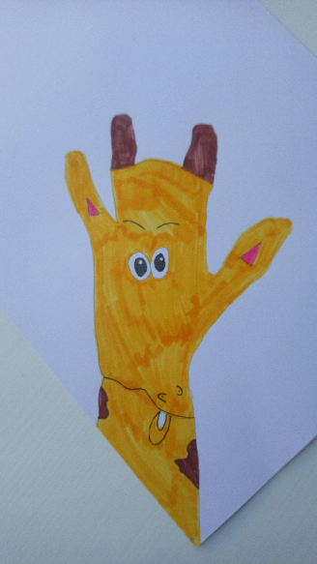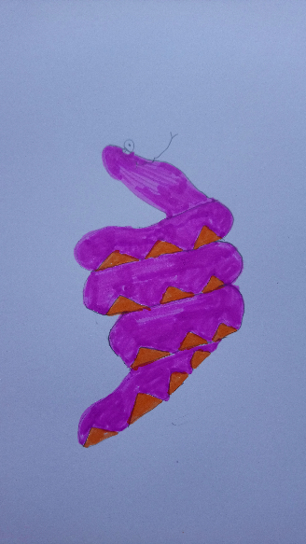
Jenna trying out some artwork using her hand

