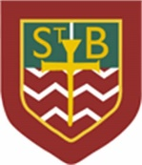St Barbara’s Primary School
Curricular Areas | Primary 7 Suggested Daily Learning Activities  Monday 18th May
Literacy | - What is the highest score you can get in today’s literacy starter task? Read the instructions carefully to get your most point worthy words.  - One of the spelling rules that we will be revising this week is- nouns ending in a single ‘f’, change the ‘f’ to a ‘v’ adding ‘es’.  Example- leaf leaves, wolf wolves and half halves  Like most spelling rules there are exceptions to the rule.  Today I would like you to come up with a list of 10 words that follow this rule. When you have created this word list remember to double check the spelling of these words using a dictionary. Can you think of any exceptions to this rule? Note them down in your jotter.  Tomorrow I will give you some focus words that follow this spelling rule that you will explore over the course of the week.  - Today I would like you to read another few chapters from either your personal reader or the novel that I have assigned to you on the Scholastic Learning Zone website. If there is someone in your house who has a little bit of spare time today maybe you could read some of your novel aloud for them. This might be a parent, guardian or a sibling. When you have finished reading you could complete the reading follow up activity that I have included below. This task asks you to focus on the adjectives in your novel. We all know what an adjective is but in case you have forgotten click on the link below for a little refresher.  https://www.bbc.co.uk/bitesize/topics/z4hrt39/articles/zj33rwx
Numeracy | - This week I would like you to try and complete some of the activities from the Daily Rigour newspaper. I have attached a copy of this weeks’ edition of the newspaper, these are published on a weekly basis. Try your best to complete as many of the articles as possible. Watch the video link below to find out the solutions for last weeks’ edition of The Daily Rigour.  https://youtu.be/Cxs72fRZJyI  - Remember to keep working on the North Lanarkshire Sum Dog competition. We are doing so well so keep it up!  - Complete the word problems that I have attached below. There are 3 sets of questions, choose the set that will challenge you the most. I will post the answers to the word problems this afternoon. Remember the step by step approach we take when tackling word problems.
TIOF | See today’s Primary 7 GLOW homepage for your TIOF activities.
Health and Wellbeing | See today’s Primary 7 GLOW homepage for your Health and Wellbeing activities.
Additional Tasks | If you wish to complete more tasks please select one or two tasks from your Second level grid for May.

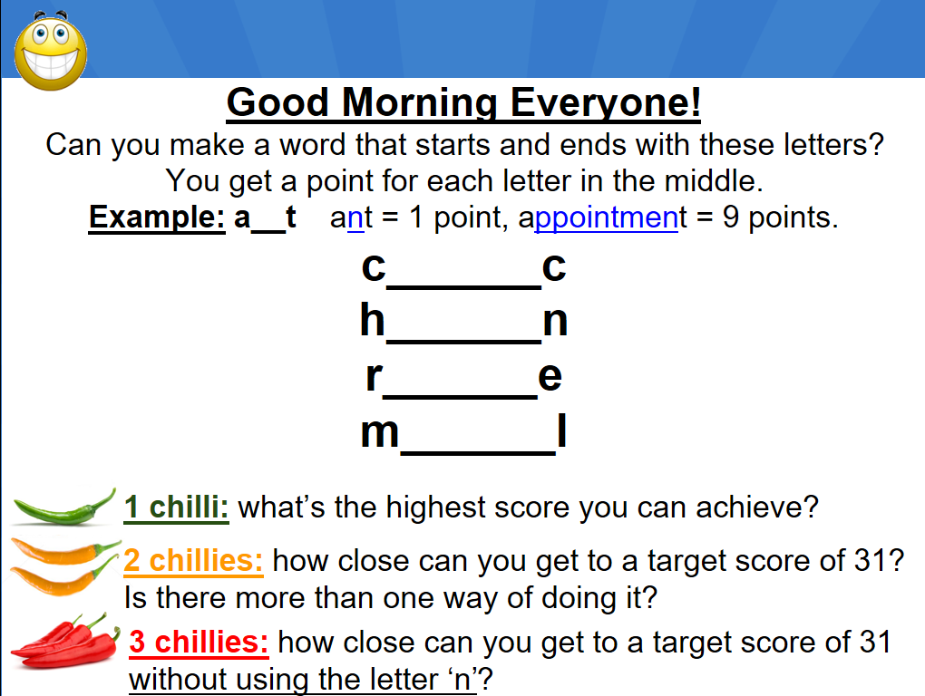
Literacy Starter Task

Reading follow up activity

The Daily Rigour
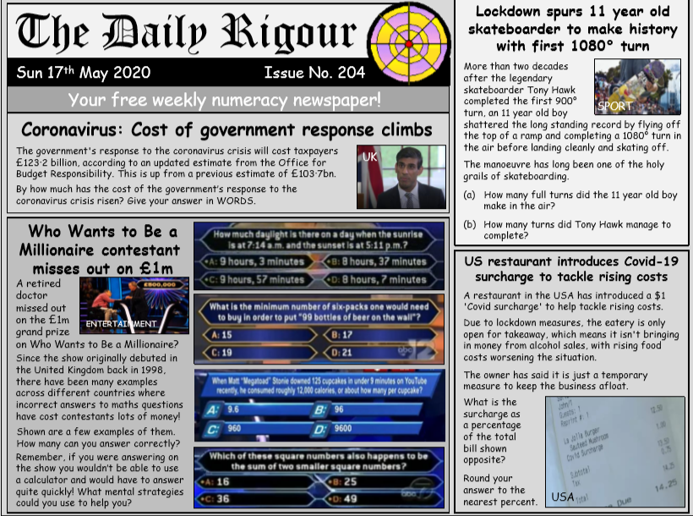

Mixed Operation Word Problems
Bronze Questions
- There are 305 children at St Luke’s School. 167 of them are girls. How many are boys?
- Charlie saves £3.20 in December and £1.95 in January. How much money does he have in total?
- There are 9 shelves of cereals in the supermarket. Each shelf has 120 packets of cereal on it. How many packs of cereal is this altogether?
- Jade’s mum buys a pack of 6 kiwi fruit. They cost 90p. How much does each kiwi fruit cost?
- A machine makes nails. Between 9am and 10am it makes 1230 nails. Between 10am and 11am it makes 1267 nails. What is the total number of nails it makes between 9am and 11am?
Silver Questions
- Jade’s mum buys a pack of 6 kiwi fruit. They cost £1.32. How much does each kiwi fruit cost?
- What is the product of 19 and 3.6?
- Mr Daw gives each child in his class 18 stickers during January. If there are 29 children in Mr Daw’s class, how many stickers has Mr Daw given out?
- Katie spends £1.29 on a magazine and £8.95 on a CD. If she had £12.50 to start with, how much does she have left?
- Mrs Sherwood puts sweets into bags before the disco. If she puts 14 sweets into each bag, how many bags will be needed to take 196 sweets?
Gold Questions
- There were 8956 ants in one ant hill and 3949 in another. How many ants were there altogether?
- 316900 people live in Coventry. Warwick has a population of 81971 and a further 49500 live in Leamington Spa. How many people live in Coventry Warwick and Leamington Spa altogether?
- The diameter of Mars is 6779km and the diameter of Earth is 12 742km. How much bigger than Mars is the Earth?
- Mr Daw shows limited willpower and eats 17 biscuits every day in 2009, except for Christmas Day when he eats 28. How many biscuits will Mr Daw have eaten by the end of the year?
- Jade’s mum buys a pack of 8 kiwi fruit for £1.92. Individual kiwi fruit cost 30p each. How much cheaper is each kiwi fruit by buying in a pack?

