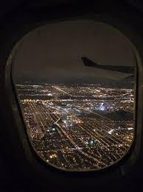**Comprehension Task**

**Looking Down**

**Anyone who has been on an aeroplane at night, circling around, waiting to come in to land at an airport near a big city will have experienced the wonderful display of lights. If you haven’t, you may be able to imagine what it looks like.**

Night has chased away the last warm glow from the evening sky. Ribbons of orange snake and criss-cross, stretching out into the sea of blackness now engulfing the twinkling mass of tiny lights.

A myriad of tiny lights shine from the miniature houses and the apartment blocks out in the suburbs. Each is a small haven, warming and comforting, banishing the darkness from the city.

Closer now and the streets are alive with frenetic, insect-like activity. Creatures with glowing eyes, some red, some white bustling busily, stopping and bustling again along the shimmering streets and roads. Splashes of neon colour – pictures, words.

The famous monuments, floodlit, stand out, tell us where we are. The massive bulk of the Sacré**-**Cœur cathedral, a glimpse of the Arc de Triomphe loom up towards us.

Between the medley of light and movement are swathes and ribbons of blackness where no lights, just an occasional reflection are to be seen.

What can be hidden there?

Section 1

Copy and complete these sentences about the aircraft coming in to land at night. Some of the answers are inferred.

1. As we come in to land, there is a wonderful display of…
2. The ancient buildings can be seen because they are…
3. In the darkness, the traffic looks like…
4. The thing that is difficult to see is probably a …
5. Looking up I can see…

**Section 2**

Which word in the passage means:

1. A very large number
2. A place to shelter
3. 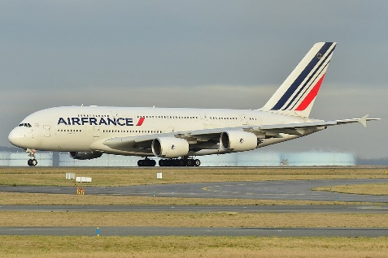Sending away
4. Historic buildings
5. Lit up