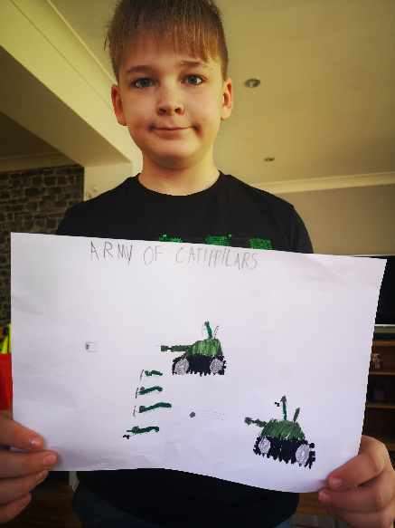**Charlie’s Army of Caterpillars**