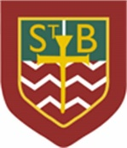**St Barbara’s Primary School**

|  |  |
| --- | --- |
| **Curricular Areas** | **Primary 7 Suggested Daily Learning Activities**  **Friday 15th May** |
| **Literacy** | 1. Who would like to play a game of Boggle? Can you use the following letters to create as many words as possible- a, l, p, i, m, s, d, t, e, b and k? Try to challenge yourself by creating words using as many letters as possible. 2. Let’s have some fun with alliteration. I would like you to write your very own tongue twister. I have attached examples of some tongue twisters below. Choose a topic that you would like to write about and get your creative hats on. When you have written your tongue twister why not record yourself saying it and send it to me? Remember tongue twisters are said quickly, that is when it gets tricky. Good luck and I look forward to hearing some of your creations. |
| **Numeracy** | 1. Complete the maths starter of the day that I have attached below. 2. A new North Lanarkshire Sum Dog competition starts today. We did so well the last time and you all put in such a great effort. There will be more people online participating in this competition so we really need to give this one our best shot. Try to get on and answer as many questions as possible over the next few days. Remember it is not just about speed, it’s about accuracy so read the questions carefully. |
| **Science** | Rainbows are something that we are seeing everywhere at the moment as a constant reminder to stay positive during these difficult times. If you have the resources listed below why not make your very own rainbow in a glass? I have attached the details for today’s experiment. |
| **TIOF** | 1. On Sunday the Primary 4 children were supposed to be receiving the sacrament of First Holy Communion. Due to the current circumstances this celebration has been postponed and as you can imagine the Primary 4 pupils are feeling very sad about this. I thought that it might be a nice idea for you to write a short prayer or message to them to let them know that you are thinking of them at this time. If you write and decorate your prayer or message and send it my glow email address I will ask the Primary 4 teachers to post them on their blog. 2. I would like you to say another decade of The Rosary today. On a Friday we celebrate the ‘Sorrowful Mysteries’. Today we will explore the third ‘Sorrowful Mystery’, Our Lord is Crowned with Thorns (Matthew 27:27-31). Go to the May altar that you have created or find a quiet spot in your house and close your eyes. |
| **Additional Tasks** | If you wish to complete more tasks please select one or two tasks from your Second level grid for May. |

**Tongue Twisters**

I had a good laugh trying to say some of these tongue twisters!

[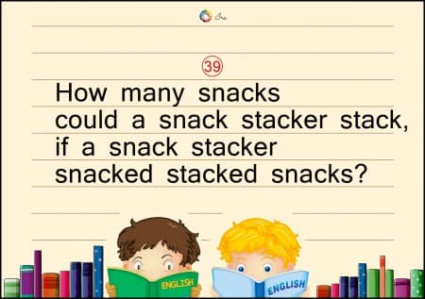](https://www.google.co.uk/url?sa=i&url=https%3A%2F%2Fwww.childfun.com%2Farticles%2Fgeneral%2Ftongue-twisters-for-kids%2F&psig=AOvVaw29b7b4tioUb_JFriD3K_Dc&ust=1589478251006000&source=images&cd=vfe&ved=0CAIQjRxqFwoTCKjS2YaysekCFQAAAAAdAAAAABAD)

[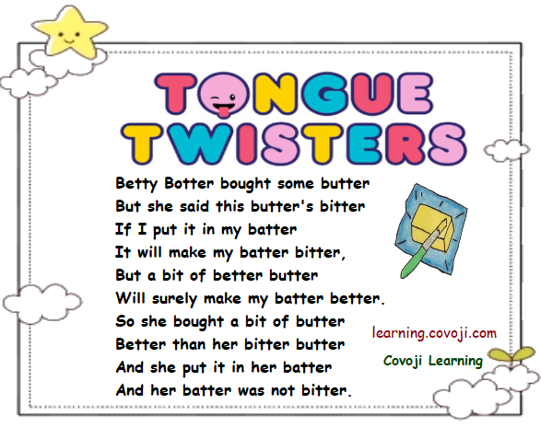](https://www.google.co.uk/url?sa=i&url=https%3A%2F%2Fwww.quora.com%2FWhat-are-some-funny-tongue-twisters-that-make-you-go-mad&psig=AOvVaw29b7b4tioUb_JFriD3K_Dc&ust=1589478251006000&source=images&cd=vfe&ved=0CAIQjRxqFwoTCKjS2YaysekCFQAAAAAdAAAAABAJ)

[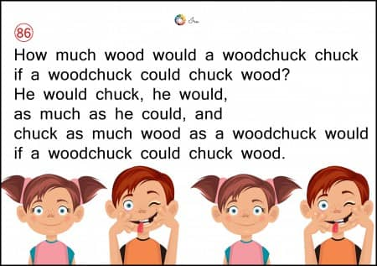](https://www.google.co.uk/url?sa=i&url=https%3A%2F%2Fwww.childfun.com%2Farticles%2Fgeneral%2Ftongue-twisters-for-kids%2F&psig=AOvVaw29b7b4tioUb_JFriD3K_Dc&ust=1589478251006000&source=images&cd=vfe&ved=0CAIQjRxqFwoTCKjS2YaysekCFQAAAAAdAAAAABAW)

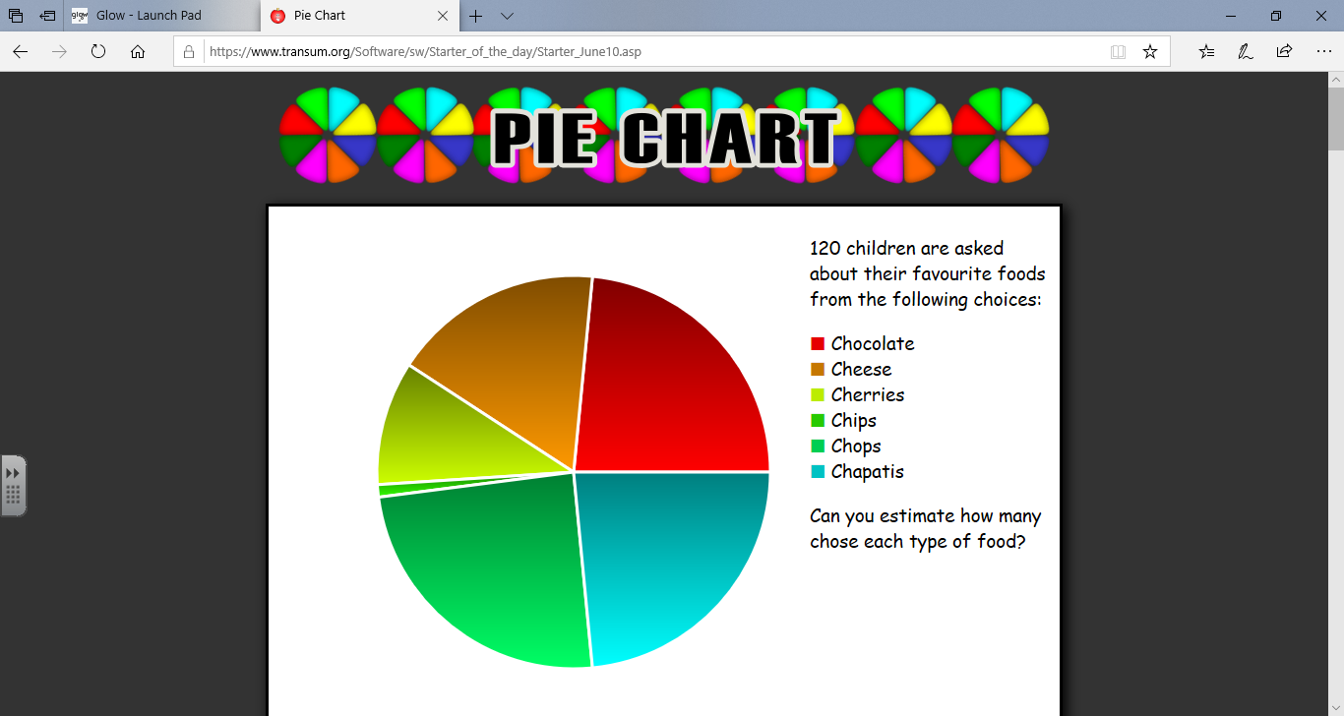**Maths Starter of the Day**

**Make your own rainbow**

**Materials needed:**

* Water
* A mug
* 5 separate cups
* A tablespoon
* A clear glass
* A dropper ( a straw would work also)

**Methodology**

1. Separate the Skittles into 5 cups, in these amounts: 2 red, 4 orange, 6 yellow, 8 green, and 10 purple.
2. Heat a mug of water in the microwave for a minute and a half (or long enough that the water is hot, but not boiling). Be careful removing the water from the microwave–it’s hot! Ask an adult to help you with this part.
3. Measure and pour two tablespoons of hot water into each cup, on top of the Skittles.
4. Stir each cup carefully so no water splashes out. The cups need to be cool for the next part of the experiment, so leave them somewhere where they won’t get knocked over. Stir them every ten minutes or so until the Skittles are dissolved and the water is room temperature.
5. Using the dropper (or straw), add the coloured water from the five cups to the clear glass. Start with purple, then add green, then yellow, orange, and red last. Go slowly here, we don’t want the different layers to mix.
6. Congratulations, you made a rainbow. You didn’t even have to go outside!

**So what is the science behind it all?**

Skittles are mostly made of sugar. When you add hot water to them, the sugar dissolves and the colouring on the shell of the Skittles turns the water different colours. The cup with only two red Skittles doesn’t have as much sugar as the cup with ten purple Skittles, but they both have the same amount of water. The amount of matter packed into a certain amount of space is called the density of the material. The red water is less dense than the purple water, so it will float on top of the purple water.

Have fun giving this experiment a go and remember to share some snaps on Twitter or email them to me at [**gw13reidsiobhan@glow.sch.uk**](mailto:gw13reidsiobhan@glow.sch.uk)**.**

[](https://www.google.co.uk/url?sa=i&url=http%3A%2F%2Fcoolscienceexperimentshq.com%2Frainbow-in-a-jar%2F&psig=AOvVaw1rlZCQ56idRvgGF7eOkrws&ust=1589476826944000&source=images&cd=vfe&ved=0CAIQjRxqFwoTCKDUlOKssekCFQAAAAAdAAAAABAD)