Friday 15th May - please begin with your morning prayer, thanking God for looking over us and keeping us safe.
Literacy  Spelling  IALT use a range of strategies to help me spell.  Reading  IALT select information from a text. | Spelling Bee-  Today I would like you to practise your spelling words by doing speed writing. Set a 60 second timer and see how many times you can write your spelling word out correctly. Do this with each of your spelling words.  When you are finished, get someone at home to test you on this week’s spelling words.  Spelling words:  Capital letters- day, always, today, away, again, rain, train, play, pray, brain.  Full stops- again, play, said, today, always, rain, train, pray, brain, day.  Reading-  Today I thought you might like to try this fun reading comprehension task.  Read through the passage and then have a go at answering the questions. Remember to look back through the passage to help you find clues.
Numeracy  IALA how numbers are constructed. | It is important we continue our oral maths. This maths activity from your grid is a perfect way to get your brains active.  Out loud, count forward in:  - 2s from 0-20  - 5s from 0-50  - 10s from 0-100  - 100s from 0-1000  - 5s from 15-60  - 10s from 30-120  - 100s from 200-900  Now use the same numbers but count backwards.  Next, I would like you to complete ‘Today’s number’ task.  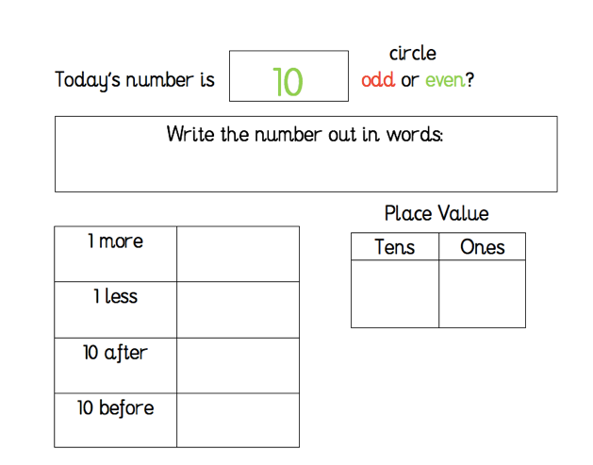  Sumdog- I would like you to take part in Sumdog’s mathematics contest for North Lanarkshire schools which begins today!  Take part, try your best and show off your maths skills.  More information on today’s blog.
HWB  IALT improve my fitness. | Since it is going to be another lovely day today, I thought you might like to keep active outdoors. I would like you to set up an outdoor obstacle course in your garden for you to complete.  You can do this by simply using objects which you have in your house and garden. Be as creative as you wish! You could include a bat and ball, hula hoops, garden chairs, a slide, skipping ropes and lots more.  You could even challenge someone at home to complete your course! I would love to see what you come up with so please tweet a picture of your obstacle course @St_BarbarasPS or send me an email.  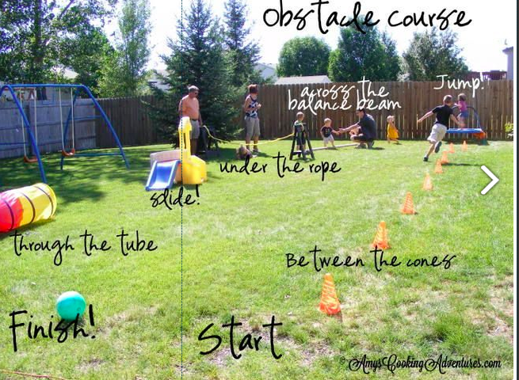
T.I.O.F  IALT honour Mary. | Throughout the month of May, we honour and pray to Our Lady.  Did you know that Our Lady has many different names? Some of these names are connected to different places where she has appeared. One of the names Our Lady has been given is Our Lady of Fatima.  Today, we are going to watch this video which tells us the story of Our Lady of Fatima.  https://www.youtube.com/watch?v=z7cD8hJ1w0Q  I would like you to listen carefully and recall the main events that happened in the story. What happened when Our Lady appeared to three children in the town of Fatima? Can you explain to someone at home.

Optional  tasks | If you wish to complete more tasks please select one or two tasks from your new First level grid for May.
Remember any work you wish to upload should be done so under your class name and if you would like to share any videos or pictures of you completing any of the tasks you have been set you can do so via Twitter. Have fun, work hard and if you need anything you can contact me by email; gw19shreenannatasha@glow.sch.uk
Miss Shreenan

