Thursday 14th May- Morning Prayer
Literacy | Reading- Oxford Owl > https://www.oxfordowl.co.uk/  Simply log in to this website by clicking- the pink ‘my class login’ button at the top right hand side.  Enter the username- miss shreenan p2 & password- books  Apples- I would like you to search for ‘The Flying Machine’ and read out loud to someone at home. Remember to use expression and make eye contact.  Bananas- I would like you search for ‘Perfect Pets’’ and read out loud to someone at home. Remember to use expression and make eye contact.  Strawberries- I would like you to search ‘The Orchid Theif’ and read out loud to someone at home. Remember to use expression and make eye contact.  Next, I would like you to complete this book review on your reading book.  Remember the author is the person who writes the story.  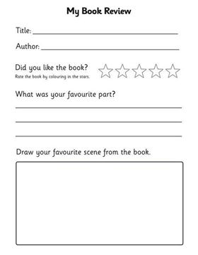
Numeracy | Today we are going to be looking over our number words. It is important we can read, spell and recognise our number words.  Jack Hartmann is here to help you learn your number words with a very catchy song!  https://www.youtube.com/watch?v=fesicySq7EU  Once you have listened a few times and are feeling confident, I would like you to have a go at unscrambling these words.  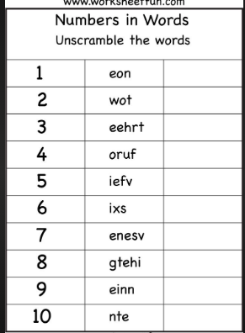  Challenge- Can you match these numbers to their sight word.  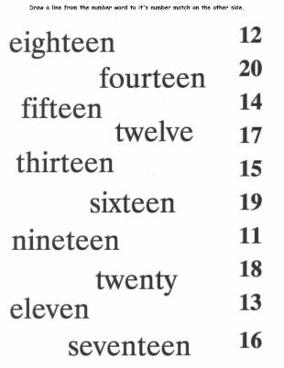
HWB  IALT improve my fitness. | It is important we continue to work on our skills for life-long learning. What better time to practise these skills than right now!  I thought this would be a great challenge to complete over the next few weeks.  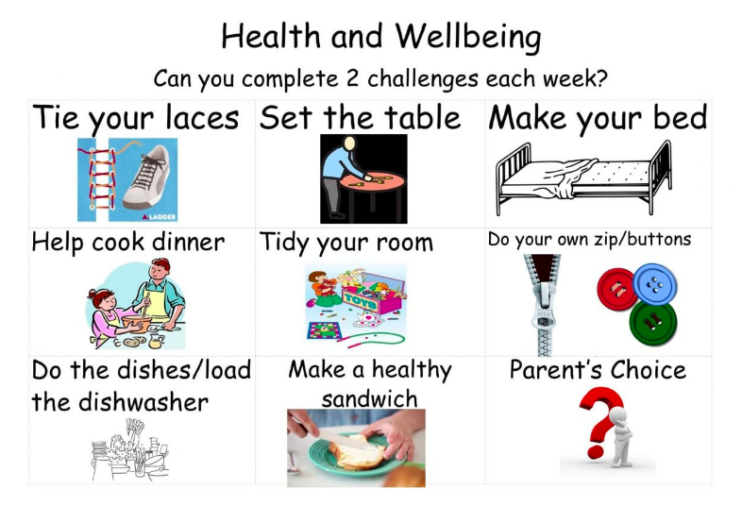  Please select 2 skills to practise over the next week.
IDL topic | Landmarks  During Barnaby Bear’s trip, he would like to go visit some famous landmarks. Can you recommend 3 famous landmarks Barnaby Bear could visit?  This video will help you decide what to recommend >  https://www.youtube.com/watch?v=YWRH7btAZPo  Barnaby Bear would like to visit the capital city of France which is Paris.  One of my favourite places to visit in Paris has two cheeky mice living at it- can you guess where?

