**St Barbara’s Primary School**

|  |  |
| --- | --- |
| **Curricular Areas** | **Primary 7 Suggested Daily Learning Activities**  **Thursday 14th May** |
| **Literacy** | 1. Today we are going to explore another figurative language technique, alliteration. Can you remember what alliteration is and how we use it? We often used alliteration when creating new group names and it was a lot of fun, it really got our imaginations flowing. I would like you to watch this short clip to remind yourself what alliteration is:   <https://www.bbc.co.uk/bitesize/topics/zfkk7ty/articles/zq4c7p3>   1. Alliteration is when words **start with the same sound:**  * For example, Peter Piper picked a peck of pickled peppers. * Alliteration is used in both written and spoken English. You can find examples in poetry, advertising and events commentary. * It is often used in newspaper headlines to grab the reader’s attention. Can you create your own newspaper headline about lockdown using alliteration?   Use the PowerPoint attached to the Primary 7 GLOW homepage to familiarise yourself with alliteration and complete some of the fun activities.   1. The word alliteration can be tricky to remember how to spell. I always remember how to spell it by singing to the tune of Old McDonald had a farm - a, double l, i, t, e, r, a, t, ion. What fun mnemonics can you come up with to help you with the spelling? 2. Remember to spend a little bit of time today reading. You may read the novel that I have assigned to you on the Scholastic website or choose your own personal reader. |
| **Numeracy** | 1. Have you got your detective hat on? Today we are going to explore a range of mathematical concepts to solve a crime. The scene is set for you and you have been given a list of suspects. You must solve each of the maths questions to help you get closer to finding the culprit. Make sure you read the questions carefully as you don’t want to let your criminal get away. All of the information that you need to take part in today’s activity has been attached to the Primary 7 GLOW homepage. 2. Complete today’s task on your 2nd level May maths calendar. Today’s activity is all about simplifying fractions, this is something we were working on in class. I have included a copy of May’s calendar below in case anyone did not save it earlier in the month. |
| **Health and Wellbeing** | Click on the link below to take part in a fitness session. Take care when doing some of the exercises and remember to be aware of your surroundings. Have some water handy and if you need a little break just pause the video.  <https://www.youtube.com/watch?v=9WgkiB-GQMI> |
| **Topic** | 1. We now know what events led to the outbreak of WWII so today we are going to move on and explore what happened to children during WWII. We want to find out when, where and why children were evacuated in the World War. Click on the PowerPoint that I have put on to the Primary 7 GLOW homepage to find out more about why children were evacuated, where they were sent to, what kind of lives they had to live and what they were allowed to bring with them. 2. The BBC Teach website has some excellent WWII evacuation clips. Click on the link below to access them. You should try to take notes as next week we will be taking on the role of an evacuee and writing a letter to our parents.   <https://www.bbc.co.uk/teach/school-radio/history-ks2-world-war-2-clips-ww2-evacuation-index/zvs3scw>   1. The plan to evacuate the children from the city was referred to as the Pied Piper operation. Read the story of the Pied Piper of Hamelin to better understand why it was called this. I have attached the story below. |
| **Additional Tasks** | If you wish to complete more tasks please select one or two tasks from your Second level grid for May. |

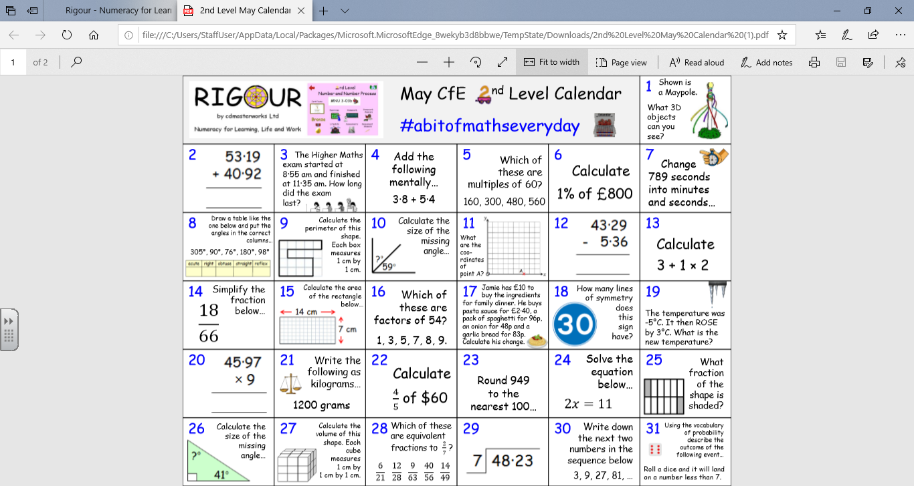**May 2nd Level Calendar**

Pied Piper of Hamelin

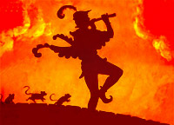Hamelin was a small town in Germany. The city was full of rats. Hamelin was a rats’ paradise truly. They were in houses, inns, shops, schools and in every street. It was a menace and a solution had to be found fast.  
  
The mayor had often held meetings with the town folks to discuss this problem. At the beginning they had thought that cats would drive away mice. However, the number of rats became a problem for them. It was very tough to take proper steps as it was really very difficult to find huge numbers of cats. They were in a real dilemma.   
  
One day, a stranger came to the town of Hamelin. He used to carry a flute along with him. He had a stern look on his face and had walked straight to the mayor's building. He faced the mayor of Hamelin and said, "It is well known around Germany that Hamelin has a problem with rats. I will get rid of all the rats. What would my reward be?" For a moment the mayor was stunned. It was difficult for him to believe that a man who was coming from somewhere suddenly was claiming to drive away all the rats from the city.  
"Ten Thousand gold coins from our treasury if you can do as you promise," said the mayor. The stranger nodded his head and said, "In a day's time Hamelin will have no rats."  
  
The stranger walked out in the street, pulled out his flute and started playing it. An eerie sound floated in the air. People of Hamelin could hear the beautiful tune from every corners of Hamelin and were paralyzed hearing this enchanting tone.  
  
All of a sudden, there was a 'whirring' noise. Thousands of rats came all the way from various directions. They followed the eerie sound that came from the Piper's flute. It seemed that the rats were mesmerized with the delightful tone of the flute. The stranger headed towards the sea, with all the rats of Hamelin behind him. It was an extraordinary sight for the folks of Hamelin.   
  
The stranger was continuously playing the flute and walked right into the sea. The rats followed him and all of them were caught by the waves which dragged them into the sea. All the rats of Hamelin drowned. The strange piper had got rid of all the rats and kept his promise.  
  
The stranger approached the mayor for his reward. The mayor and the town's people were rejoiced watching the bizarre thing. But the mayor had changed his mind. When the stranger went to him, he said, "It is a wonderful task you have accomplished but isn't ten thousand gold coins a hefty reward for a day's work. I will pay you five hundred gold coins." The stranger looked at the mayor and then walked out.  
  
In the street he pulled out his flute again and started playing it. This time the sound that came from the flute was different but was eerie as well. All the children of Hamelin started to follow the stranger.  
  
The stranger walked out of town and disappeared into the mountains. Children followed him. The parents of the children wept, "Where had the stranger taken their children," they went to the mayor and complained about it. The mayor was helpless. He knew that he had been dishonest with the stranger.   
The stranger returned to Hamelin but children didn’t accompany him. The mayor rushed to him, begging for forgiveness. He pleaded to the stranger to get the children back. Without uttering a single word, the stranger turned and walked away. He returned after a few hours, this time with all the children.  
  
The stranger was rewarded with his ten thousand gold coins. The mayor had learnt his lesson.