Wednesday 13th May – Morning Prayer
Literacy  IALT decode words using phonemes. | Phonics Task- consolidation  Starter- Alphabet name and sounds- My name is A, my sound is a.. (orally)  Warm-up- read through the phonics cards- see how many you know! (sh for shop, ch for chest…)  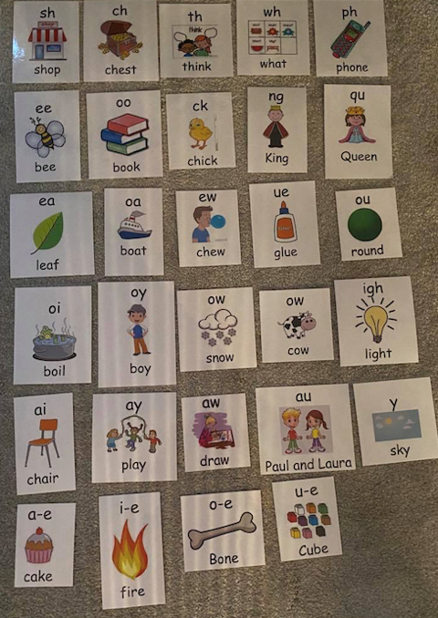  Capital letters & full stops group- ay or ai  Watch > https://www.youtube.com/watch?v=BGrIyCT7nK0  Now that we have watched and listened to this video, we should know that we use ‘ai’ if the sound is in the middle of the word and we use ‘ay’ if the sound is at the end of the word.  (example- brain / play )  Complete the task below- match the word to the correct picture.  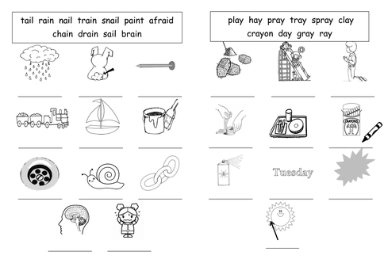  Challenge- can you fill in the missing words. Remember the spelling rules of ‘ai’ or ‘ay’ when you are deciding. Some of the words have a ‘tail’- remember with words ending in ‘ing’ or ‘ed’ the sound is ‘ay’  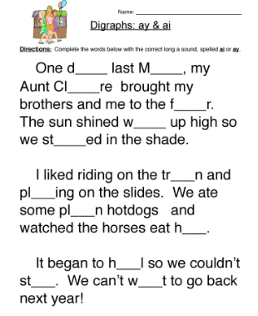
Numeracy | Today we are going to revise our number bonds to 10.  Let’s sing along to one of our favourite songs by Jack Hartmann to help us in today’s task!  Watch > https://www.youtube.com/watch?v=lD9tjBUiXs0  Now that you have watched, you will know there is lots of different ways to make 10!  Can you think of 11 different ways we could make 10?  I’ll give you a head start…10 + 0 = 10  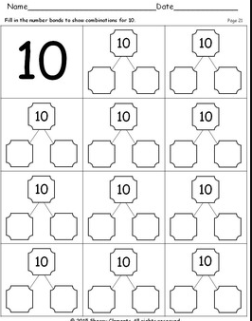
HWB  IALT improve my fitness. | Today we are going to be learning more about our own feelings.  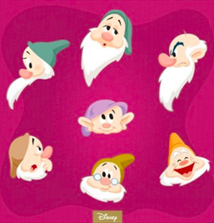  What dwarf do you feel like today?  Happy, Grumpy, Sleepy?  It is normal to go through lots of different emotions, especially just now when you are missing school and your friends. So I have found a little video to help you understand that it is OK to have a blue day.  This video is called ‘Lucy’s in Lockdown’. I would like you to watch and see how Lucy is feeling today. Have you have ever felt like Lucy before? >https://www.youtube.com/watch?v=-RXF5-29VGU
IDL topic | Barnaby Bear really enjoyed his time in Scotland. Next stop on Barnaby Bear’s adventure around the world is…France.  Barnaby Bear doesn’t know a lot about France so he needs your help. He would like to know what colours the France flag is. Can you find out and colour in this flag below to show Barnaby.  Barnaby Bear would like to be able to greet people during his time in France but he doesn’t know how to speak any French. Can you help Barnaby Bear learn some French…  Here is a video to help you and Barnaby learn some French greetings >  https://www.youtube.com/watch?v=mDMFi381mVU&list=PLxY-Ss_lv7gf02LfJiNl9m_uX_05JqGWB  Have a go at trying these greetings on someone at home after.

