**St Barbara’s Primary School**

|  |  |
| --- | --- |
| **Curricular Areas** | **Primary 7 Suggested Daily Learning Activities**  **Wednesday 13th May** |
| **Literacy** | 1. **Did you enjoy exploring similes and metaphors yesterday? I would like you to spend a little bit more time focusing on these today. Watch the BBC Bitesize clip that I have attached to the Primary 7 GLOW homepage to remind yourself what a simile is and what a metaphor is. Take care not to get these confused!** 2. **I would like you to use the PowerPoint that I have attached to the Primary 7 GLOW homepage to learn a bit more about similes and metaphors. This will help consolidate what we explored yesterday. Complete the activities in your jotter and try to be as imaginative as possible when creating your own similes and metaphors.** 3. **For reading today explore the First News newspaper article, *VE Day- Celebrating in lockdown.* When you have finished reading the article, read the questions and then skim and scan the text before attempting to answer any of the questions. Answer the questions in your jotter and remember to use the question to help you structure your answer. The answers are in the text so always refer back to the article to help support you. I have attached a link to today’s article, questions and answers on the Primary 7 GLOW homepage. Remember no peeking at the answers before you give the questions a go!** 4. **Remember to take some time out of your day to do some personal reading. I am finding myself reading a lot more during lockdown, it is a great way to relax and switch off for a little while.** |
| **Numeracy** | 1. **To get our brains working this morning I would like you to complete the maths starter that I have attached below. Record your answer and working in your jotter.** 2. **I would like you to complete a little consolidation exercise on multiplying and dividing whole numbers and decimal numbers by 10, 100 and 1000. I have attached 3 sets of questions below. Choose the set that challenges you the most.** 3. **I have created a times table competition on Sum Dog. This competition will recall all times table facts, I will announce the winner at the end of the day. Good luck everyone!** |
| **Topic** | **Last week we did a bit of research on the events that led to the beginning of WWII. Today I would like you to use the notes you have made to create a timeline of events.**  **I have attached a timeline template and date cards to the Primary 7 GLOW homepage. You have to cut out the fact cards and put them on the timeline in the order in which you think they took place. If you are unable to print out this worksheet you can copy the timeline template into your jotter and write in the fact cards with the date.** |
| **TIOF** | 1. **Today we are going to say another decade of the rosary. On a Wednesday we celebrate the ‘Glorious Mysteries’. Today we will explore the second ‘Glorious Mystery’, The Ascension of Our Lord (Luke 24:50-53).** 2. **Remember to go on to The Diocese of Motherwell Twitter page to access the Daily Angelus Challenge.** |
| **Health and Wellbeing** | **To help get us motivated and active complete a Joe Wicks workout. Go to the ‘P.E. with Joe’ section and let’s keep fit.** |
| **Additional Tasks** | **If you wish to complete more tasks please select one or two tasks from your Second level grid for May.** |

**Maths Starter**

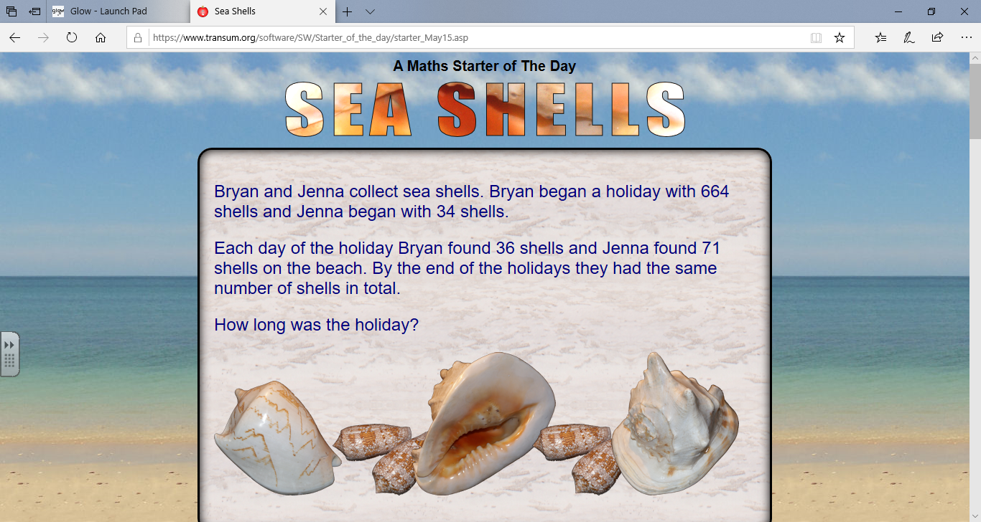

**Multiplying and Dividing by 10, 100 and 1000**

Bronze

1. 302 x 10 2. 8236 x 10 3. 1920 x 100

4. 8900 ÷ 10 5. 1200 ÷ 100 6. 36000 ÷ 1000

7. 1.8 x 10 8. 32.7 x 10 9. 2.03 x 100

10. 9.44 x 100 11. 15 ÷ 10 12. 235 ÷ 10

Word Problems

1. The total weight of 100 safety pins is 121 grams.

What is the weight of 1 safety pin?

1. 10 people shared a £175.80 bill in a restaurant.

How much did each person have to pay?

1. One thousand people each paid £33.20 into a charity last week.

How much did the charity receive last week?

Silver

1. 755 x 10 2. 1472 ÷ 10 3. 8000 x 100
2. 5010 x 100 5. 10 x 1000 6. 3800 ÷ 100
3. 35500 ÷ 100 8. 32.387 x 10 9. 216 ÷ 1000

10. 0.145 x 100 11. 235.68 x 1000 12. 0.634 x 100

Word Problems

1. Sally measured the thickness of 100 sheets of paper as 385mm. How thick is each sheet?
2. Nick is improving his home and needs wood for shelving. He needs 1000 planks of wood but they only come in packs of 10. If each pack costs £7.95, how much will he need to spend?
3. Anne bought plastic to cover her books. She needed 41.5cm for each book. How much plastic did she need for 10 books? How about 100 books?

Gold

1. 0.06 x 10 2. 0.0407 x 10 3. 135.27 ÷ 10
2. 1.07 x 100 5. 865.12 ÷ 100 6. 0.0025 x 100

7. 2.070 x 1000 8. 14.1 x 1000 9. 900 ÷ 1000

10. 736.41 ÷ 1000 11. 81.2 ÷ 1000 12. 17 ÷ 1000

Word Problems

1. There are 1000 grams in 1 kilogram. How many kilograms are there in:-
2. 1528 grams b) 94.4 grams c) 7.5 grams
3. David went to the shop and spent £2.20 on bacon. Susie went and bought 10 times the amount David did. How much did Susie spend?
4. Every day, Arielle finds 154 pearls. How many would she have found after 100 days?
5. One Direction’s new song, “Love Yourself”, has had 1.2million downloads. Little Mix’s new song has had one thousand times less than this. How many downloads did Little Mix’s song have?