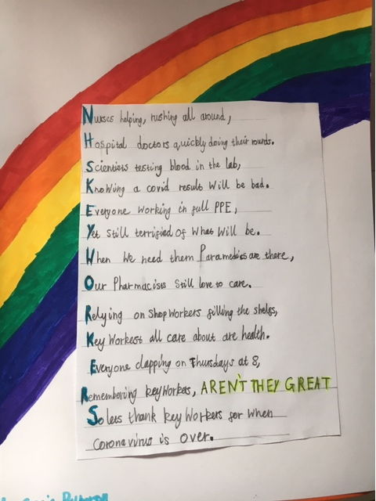**NHS and Keyworker Acrostic Poem by Sofia**