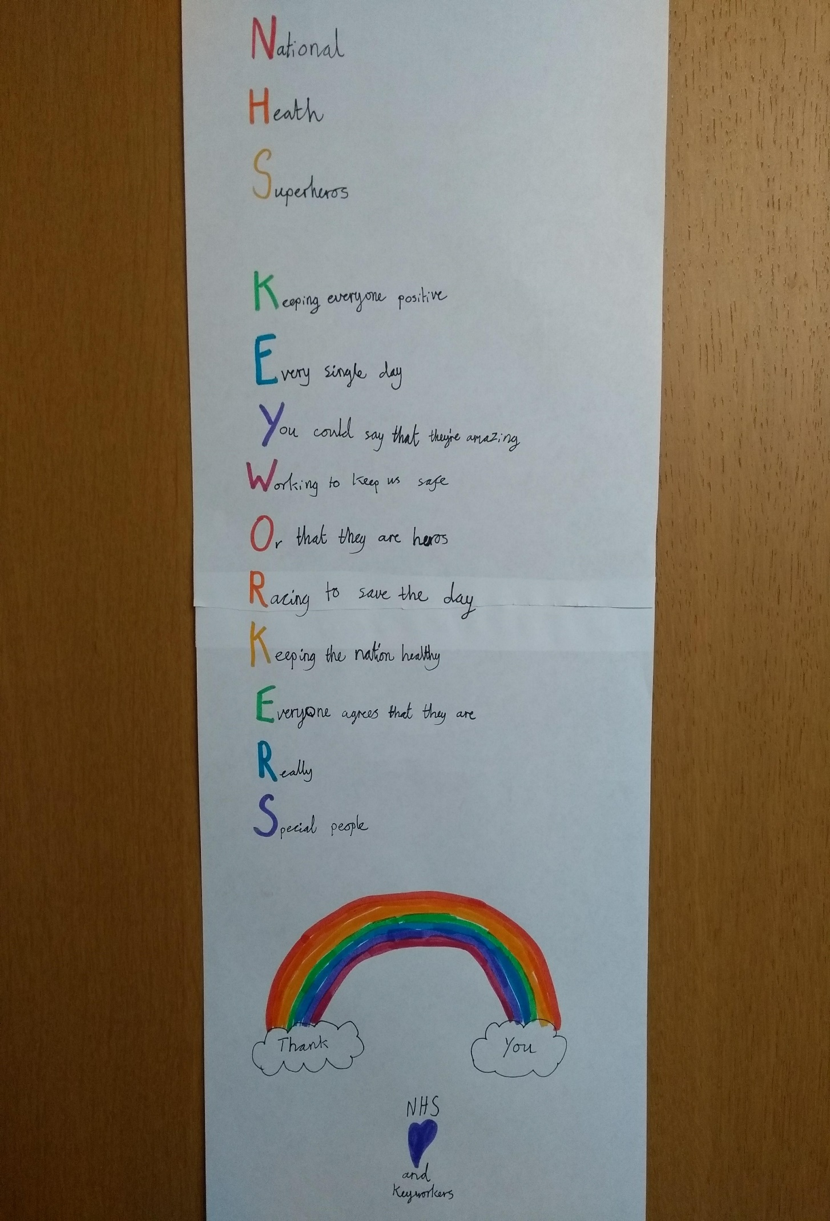**Natasha’s NHS Superhero Acrostic Poem**